Adult Information: Children in year 2 are taught to recognise the place value of each digit in a two-digit number (10s, 1s) and
use place value and number facts to solve problems. They are also taught to solve problems with addition, subtraction, multiplication and division.

The children are taught to identify and describe the properties of 2-D shapes, including the number of sides. They are also taught to identify and describe the properties of 3-D shapes, including the number of edges, vertices and faces

This week the children will be using all these skills for their maths.

Maths Day 1:
Choose as many of the odd and even worksheets as you’d like in the Monday folder.
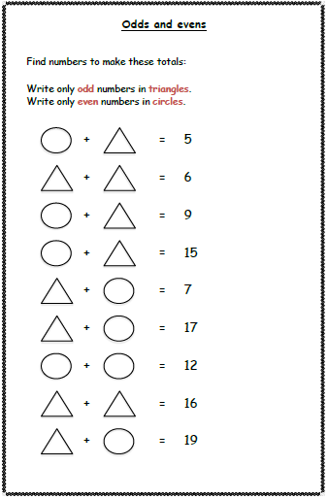
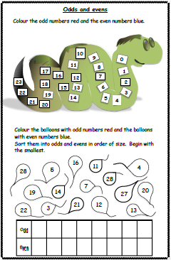
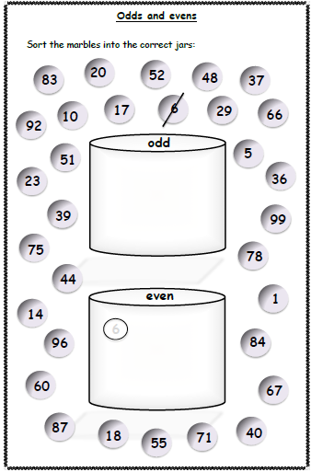

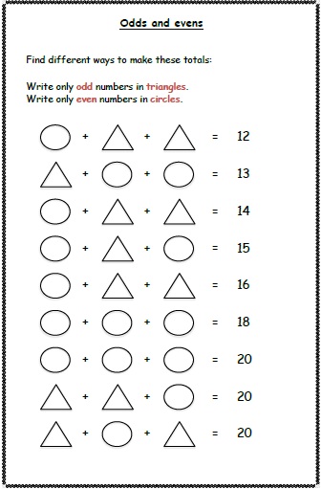
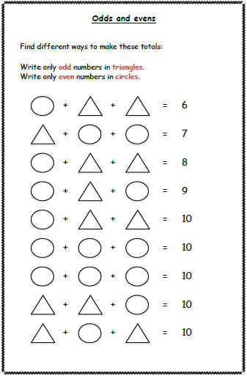

Each sheet gets a bit trickier!

Maths Day 2: Place value code breaker. There are 3 to choose from; you can complete 1, 2 or all 3 of them depending on how confident you are. Make sure you look carefully at the examples to help you understand what you need to do.

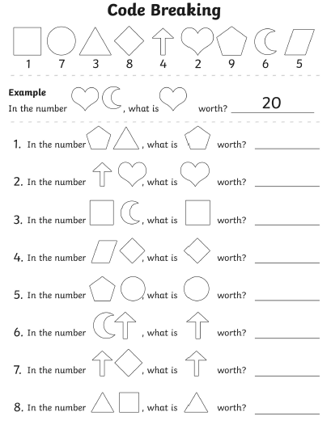

Code breaker 2 – place value
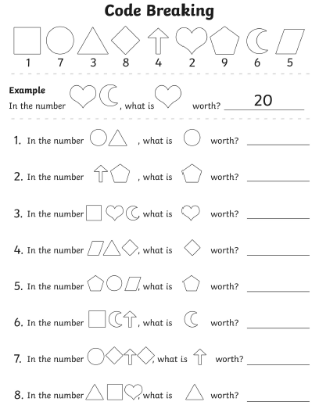

Code breaker 3 – place value
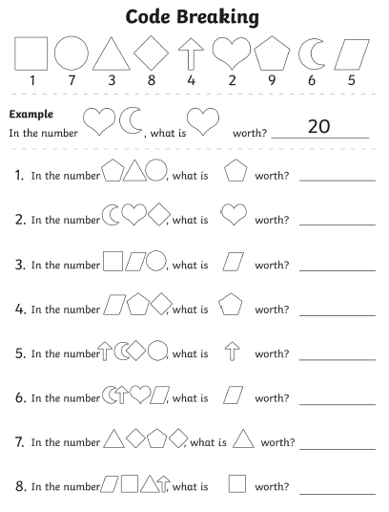

Code Breaker Answers

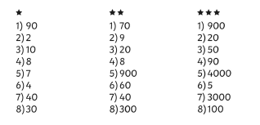

Maths Day 3:
Number code breakers. There are 3 to choose from; you can complete 1, 2 or all 3 of them depending on how confident you are. All 4 operations are used, so make sure you read each number sentence carefully!
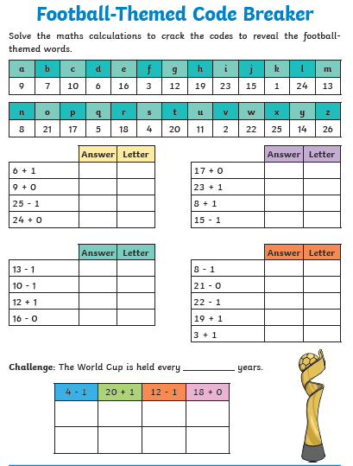

Code breaker 2 – adding and subtracting

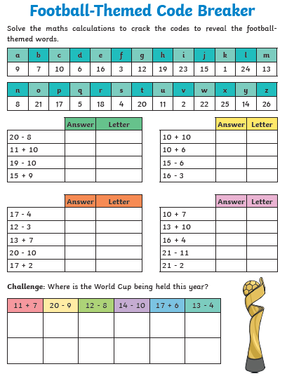

Code breaker 3 – all 4 operations
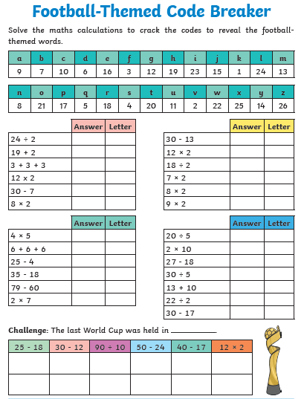

Code Breaker 1 Answers
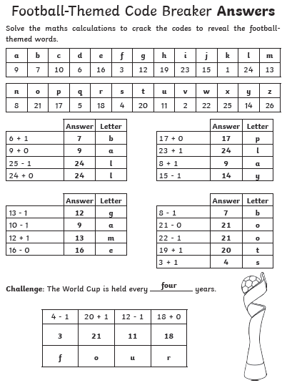

Code Breaker 2 Answers

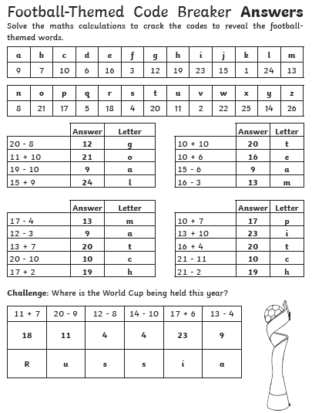

Code Breaker 3 Answers
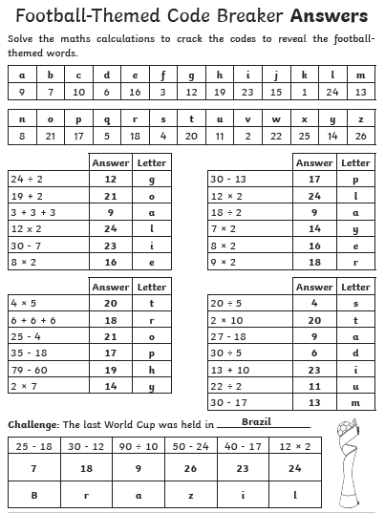

Maths Day 4: 2D shape sheets. Use the links on the planning document to remind yourself of the features of 2D shapes.

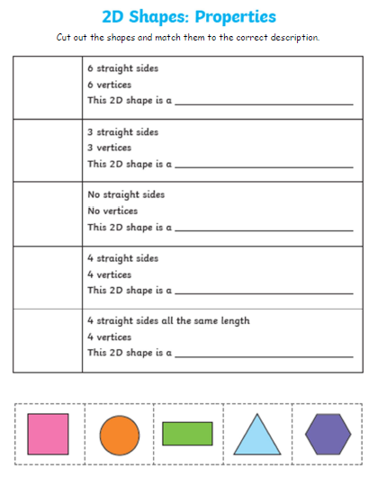

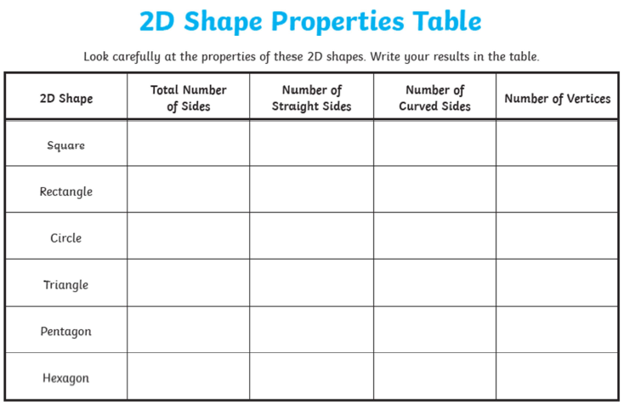

Maths Day 5: 3D shapes. Use the links, PowerPoint and revision sheets to remind yourself of the features of 3D shapes and have a go at making some with the nets.



