Adult Information: Children in year 2 are taught to recognise and use symbols for pounds (£) and pence (p) and to be able to combine amounts to make a particular value. They also learn to find different coins that equal the same amount of money and find ways to solve problems involving addition and subtraction of money, including giving change.
This week the children will be using their adding and subtracting skills to solve and investigate problems.

Maths Day 1:
Task 1 Add up the totals then work out the change

Coins | Total | Change from £1

Maths Day 1: Task 2

Choose 4 of the amounts in the total column and find 3 different ways of making the same amount. Draw and label the coins.

Amount | 1 | 2 | 3

Maths Day 2: Task 1
Work out the change to be given from £2.00. Draw the coins.

Cost of Item | Change from £2.00
£1.20

£1.55

94p

86p

72p

69p

58p
33p

Maths Day 2: Task 2 (challenge)

Use real coins or draw them in to make the amount.
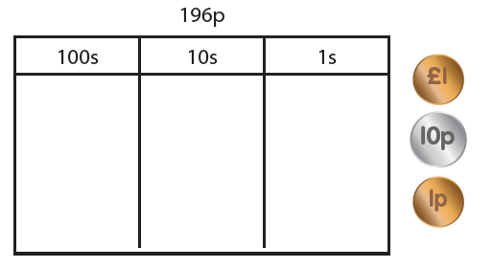

How many different ways can you make the same amount?
_____________________________________________________
_____________________________________________________
_____________________________________________________
_____________________________________________________
_____________________________________________________
_____________________________________________________
_____________________________________________________
_____________________________________________________
_____________________________________________________

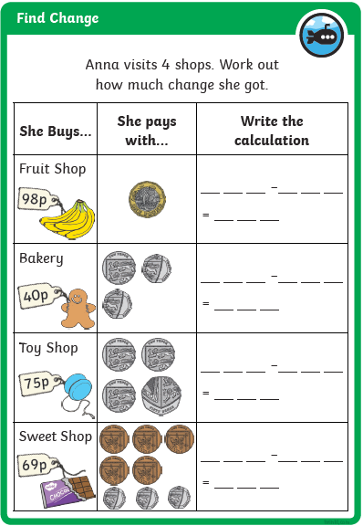
Maths Day 3: Task (guidance, prompt questions and answers below)

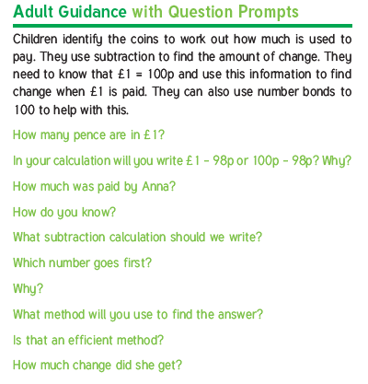

Answers
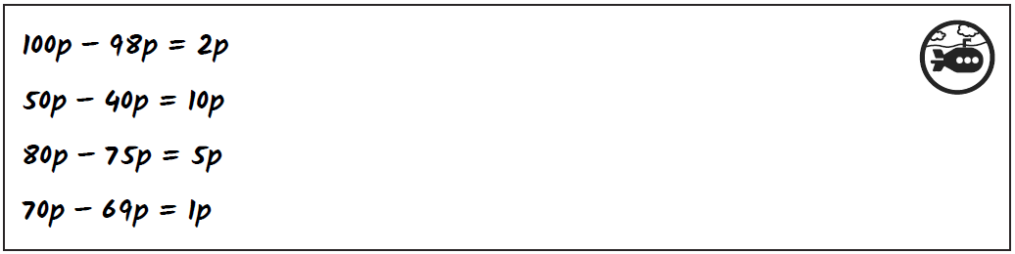

Maths Day 4: Task (guidance, prompt questions and answers below)
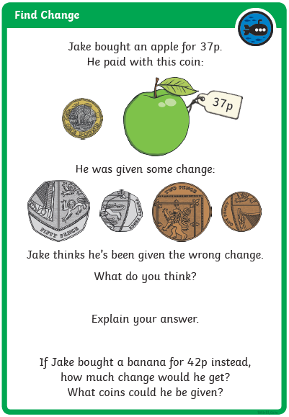

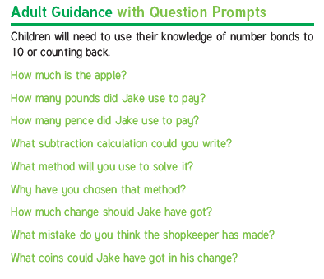

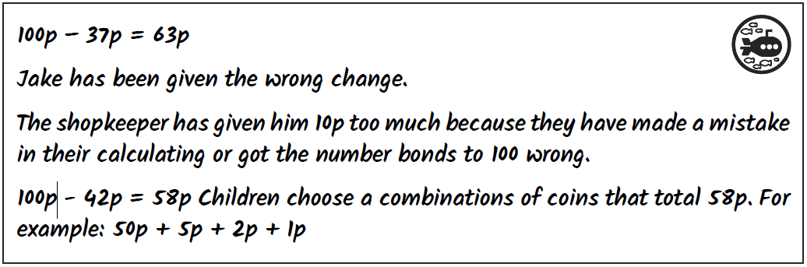
Answers

Maths Day 5: Task (guidance, prompt questions and answers below)
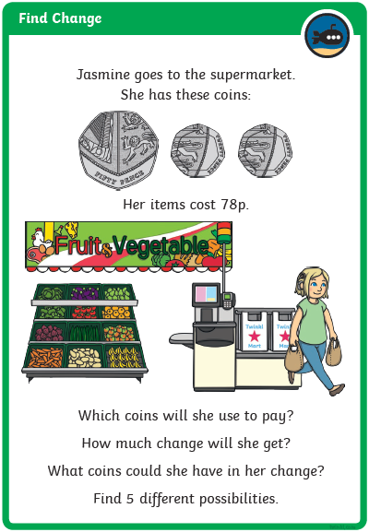

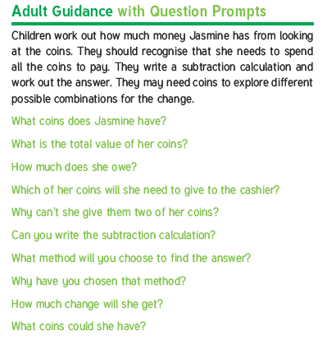

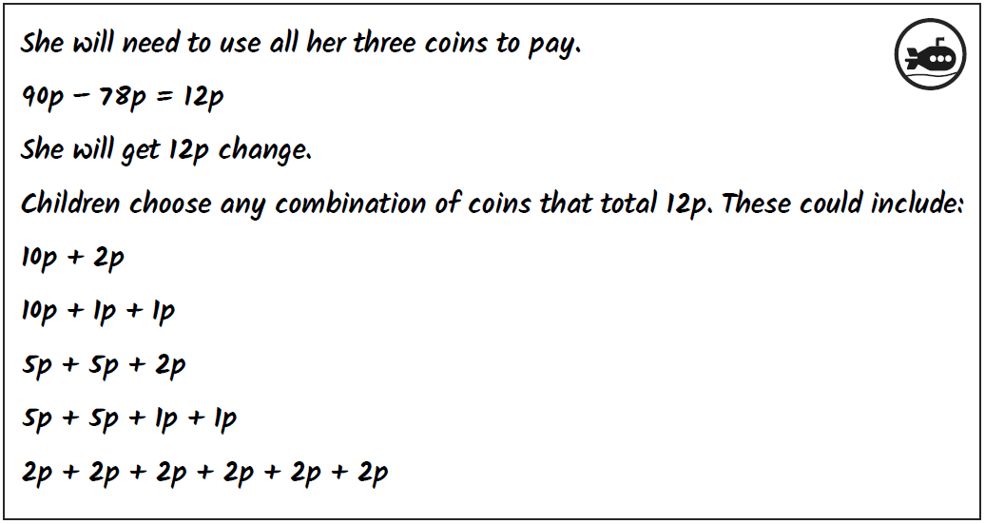
Answers

