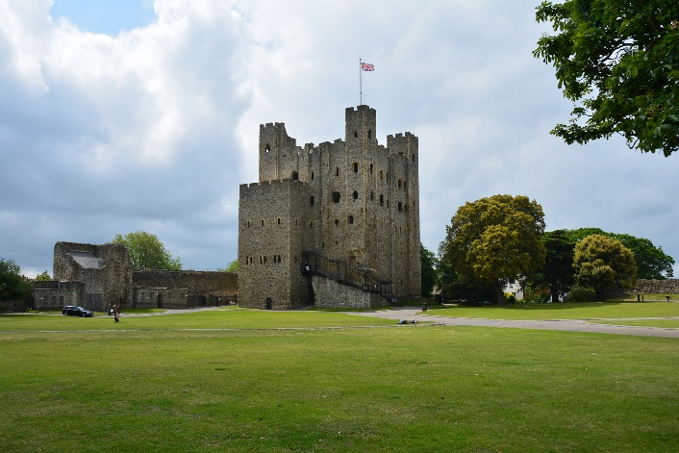
Rochester Castle was built by the Normans, who invaded England in 1066. That makes it over 900 years old! Its great Keep is made of stone and it is one of the tallest castles in the country. It is 113 feet (35m) high, and is 70 feet (22m) square and the walls of the Castle are between 11 and 13 feet (3.5-4m) thick.

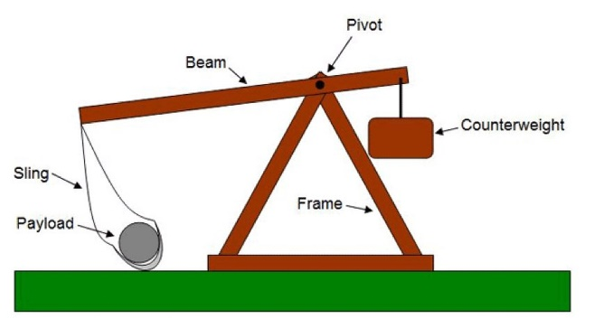

Inside the wall is the Keep where the noblemen would live.
It is an excellent example of Norman military building, built to protect and withstand an attack. Its position next to the river Medway made it the perfect place to look out for any enemy approaching. The Keep (the tall building) has a stone wall surrounding it, with grass inside; this would have been an extra layer of defence against attack.
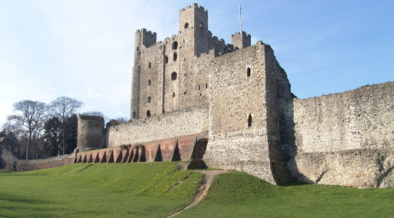

Outer wall and green of castle
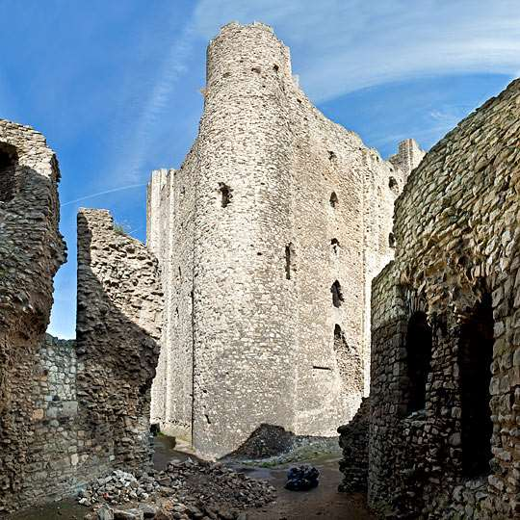
The Siege of 1215
The castle has an interesting history. One of the most significant of these was the siege of 1215. King John was on the throne; sadly, he was not a great king and struggled to keep his power. Having control of a strong castle like Rochester would help him gain more respect, plus it was in an important position to protect London from European attacks.
The trouble was that King John did not own the castle; it belonged to the local barons who would not give it to the King. John tried asking nicely for it but the barons locked themselves inside the Keep, making sure they had plenty of food, water and clothing to last for a long time. The siege had begun!
King John was not happy and rushed to the castle in October, bringing with him an army to break down the walls. They used trebuchet siege-engine to hurl huge stones to destroy the outer wall.

Diagram of a Trebuchet; a medieval weapon that caused terrible damage to buildings.
By the end of October they had managed to dig under the wall and reach the Keep. The Keep was the strongest part of the Castle and even though the King’s army pelted it with vast rocks, it stood firm, protecting all those who were inside.
King John would not give up, however, and came up with a rather cunning plan. He wrote to London and asked them to send him forty of the fattest pigs; before gunpowder was invented, pig fat was used to start fires. They dug under one of the towers and lit a fire, using the pig fat. It created the fiercest of fires and eventually the tower collapsed and allowed the King’s soldiers to enter and end the siege.
This is the south east tower that was destroyed during the siege. It was originally a square tower like the other three but was rebuilt as a semi-circle because this a much stronger design.

