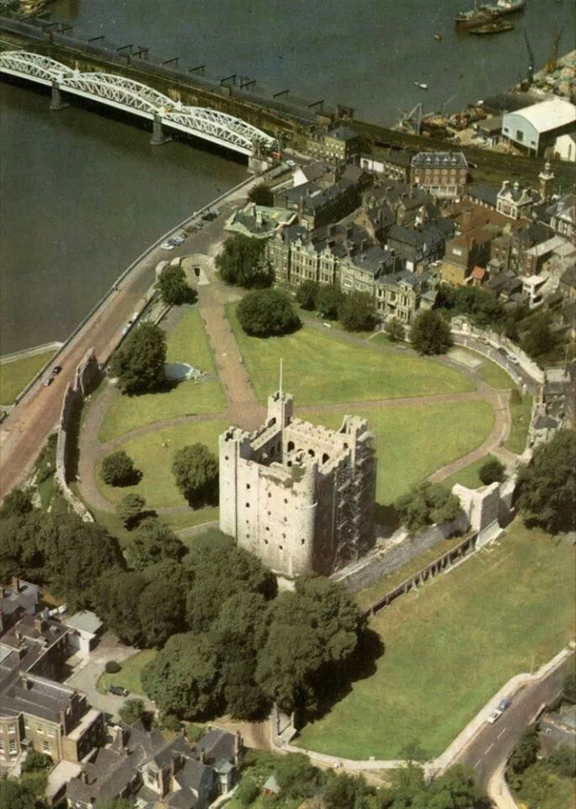
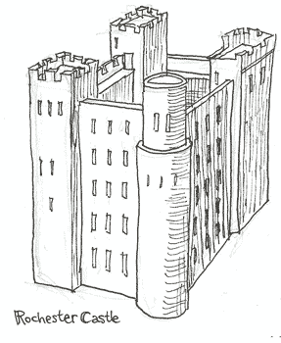
Use this aerial photo to help you draw the area around Rochester castle.
See if you can label the:
Curtain wall
Castle green
River Medway
Rochester Bridge

Use this to help you draw your own diagram of Rochester castle.
See if you can label the different parts:
Windows
Round tower
Square towers
Turrets

