Meet..
The Big Bad Wolf
I like...
I have...

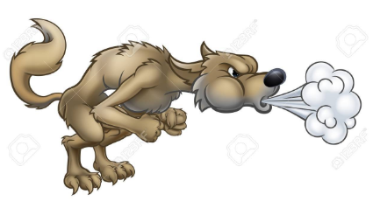

I am...

I am...

My Big Bad Wolf

