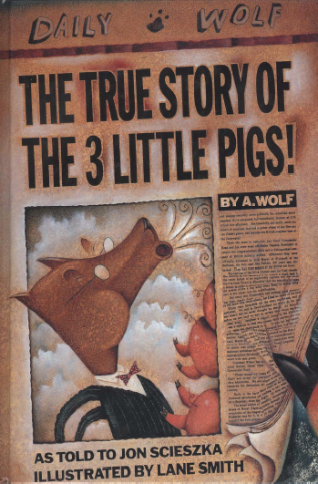

The True Story of The Three Little Pigs

- Who is the author of the book?

- What is the name of the Wolf?

- Why was the Wolf sneezing?

- Who was he making a cake for?

- What had he run out of to bake his cake?

- Why didn’t the Wolf walk into the first pig’s house when the door fell in?

- How was the second pig different to the first pig?

- What was the second pig doing when the Wolf knocked?

- “He must have been the brains of the family.” What does this tell you about the third pig?

- Why did the news reporters’ ‘jazz up’ the story of the Wolf?

