Maths Day 6:
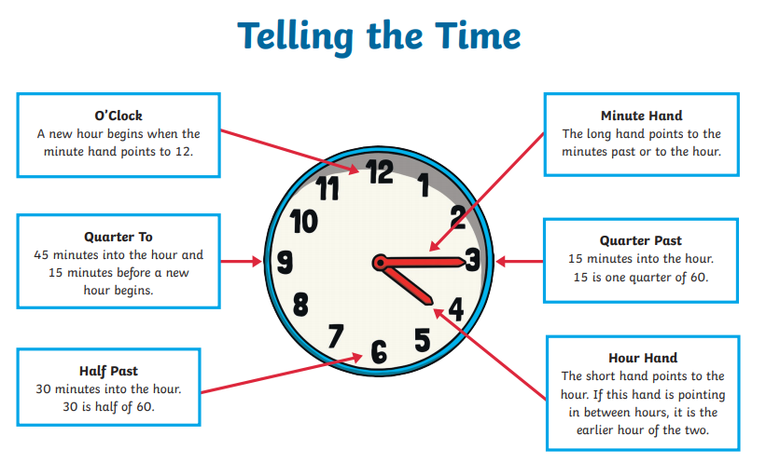

- Practise matching o’clock and half past times using the website below. http://www.scootle.edu.au/ec/viewing/L9643/index.html

- Make your own clock – this will help you learn to tell the time better (if you have already done this as part of your home learning then you don’t need to do it again).

- Create your own snap/pairs game by drawing times on clocks and then writing the times on another bit of paper. See example…
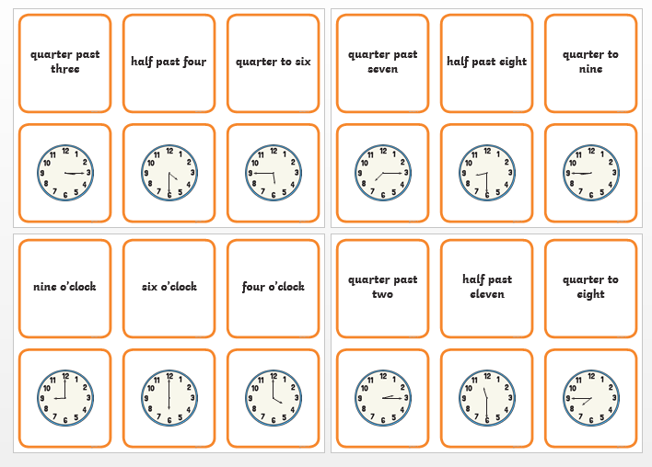

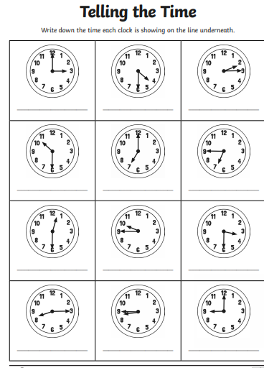
Maths Day 7:

1.

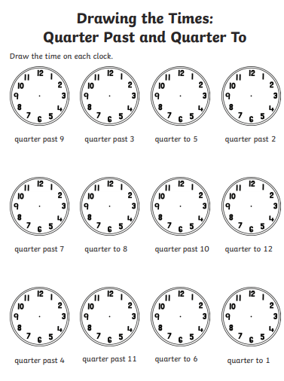
2.

Maths Day 8:
Solve this number sentences. You can use any method you like.

- 24+29=

- 32-11=

- 70-35=

- 13+79=

- 100-44=

- 14+17+20=

- 66-32=

- 20-18=

- 98-39=

- . 32+67

Maths Day 9:

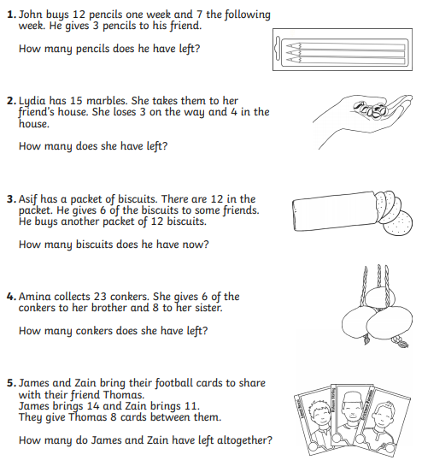

Maths Day 10:



