Maths Day 1:
1.
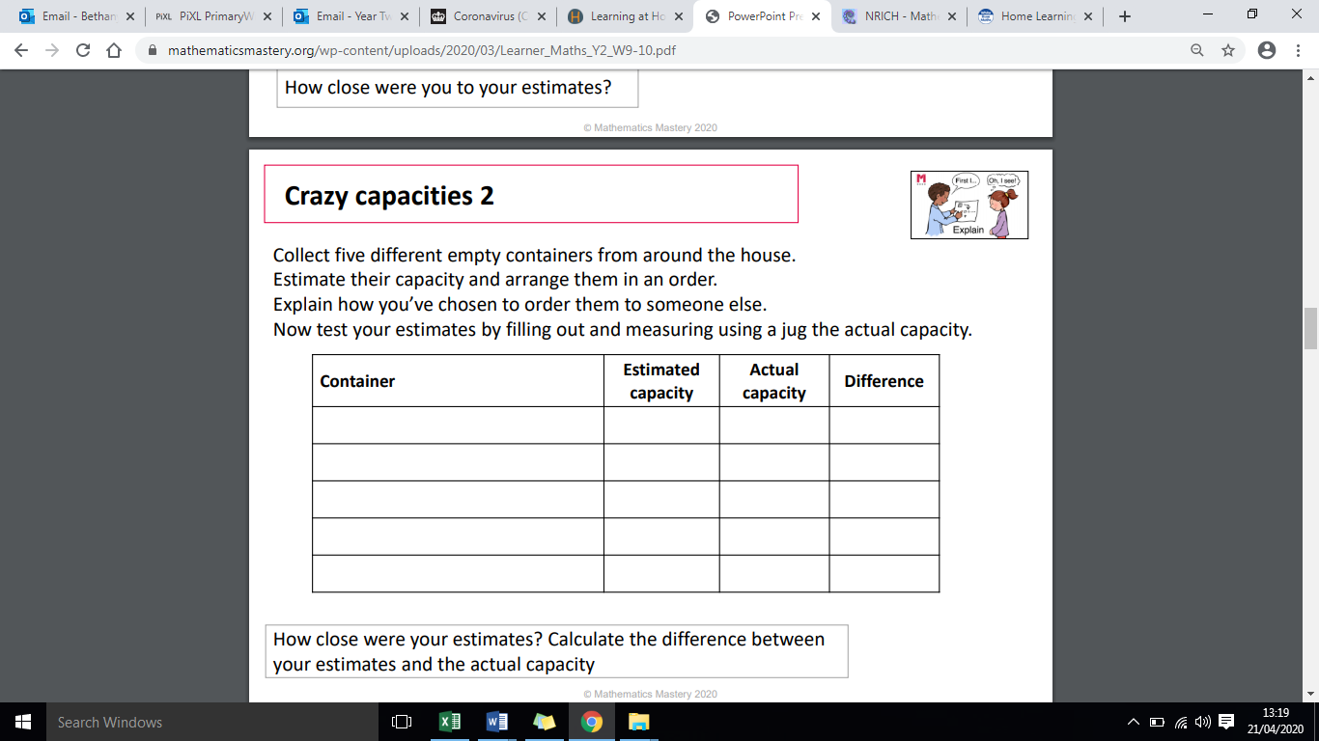

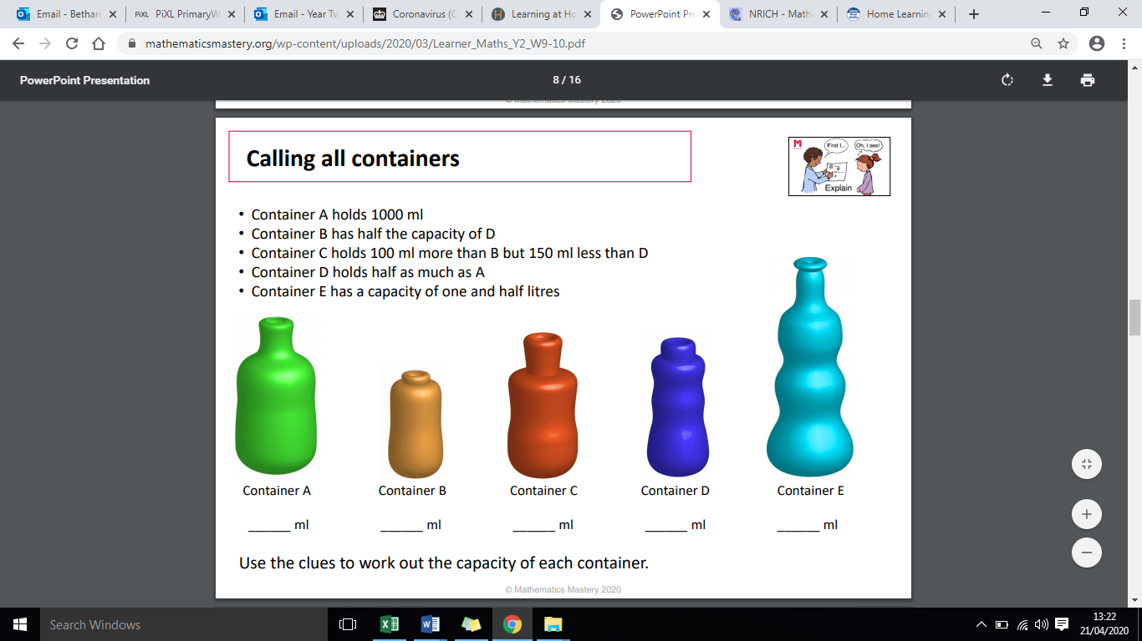
2.
Maths Day 2:
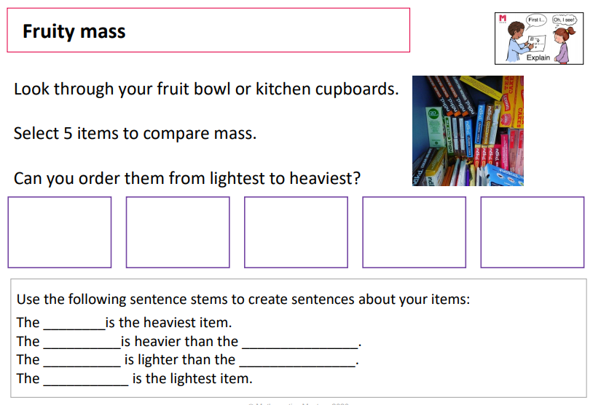
1.
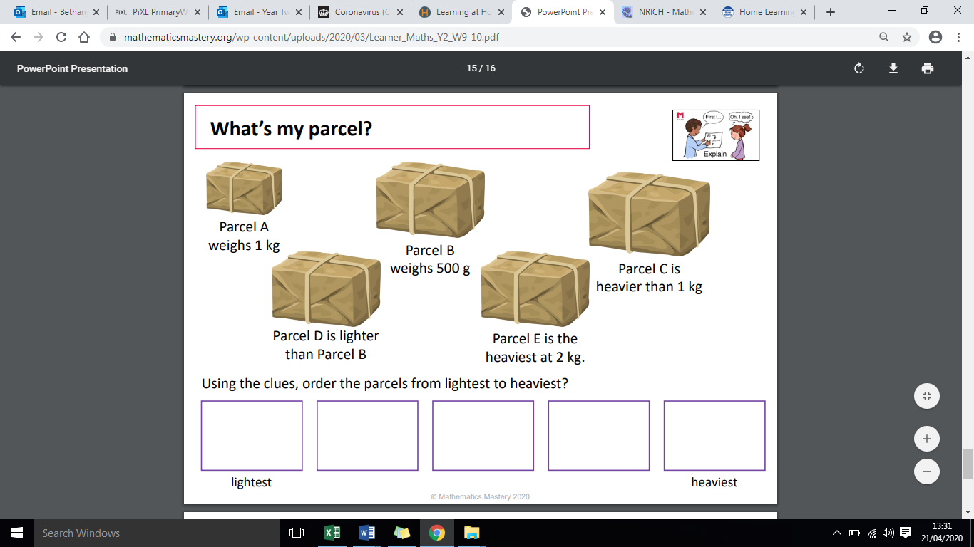
2.

Maths Day 3:
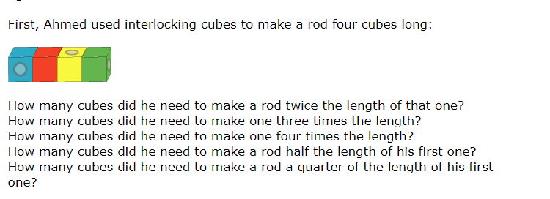
1.

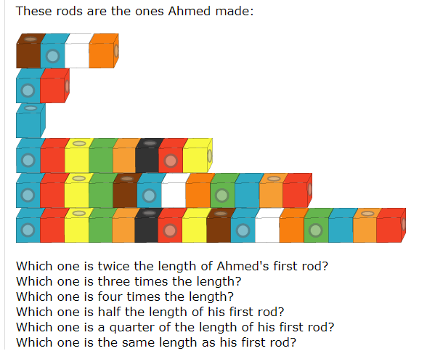
2.
A
B
C
D
E
F

3.
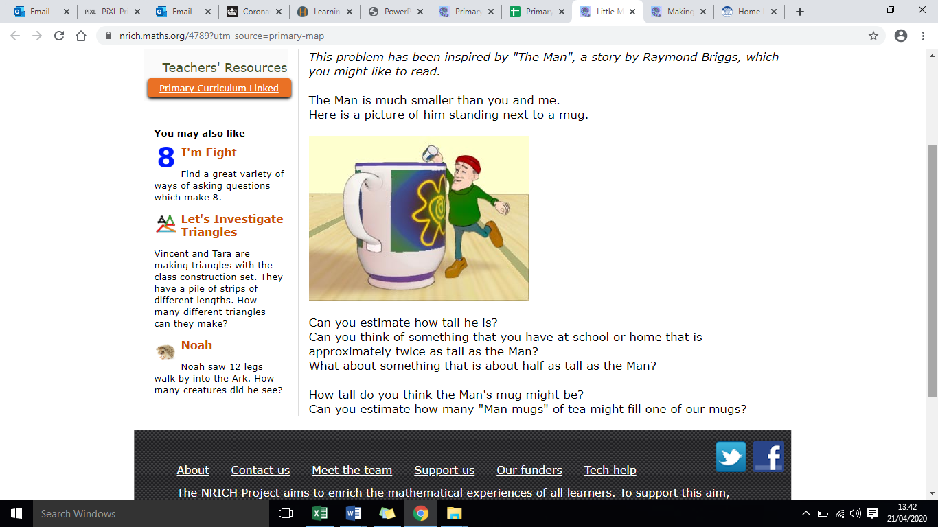

Maths Day 4:
- Ben has five different coins in his pocket. What are the different combinations of coins he could have and how much money does he have in total with each combination? Find as many as you can.
e.g. 1p + 2p + 5p + 10p + 20p = 38p
1p + 2p + 5p + 10p + 50p =68p etc.

Which combination would give you the most about of money?

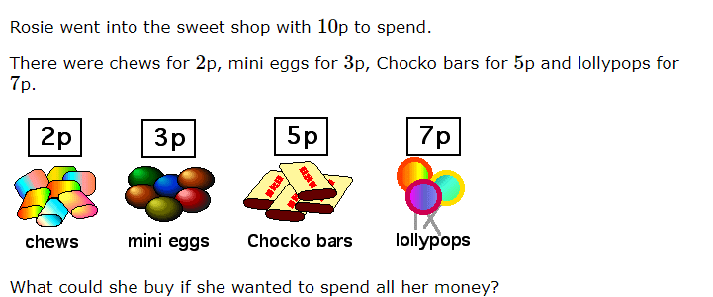
2.

Maths Day 5:
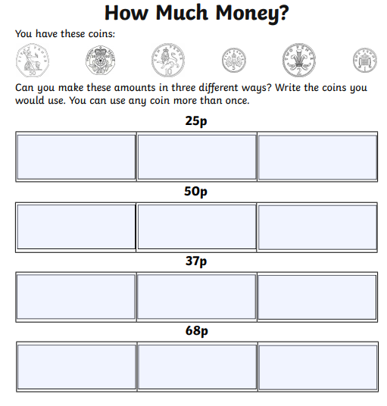
1.

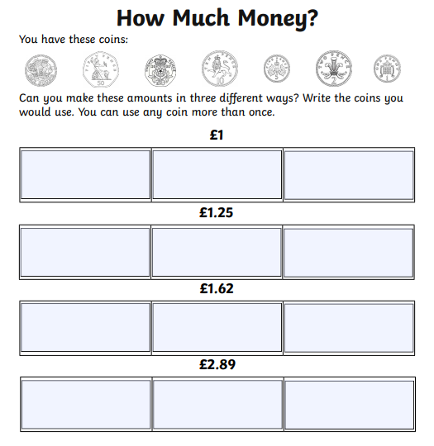

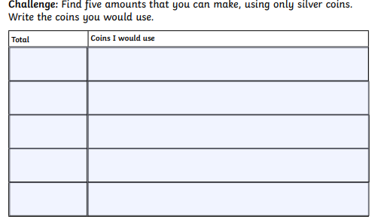
3.

