Tuesday – Day 2 – Topic
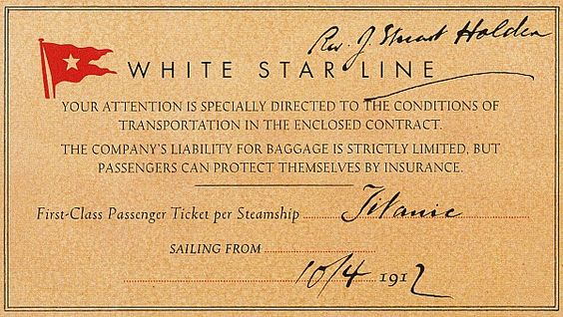
Ticket examples:

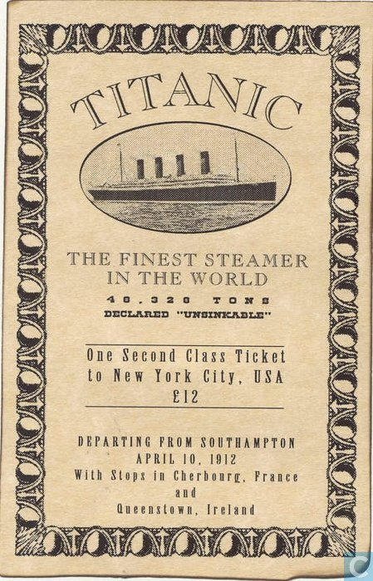

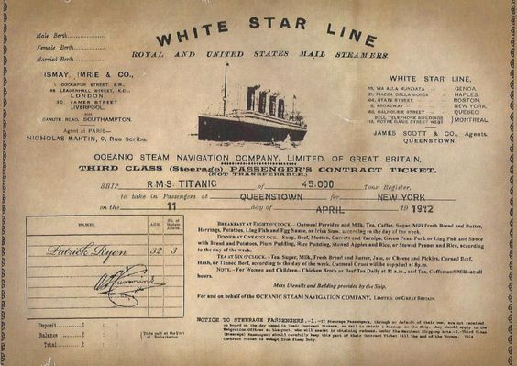

Thursday – Day 4 – English
This is just an example to get you started. Your advert should include further information about what is onboard and should make people want to buy a ticket. The advert should be written in the present tense as you are telling people what the Titanic has on it now and why they should buy a ticket now.
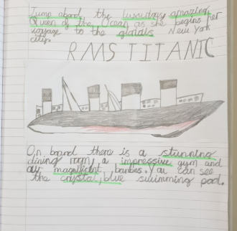

Friday – Day 5 – English
Using different conjunctions.
and but or because that so if

- I went to bed very late ___________________ I am tired today.
- I put an umbrella in my bag ________________it is meant to rain today.
- I enjoy playing hockey ___________________ it’s not my favourite sport.
- We could go to the park ___________________ to the cinema.
- I can have chocolate for dessert _____________I eat my dinner.
- I ran to the park ____________I played on the swings.
- The witch was wearing a cloak _____________was dark and long.

Answers
- so
- because
- but
- or
- if
- and
- that
- Wednesday- Day 8
Story Plan
Onboard there is… (Include adjectives)

What disaster happens?

Where spaceship is leaving from:

Where spaceship is travelling to:

Name of spaceship:

