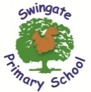
Year 1 Newsletter ~ Term 6 June 2026
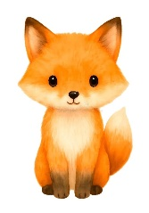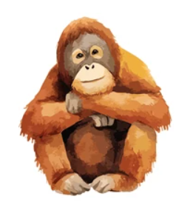
Welcome back, it was lovely to hear everything about the children’s half-terms. We cannot believe it is already term 6, this year has flown by! Even though it is nearly time to say good-bye, we will still be having fun with plenty of learning experiences.
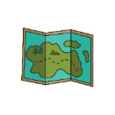
In Geography, we will be looking at the research question ‘Why is Lordswood a great place to live?’ and thinking about human and physical features in our surrounding areas. We will also be learning about our environment and how we can make more sustainable choices. Further into the term we will be looking at addresses and where our school and other locations are on a map.
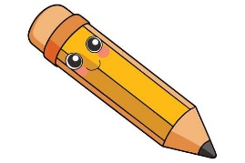
In English we are learning to write in a new style. We are starting the term writing non-fiction fact files. This will encourage children to include titles, sub-headings and facts as well as teaching the children to write in a new format. Additionally, we will be writing a recount of our school trip to Old MacDonald’s Farm. We will then be writing letters to our new teacher which will be handed to them to read. We will be recapping the previous spellings to make sure we know them really well.

In Maths we are finishing looking at finding a quarter of shapes and amounts. We will be continuing to develop and deepen our knowledge of number within 100. We will also be looking at position and direction. We will then use our previous place value skills to identify tens and ones in a number and use this to add and subtract two-digit numbers. We will also be learning about how to tell the time by identifying days of the week, months of the year, and how to tell the time to the hour. Lots of exciting Maths happening!
PE- Please remember that all jewellery has to be removed to do PE; staff are not authorised to remove earrings for children and other jewellery items would not be safe.

Here is a reminder of our PE days for Term 6. Please check in case this day has changed from previous days earlier in the year.
Fox = Wednesday. Lions = Monday. Orangutans = Thursday

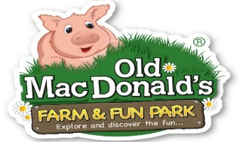
School trip
This term brings us our well anticipated school trip. We have linked our school trip to several science units of learning. We will be going to Old MacDonald’s Farm on the Monday 15th June 2026.
We will be completing activities such as identifying various animals, feeding animals and exploring seeds within the farm maze. Children need to be at school at normal time and will be picked up at normal time.
Children are required to bring their own packed lunch (please email the office to arrange a packed lunch from the kitchen if you require this).
As it is June and may be hot, please can children ensure they have enough water for the day, are already wearing sun cream and bring a hat with them. All of these need to be labelled please!

Reminders:
- Week commencing 9th June, the phonics screening check will take place.
- Old MacDonald’s Farm on Monday 15th June (See above).
- Shuffle up day Thursday 2nd July. Children will meet their new teachers.
- Week commencing 6th July: Healthy living week and sports day (10th July). Children will be wearing PE kits all week.
- Swingate’s Got Talent Wednesday 15th July (Auditions will be beforehand, so if your child would like to audition, they need to make sure they have practised beforehand).
- Last day Friday 17th July- Beach Day! (Information will be sent out separately)

Thank you for your continued support.

The Year 1 Team

