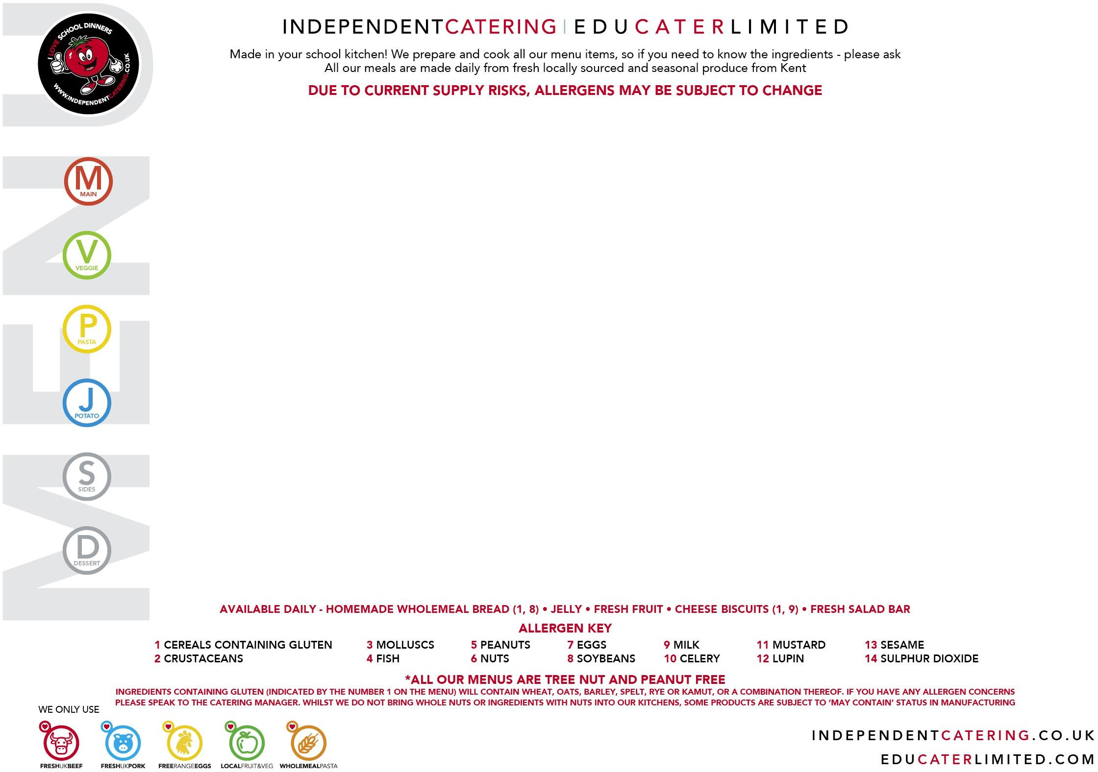
WEEK
1

MONDAY 1 JUNE | TUESDAY 2 JUNE | WEDNESDAY 3 JUNE | THURSDAY 4 JUNE | FRIDAY 5 JUNE
Mac n’ Cheese & Garlic Bread  (1,9,11)  (May Contain 8) | Chicken Meatballs served in a Tomato Sauce  (1)  (May Contain 10) | Roast Turkey  with Stuffing and Gravy  (1) | Beef Chilli & Nachos  (May Contain 1,11) | Breaded Fish  (1, 4)
Chickpea Korma  with Rice and Naan Bread  (1)  (May Contain 11)  VEGAN | Lentil Meatball in a Tomato Sauce  (1,7) | Butternut Squash & Mixed Bean Turnover  (1) VEGAN | Quorn Chilli & Nachos  (8)  (May Contain 1,11)  VEGAN | Courgette & Sweetcorn Fritters  (1)  Try our Ingredient of the month
Fresh Basil Pasta  (1) | 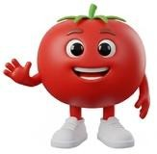 | Mixed Pepper Pasta  (1) |  | Arrabiata Pasta Twirls  (1)
 | Jacket Potato with Topping of the Day |  | Jacket Potato with Topping of the Day
Green Beans  Fresh Salad Bar | Jacket Wedges Sweetcorn  and Salad Bar | Roast Potatoes, Fresh Carrots and Cabbage | Savoury Rice Broccoli & Salad Bar | Chips, Garden Peas and Salad Bar
Oaty Apple & Berry Crumble with Custard  (1, 9)  (May Contain 7, 8) | Fresh Strawberry Jelly | Pineapple Upside Down Sponge  and Custard  (1, 7, 9)  (May Contain 8) | Tutti Frutti Thursday | Cherry Oaty cookie  (1,14)  (May contain 8)

3 CHOICE MENU

WEEK
2

MONDAY 8 JUNE | TUESDAY 9 JUNE | WEDNESDAY 10 JUNE | THURSDAY 11 JUNE | FRIDAY 12 JUNE
Mild Chicken Korma Curry with Rice and Naan Bread (1)  (May Contain 11) | Cheese and Tomato Pizza (1, 8, 9)  (May Contain 7) | Roast Beef with a Yorkshire Pudding and Gravy  (1, 7, 9) | BBQ Chicken Wrap  (1,14) | Fishfingers  (1, 4)
Halloumi, Sweet potato & Pepper Quesadilla  (1,9) | Quorn & Vegetable Noodles  (1, 7, 8) | Roast Vegetable Quiche  (1, 7, 9)  (May Contain 8,10)  Try our Ingredient of the month | Roast Vegetable & Bean Wrap  (1)  (May contain 10)  VEGAN | Falafel Burger in a Bun  (1)  (May contain 13)  VEGAN
Mac n’ Cheese  (1, 9, 11)  (May Contain 8) |  | Tomato and Basil Pasta  (1) |  | Mixed Vegetable Ragu Twirls  (1)
 | Jacket Potato with Topping of the Day |  | Jacket Potato with Topping of the Day
Fresh Broccoli and Salad Bar | Cubed Potatoes, Sweetcorn and Salad Bar | Roast Potatoes, Cabbage and Garden Peas | Broccoli, Herby New Potatoes and Salad Bar | Chips, Peas, Baked Beans and Salad Bar
Iced Carrot Cake  (1, 7, 9)  (May Contain 8) | Shortbread Served with Watermelon  (1, 8)  (May Contain 8) | Chocolate Sponge and Chocolate Sauce  (1, 7, 9)  (May Contain 8) | Tutti Frutti Thursday | Strawberry Cup Cake  (1, 7)  (May Contain 8)

3 CHOICE MENU

WEEK
3

MONDAY 15 JUNE | TUESDAY 16 JUNE | WEDNESDAY 17 JUNE | THURSDAY 18 JUNE | FRIDAY 19 JUNE
Open Beef Burrito  (1,9)  (May Contain 10,11) | Homemade Sausage Roll  (1,14) | Roast Gammon and Pineapple with Gravy |   Italian Meatballs with Spaghetti served with Focaccia  (1, 8)  3 Cheese Risotto  (9)  Pasta Arrabbiata  (1)  Pasta in a Tomato Sauce  Italian Oven Roasted Vegetables  Chocolate Torta Della Nonna  (1, 7, 9)  Chocolate Tart  (May Contain 8) | Breaded Fish  (1, 4)
Mixed Bean Chilli Burrito (May Contain 1,10, 11) VEGAN | Vegetarian Sausage Roll  (1) VEGAN | Cauliflower & Broccoli Cheese Yorkshire pudding  (1,7,9,11)  (May Contain 8) |  | Quorn Dippers  (1,8) VEGAN
Roasted Vegetable Pasta Bows
(1)
Try our Ingredient of the month
Jacket Potato with Topping of the Day |  | Jacket Potato with Topping of the Day |  | Jacket Potato with Topping of the Day
Grated Carrots and Salad Bar | Herby New Potatoes, Baked Beans and Salad Bar | Roast Potatoes, Fresh Carrots and Broccoli |  | Chips, Garden Peas and Salad Bar
Lemon Drizzle cake  (1,7)  (May Contain 8) | Peach Sponge & Custard  (1,7,9)  (May Contain 8) | Homemade Scone Fresh Cream & Strawberries (1,9)  (May Contain 8) |  | Rice Krispie cake  (1,9)

3 CHOICE MENU

WEEK
4

MONDAY 22 JUNE | TUESDAY 23 JUNE | WEDNESDAY 24 JUNE | THURSDAY 25 JUNE | FRIDAY 26 JUNE
Mac n’ Cheese & Garlic Bread  (1,9,11)  (May Contain 8) | Chicken Meatballs served in a Tomato Sauce  (1)  (May Contain 10) | Roast Turkey  with Stuffing and Gravy  (1) | Beef Chilli & Nachos  (May Contain 1,11) | Breaded Fish  (1, 4)
Chickpea Korma  with Rice and Naan Bread  (1)  (May Contain 11)  VEGAN | Lentil Meatball in a Tomato Sauce  (1,7) | Butternut Squash & Mixed Bean Turnover  (1) VEGAN | Quorn Chilli & Nachos  (8)  (May Contain 1,11)  VEGAN | Courgette & Sweetcorn Fritters  (1)  Try our Ingredient of the month
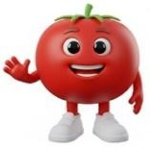 | Vegetable Ragu Twirls  (1) |  | Creamy Tomato Pasta  (1,9)
Jacket Potato with Topping of the Day |  | Jacket Potato with Topping of the Day |  | Jacket Potato with Topping of the Day
Green Beans  Fresh Salad Bar | Jacket Wedges Sweetcorn  and Salad Bar | Roast Potatoes, Fresh Carrots and Cabbage | Savoury Rice Broccoli & Salad Bar | Chips, Garden Peas and Salad Bar
Oaty Apple & Berry Crumble with Custard  (1, 9)  (May Contain 7, 8) | Fresh Strawberry Jelly | Pineapple Upside Down Sponge  and Custard  (1, 7, 9)  (May Contain 8) | Tutti Frutti Thursday | Cherry Oaty cookie  (1,14)  (May contain 8)

3 CHOICE MENU

WEEK
5

MONDAY 29 JUNE | TUESDAY 30 JUNE | WEDNESDAY 1 JULY | THURSDAY 2 JULY | FRIDAY 3 JULY
Mild Chicken Korma Curry with Rice and Naan Bread (1)  (May Contain 11) | Cheese and Tomato Pizza (1, 8, 9)  (May Contain 7) | Roast Beef with a Yorkshire Pudding and Gravy  (1, 7, 9) | BBQ Chicken Wrap  (1,14) | Fishfingers  (1, 4)
Halloumi, Sweet potato & pepper Quesadilla  (1,9) | Quorn & Vegetable Noodles  (1, 7, 8) | Roast Vegetable Quiche  (1, 7, 9)  (May Contain 8,10) | Roast Vegetable & Bean Wrap  (1)  (May contain 10)  VEGAN | Falafel Burger in a Bun  (1)  (May contain 13)  VEGAN
Chunky Tomato Twirls  (1) |  | Tomato and Basil Pasta  (1) |  | Mixed Vegetable Ragu Twirls  (1)
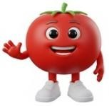 | Jacket Potato with Topping of the Day |  | Jacket Potato with Topping of the Day
Fresh Broccoli and Salad Bar | Cubed Potatoes, Sweetcorn and Salad Bar | Roast Potatoes, Cabbage and Peas | Broccoli, Herby New Potatoes and Salad Bar | Chips, Peas, Baked Beans and Salad Bar
Iced Carrot Cake  (1, 7, 9)  (May Contain 8) | Shortbread served with Watermelon  (8)  (May Contain 8) | Chocolate Sponge and Chocolate Sauce  (1, 7, 9)  (May Contain 8) | Tutti Frutti Thursday  Try our Ingredient of the month | Strawberry Cup Cake  (1, 7)  (May Contain 8)

3 CHOICE MENU

WEEK
6

MONDAY 6 JULY | TUESDAY 7 JULY | WEDNESDAY 8 JULY | THURSDAY 9 JULY | FRIDAY 10 JULY
Open Beef Burrito  (1,9)  (May Contain 10,11) | Homemade Sausage Roll  (1,14) | Roast Gammon and Pineapple with Gravy | Beef Spaghetti Bolognaise and Garlic Bread  (1, 8)  (May Contain 10) | Breaded Fish  (1, 4)
Mixed Bean Chilli Burrito (May Contain 1,10, 11) VEGAN | Vegetarian Sausage Roll  (1) VEGAN | Cauliflower & Broccoli Cheese Yorkshire pudding  (1,7,9,11)  (May Contain 8) | Lentil and Bean Spaghetti Bolognaise and Garlic Bread (1)  (May Contain 8)  VEGAN | Quorn Dippers  (1,8) VEGAN
 | Roasted Courgette Ragu Twirls  (1)  Try our Ingredient of the month |  | Fresh Pesto Pasta  (1)
Jacket Potato with Topping of the Day |  | Jacket Potato with Topping of the Day |  | Jacket Potato with Topping of the Day
Grated Carrots and Salad Bar | Herby New Potatoes, Baked Beans and Salad Bar | Roast Potatoes, Fresh Carrots and Broccoli | Green Beans and Salad Bar | Chips, Garden Peas and Salad Bar
Lemon Drizzle Cake  (1,7)  (May Contain 8) | Peach Sponge & Custard  (1,7,9)  (May Contain 8) | Homemade Scone Fresh Cream & Strawberries (1,9)  (May Contain 8) | Tutti Frutti Thursday  Try our Ingredient of the month | Rice Krispie cake  (1,9)

3 CHOICE MENU

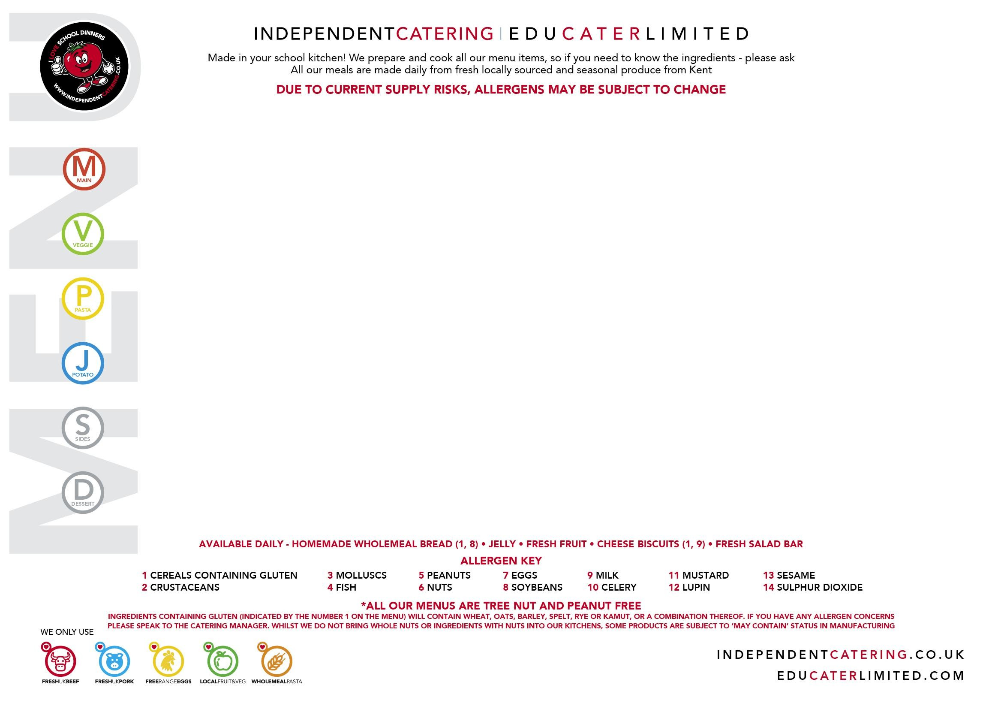
WEEK
7

MONDAY 13 JULY | TUESDAY 14 JULY | WEDNESDAY 15 JULY | THURSDAY 16 JULY | FRIDAY 17 JULY
BBQ Chicken Wrap  (1,14) |   Bacon Mac n’ Cheese  (1, 9, 11)  (May Contain 8)  Roasted Red Peppers, stuffed with Broccoli and Maple  Tabbouleh  (1) VEGAN  Jacket Potato with Choice of Toppings  Peas, Sweetcorn and Salad Bar  Mixed Canadian Salad Canadian Blueberry Muffins (1, 7, 9)  (May Contain 8) | Roast Turkey  with Stuffing and Gravy  (1) | Beef Chilli & Nachos  (May Contain 1,11) | Breaded Fish  (1, 4)
Roast Vegetable & Bean Wrap  (1)  (May contain 10) VEGAN |  | Butternut Squash & Mixed Bean Turnover  (1) VEGAN | Quorn Chilli & Nachos  (8)  (May Contain 1,11)  VEGAN | Courgette & Sweetcorn Fritters  (1)
Fresh Basil Pasta  (1) |  | Mixed Pepper Pasta  (1) |  | Arrabiata Pasta Twirls  (1)
 |  |  | Jacket Potato with Topping of the Day
Broccoli, Herby New Potatoes and Salad Bar |  | Roast Potatoes, Fresh Carrots and Cabbage | Savoury Rice Broccoli & Salad Bar | Chips, Garden Peas and Salad Bar
Oaty Apple & Berry Crumble with Custard  (1, 9)  (May Contain 7, 8) |  | Pineapple Upside Down Sponge  and Custard  (1, 7, 9)  (May Contain 8) | Tutti Frutti Thursday  Try our Ingredient of the month | Cherry Oaty cookie  (1,14)  (May contain 8)

3 CHOICE MENU

WEEK
8

MONDAY 20 JULY | TUESDAY 21 JULY | WEDNESDAY 22 JULY | THURSDAY 23 JULY | FRIDAY 24 JULY
Cheese and Tomato Pizza (1, 8, 9)  (May Contain 7) | Fishfingers  (1, 4)  or Salmon Fishcake  (1, 4) | Summer Holiday | Summer Holiday | Summer Holiday
Quorn & Vegetable Noodles  (1, 7, 8) | Falafel Burger in a Bun  (1)  (May contain 13)  VEGAN | Summer Holiday | Summer Holiday | Summer Holiday
 | Mixed Vegetable Ragu Twirls  (1) | Summer Holiday | Summer Holiday | Summer Holiday
Jacket Potato with Topping of the Day |  | Summer Holiday | Summer Holiday | Summer Holiday
Cubed Potatoes, Baked Bean and Salad Bar | Chips, Garden Peas and Salad Bar | Summer Holiday | Summer Holiday | Summer Holiday
Iced Carrot Cake  (1, 7, 9)  (May Contain 8) | Strawberry Cup Cake  (1, 7)  (May Contain 8) | Summer Holiday | Summer Holiday | Summer Holiday

3 CHOICE MENU

