
Learning Activities
Year 2019-20
Self-Isolation Learning Week 14
13th July
 | Topic- SPORT AND HEALTHY LIVING WEEK | Additional comments
Monday | Reading: I will never eat a Tomato: https://www.youtube.com/watch?v=taDxIIhL3mU  Do you like vegetables? What vegetables do you like? What colour are they? What don’t you like? Why?  Writing: What vegetables can you think of? Write a list of your favourites and also a sentence for one you dislike/not your favourite. i.e.: I do not like Brussel Sprouts because…….  Phonics: https://www.youtube.com/watch?v=YShHtU2jLzM  Join in with the this phonics video all about the initial sounds of fruit and vegetables.  Have a look in the fridge, what fruit or vegetables do you have? Can you practice writing some?  Maths: All the Maths this week will have a physical theme for the whole family to join in. Let us get moving! Musical Numbers: using a suitable space i.e. outside or large space inside place number cards or chalk numbers in a circle. When music plays children move clockwise around the numbers. When the music stops, they stop on the nearest number to them and say the number. Add questions i.e. what is one less, one more, etc.  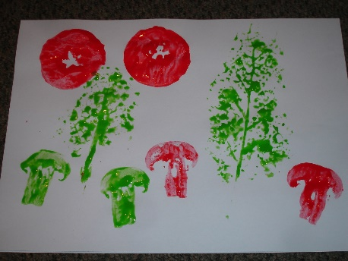  Art/ Construction: Vegetable printing …using some of Mums old vegetables can you print with paint or make a rubbing with pencils/crayons  Imaginative play: Free choice  Handwriting: Follow this link to practice the ‘tunnel cursive letters: n, m, h, p, b, u: Focus on the height of h and b, as well as the length of the tail on the letter p. https://www.teachhandwriting.co.uk/cursive-letters-beginners-choice-3.html | Join the daily Joe Wicks PE challenge on his YouTube challenge to burn some excess energy.  Or any of the Cosmic Kids Yoga Disco videos (these can be found on YouTube)  Daily reading – choose a story to read together as a family. Ask your child to find specific words (maybe words from their most recent word list) or read a page each. Talk about the pictures. Ask the children what they think will happen at the end before you reach the final pages.  Or you can use the Oxford Reading Tree website which has lots of free E-Books for you to share:  https://home.oxfordowl.co.uk/books/free-ebooks/  Handwriting practice:  https://www.teachhandwriting.co.uk/route-c-letter-choice-3-fs.html  So far in Reception we have practised all of the letter shapes. However, we have found the following letters have proved to be the trickiest:  g, y, j – because the tails loop over and go underneath the line  p, q, - because they need to go underneath the line.  h,b,d,k – because they are taller than the rest of the other letters  f – has proved to be the most difficult! Because it loops but is also tall AND long.  Dough disco: Early Years Emily on Youtube or Shontelle Bason do great videos.
Tuesday | Reading: Oliver’s Vegetables: https://www.youtube.com/watch?v=2yvllKqyVUc  Have you tried the same vegetables that Oliver has tried in the story?  Writing. Draw a picture and write a sentence about your favourite dinner. Does it include any vegetables? Use the sentence structure: I like …. because  Your adult can help with you the words ‘like’ and ‘because’ but remember to try sounding out the names of the food you like yourself.  Maths: Again, in a suitable space decide on a physical action you may want to do i.e. star jumps, hops, etc. The number card that is held up will be how many of those actions you do. Swap over and suggest an action for your family to do.  Phonics: Practice reading and writing the phase 2 and 3 HFW:  the, to, no, go, I, into  she, he, we, be, me, they, all, are, her, you  Art/ Construction: Create your favourite dinner using any construction you have at home.  Imaginative play: If you have any playdough at home you could pretend to open a restaurant and invite Mummy or Daddy to eat some of your yummy food you have made!  Handwriting: Follow this link to practice the ‘hooks, loops and lines’ cursive letters: j, y, f, k https://www.teachhandwriting.co.uk/cursive-letters-beginners-choice-3.html
Wednesday | Reading- Oliver’s Fruit Salad: https://www.youtube.com/watch?v=jcTprkImlmI  Do you like any of the fruit that Oliver eats in the story?  Writing/Imaginative play: Pretend you have a Fruit Shop. What would you call it? Can you write a list of fruits that you sell? What would be your favourite?  Maths: Using a timer on a phone or watch, count how many jumps, hops, etc can you do in 1 minute? Did your family member do more or less? Who did more?  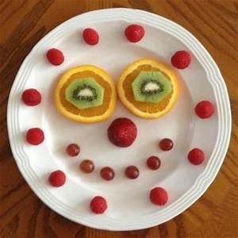  Phonics: Can you find the digraphs in the following words? Maybe your adult could write them out for you and you can draw a line underneath (like when we add sound buttons at school): shin, chip, long, feet, rain, book, card, port.  Art/ Construction: Make a fruit salad face on a plate. It could be real one or a collage of pictures. If you make a real one you can eat it after!  Handwriting: Follow this link to practice the ‘straight line’ cursive letters: i, l, t, x, z. Focus on how tall l and t should be in comparison to the other letters: https://www.teachhandwriting.co.uk/cursive-letters-beginners-choice-3.html  Fine motor/Jigsaw: Can you create a healthy lunchbox? Remember it is important to have a balanced diet!
Thursday | Reading: Read the story Life with the Large Family –Sports day: https://www.youtube.com/watch?v=DS1c4jQT9nY We would have had a sports day at school this week. Have you tried any of these activities or races before?  Writing: How many sports can you think of? Write a list using your sounds. Do not forget to use your sound mat!  Maths: Can you remember how to play What is the time Mr Wolf? Teach your family. Make sure you count your steps carefully as you walk. Remember the clock will only go up to the number 12!  Phonics: Revisit the Phase 3 phonics video: https://www.youtube.com/watch?v=aNcBWSBxSp0 Watch this and then practice writing down some of the digraphs/trigraphs. Maybe your adult can check them for you. Any you get stuck on you can continue to practice.  Art/ Construction: Today you are going to design a sports outfit. What sport would you do? What would be your favourite colour? Would you have a pattern on your kit?  Imaginative play: Create a tea part for some of your toys – what heathy dinner are you going to make for them?  Handwriting: Follow this link to practice the ‘curves to start cursive letters: c,a,d,g Focus on how tall d should be and long the tail is on the letter g: https://www.teachhandwriting.co.uk/cursive-letters-beginners-choice-3.html
Friday | Reading: Read the story: Supertato – Run Veggies Run  What races do they vegetables do? Who wins the races?  https://www.youtube.com/watch?v=BIeAHK-5m6E  Writing: What is your favourite sport? Draw a picture and write some sentences i.e. ‘I like football and I need football boots.’  Maths: Can you make a hopscotch? What numbers will you need? Can you make your hopscotch bigger? How? Ask your family if they remember playing it. Maybe they have a different way.  Phonics: Practice reading the Phase 3 sentences. If they are a little tricky get your adult to help you with the words with digraphs in, you can segment and blend the CVC words (3 letter words).  Art/ Construction: Design a pair of trainers that you might like to wear when we next do sports day at school. What pattern would they have? Maybe you might have rainbow laces?  Imaginative play: Use any old or left-over vegetables to make your own vegetable sports day like in the story! Maybe you can add googly eyes and give Supertato a cape?  Handwriting: Follow this link to practice the ‘curves to start cursive letters: q,o,e,s Focus on the leaving lines of the letters o and s, and the length of the tail on the letter q: https://www.teachhandwriting.co.uk/cursive-letters-beginners-choice-3.html

Learning Activities
Year 2019-20

self-isolation learning Week 14
20th July

