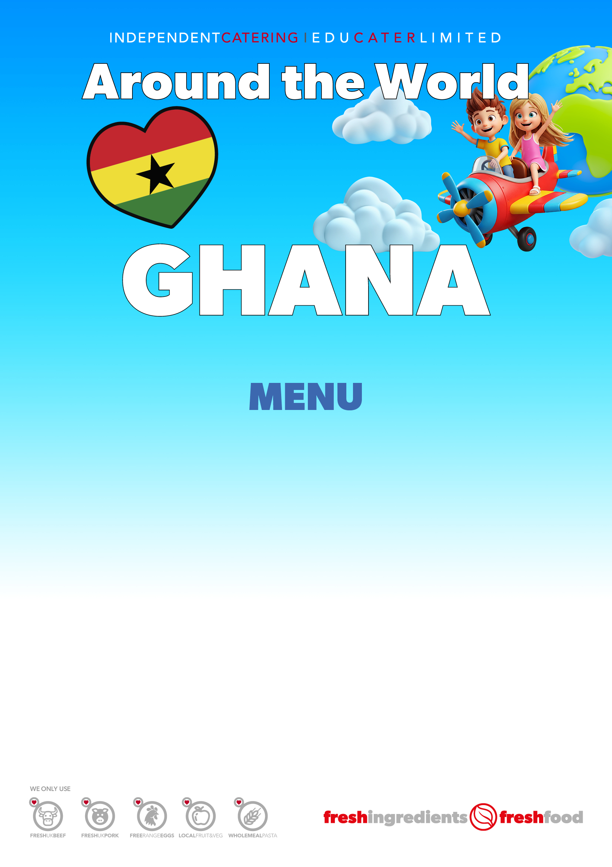
Chicken Jollof Rice (1,10)

Black Eyed Bean Curry with Rice (1) VEGAN

Ghanaian Pasta (1)
(Pasta in a Rich Tomato Sauce and Peas)

Strawberry Fool (9)

TUESDAY 19 MAY

