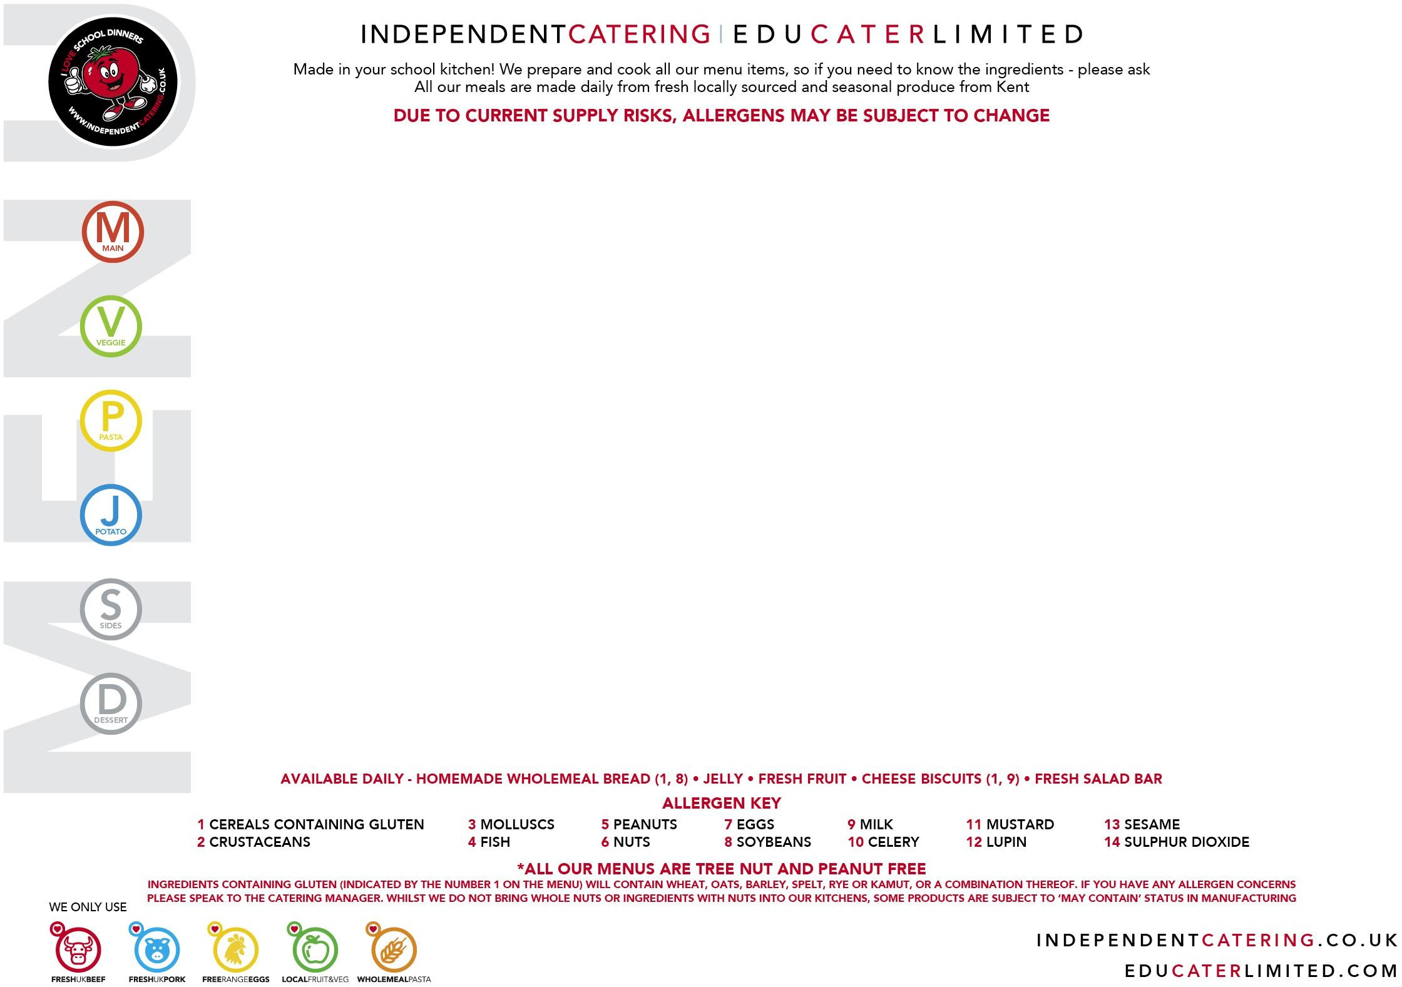
WEEK

1

MONDAY 20 APRIL | TUESDAY 21 APRIL | WEDNESDAY 22 APRIL | THURSDAY 23 APRIL | FRIDAY 24 APRIL
Sausages with Gravy  (1,14) | Beef Lasagne with Garlic Bread  (1, 7, 8, 9, 11) | Roast Turkey  with Stuffing and Gravy  (1) | St Georges Day  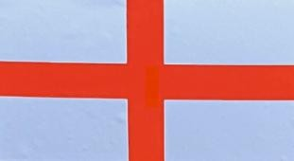  Beef & Onion Pie with Creamed Potatoes  (1,9) | Burger in a Bun  (with Ketchup & Cheese on the Side)  (1, 9, 14)  (May Contain 13)
Vegetable Sausage  (1) VEGAN | Vegetable Lasagne with Garlic Bread  (1, 7, 8, 9, 11)  (May Contain 10) | Vegetable & Lenti Cottage pie with Sweet Potato Topping (May Contain 10)  VEGAN |  | Homemade Chickpea Burger in a Bun  (1)  (May Contain 13)  VEGAN
Chunky Tomato Pasta  (1) | 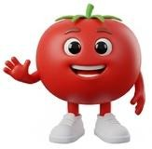 | Tomato and Basil Pasta  (1) |  | Mixed Vegetable Ragu Twirls  (1)
Cheese & Onion Pasty
(1,9)
(May Contain 8)
VEGAN
 | Jacket Potato with Topping of the Day |  | Cheese & Onion Pasty  (1,9)  (May Contain 8)  VEGAN
Jacket Potato with Choice of Toppings

Braised Green Cabbage
Diced Potatoes with Garden Peas and Salad Bar | Garden Peas and Salad Bar  Try our Ingredient of the month | Roast Potatoes, Fresh Carrots and Cabbage | Jacket Potato with Choice of Toppings  Braised Green Cabbage | Chips, Garden Peas and Salad Bar
Oaty Apple Crumble with Custard  (1, 9)  (May Contain 7, 8) | Tutti Frutti Tuesday | Toffee Sponge and Custard (1, 7, 9, 14)  (May Contain 8) | Iced Vanilla Cupcake  (1, 7, 9)  (May Contain 8) | Marble Shortbread  (1)  (May Contain 8)

3 CHOICE MENU

WEEK

2

MONDAY 27 APRIL | TUESDAY 28 APRIL | WEDNESDAY 29 APRIL | THURSDAY 30 APRIL | FRIDAY 1 MAY
Beef Pasta Bolognaise and Garlic Bread  (1, 8) | Fajita Chicken Wrap  (1, 11) | Roast Beef with a Yorkshire Pudding and Gravy  (1, 7, 9) | Homemade Sausage Roll  (1, 8, 9,14) | Fishfingers  (1, 4)  or Salmon Fishcake  (1, 4)
Lentil and Bean Spaghetti Bolognaise and Garlic Bread (1, 8)  VEGAN | Roast Vegetable & Bean Wrap  (1, 11) VEGAN | Pea, Sweet Potato, and roast Cherry Tomato Risotto  (9) | Cheese, Potato and Leek Turnover (1, 9) | Pesto Halloumi and Roasted Vegetables with Pitta Bread (1, 9)
 | Mac n’ Cheese  (1, 9, 11)  (May Contain 8) |  | Fresh Pesto Pasta  (1)
Jacket Potato with Topping of the Day |  | Jacket Potato with Topping of the Day |  | Jacket Potato with Topping of the Day
Fresh Broccoli and Salad Bar | Savoury Rice, Fresh Carrots and Salad Bar | Roast Potatoes, Spring Cabbage and Peas | Broccoli, Herby New Potatoes and Salad Bar  Try our Ingredient of the month | Chips, Peas, Baked Beans and Salad Bar
Banana Cake with Custard  (1, 7, 9)  (May Contain 8) | Iced Carrot Cake  (1, 7, 9)  (May Contain 8) | Chocolate Sponge and Chocolate Sauce  (1, 7, 9)  (May Contain 8) | Tutti Frutti Thursday | Oaty Cherry Cookie  (1, 14)  (May Contain 8)

3 CHOICE MENU

WEEK

3

MONDAY 4 MAY | TUESDAY 5 MAY | WEDNESDAY 6 MAY | THURSDAY 7 MAY | FRIDAY 8 MAY
Bank Holiday | Open Beef Burrito  (1,9)  (May Contain 11) | Roast Gammon and Pineapple with Gravy | Meat Feast Pizza  (1, 8, 9)  (May Contain 7) | Breaded Fish  (1, 4)
Bank Holiday | Mixed Bean Chilli in a Taco  (May Contain 1, 11)  VEGAN | Cheese and Roast Vegetable Quiche  (1, 7, 9)  (May Contain 10) | Cheese and Tomato Pizza (1, 8, 9)  (May Contain 7) | Courgette & Sweetcorn Fritters, with a poached Egg (1, 7)
Bank Holiday |  | Mixed Pepper Pasta  (1) |  | Arrabiata Pasta Twirls  (1)
Bank Holiday | Jacket Potato with Topping of the Day |  | Jacket Potato with Topping of the Day
Bank Holiday | Tomato Rice with Green Beans and Salad Bar | Roast Potatoes, Carrots and Cabbage | New Potatoes, Sweetcorn | Chips, Peas & Baked Beans and Salad Bar
Bank Holiday | Mixed Berry Cheesecake  (1, 9)  (May Contain 8)  Try our Ingredient of the month | Strawberry Cupcake  (1, 7)  (May Contain 8)  Try our Ingredient of the month | Tutti Frutti Thursday | Chocolate Krispie  (1, 9)

3 CHOICE MENU

WEEK

4

MONDAY 11 MAY | TUESDAY 12 MAY | WEDNESDAY 13 MAY | THURSDAY 14 MAY | FRIDAY 15 MAY
Mild Chicken Rogan Josh Curry  with Rice and Naan Bread  (1)  (May Contain 11) | Beef Lasagne with Garlic Bread  (1, 7, 8, 9, 11) | Roast Turkey  with Stuffing and Gravy  (1) | BBQ Chicken with Rice | Burger in a Bun  (with Ketchup & Cheese on the Side)  (1, 9, 14)  (May Contain 13)
Chickpea Korma  with Rice and Naan Bread  (1)  (May Contain11)  VEGAN | Vegetable Lasagne with Garlic Bread  (1, 7, 8, 9, 11)  (May Contain 10) | Vegetable & Lenti Cottage pie with Sweet Potato Topping (May Contain 10)  VEGAN | Spring Vegetable & Bean Stew with Rice | Homemade Chickpea Burger in a Bun  (1)  (May Contain 13)  VEGAN
Chunky Tomato Twirls  (1) |  | Tomato and Basil Pasta  (1) |  | Mixed Vegetable Ragu Twirls  (1)
 | Jacket Potato with Topping of the Day |  | Jacket Potato with Topping of the Day
Sweetcorn and Salad Bar | Garden Peas and Salad Bar | Roast Potatoes, Fresh Carrots and Cabbage | Sweetcorn and Broccoli and Salad Bar | Chips, Garden Peas and Salad Bar
Apple Sponge with Custard  (1, 7, 9)  (May Contain 8) | Tutti Frutti Tuesday  Try our Ingredient of the month | Toffee Sponge and Custard (1, 7, 9, 14)  (May Contain 8) | Chocolate and Orange Brownie (1, 7)  (May Contain 8) | Marble Shortbread  (1)  (May Contain 8)

3 CHOICE MENU

WEEK

5

MONDAY 18 MAY | TUESDAY 19 MAY | WEDNESDAY 20 MAY | THURSDAY 21 MAY | FRIDAY 22 MAY
Beef Pasta Bolognaise and Garlic Bread  (1, 8) |   Chicken Jollof Rice  (10)  Black Eyed Bean Curry with Rice VEGAN  Pasta in a Rich Tomato Sauce and Peas  (Ghanaian Pasta)  (1)  Strawberry Fool (9)  Try our Ingredient of the month | Roast Beef with a Yorkshire Pudding and Gravy  (1, 7, 9) | Homemade Sausage Roll  (1, 8, 9,14) | Fishfingers  (1, 4)  or Salmon Fishcake  (1, 4)
Lentil and Bean Spaghetti Bolognaise and Garlic Bread (1, 8)  VEGAN |  | Pea, Sweet Potato, and roast Cherry Tomato Risotto  (9) | Cheese, Potato and Leek Turnover (1, 9) | Pesto Halloumi and Roasted Vegetables with Pitta Bread (1, 9)
Fresh Pesto Pasta
(1)
Jacket Potato with Topping of the Day |  | Jacket Potato with Topping of the Day |  | Jacket Potato with Topping of the Day
Fresh Broccoli and Salad Bar |  | Roast Potatoes, Spring Cabbage and Peas | Broccoli, Herby New Potatoes and Salad Bar | Chips, Baked Beans and Salad Bar
Banana Cake with Custard  (1, 7, 9)  (May Contain 8) |  | Chocolate Sponge and Chocolate Sauce  (1, 7, 9)  (May Contain 8) | Tutti Frutti Thursday  Try our Ingredient of the month | Oaty Cherry Cookie  (1, 14)  (May Contain 8)

3 CHOICE MENU

