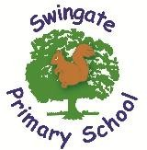


Year 5 Newsletter Term 5 - April 2026

Welcome back! We hope you had a wonderful Easter break and are ready for the term ahead.
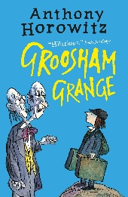
English - English learning will focus on a variety of genres, including character descriptions, folktales
and poetry. Please help your child by reading with them on a regular basis. This is SO important as it
not only gives you quality time together, it gives your child the chance to practise a key life skill. Please
make a note in your child’s home reading contact book as this is recorded. Our class book this term is
‘Groosham Grange’ by Anthony Horowitz. Please continue to support your children at home in using
Spelling Shed, we will continue our weekly testing after the half term break. Their first test will be at
the end of week 2.


This term in History, we will be learning about the Maya civilisation. Children will be able
to place the Maya within a historical timeline and understand that their society had a
clear hierarchy of power. They will explore why religion was important to the Maya.



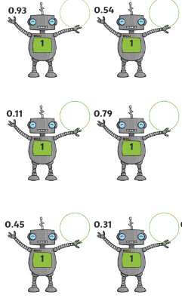

Maths - Maths this term will involve shape, position and direction and decimals. This term’s Rocking Recall will focus on decimal number bonds. A decimal number bond to 1 could be 0.9 + 0.1 or 0.7 + 0.3 and to 10 could be 9.9 + 0.1 or 4.5 + 5.5. Children will apply their number bonds to 10 to support with this. Children should also be practising their times tables on TT Rockstars at home and should be completing at least 10 sessions every week. Please see the QR codes for useful links to support alongside TTRS.

Times tables.co.uk Top Marks.co.uk



Science - This term we will be using our investigative skills to look into forces. We will research gravity, air resistance, friction and water resistance and complete investigations into some of these. Children will improve their skills in completing their own investigation ensuring it is a fair test

P.E. – will be athletics this term.
Panther class: Thursday
Otter class: Thursday
Turtle class: Tuesday
Wombat class: Thursday

Uniform: Children need to have the correct school uniform and black shoes. Please ensure that your child’s uniform is clearly labelled, particularly fleeces and jumpers as these are very easily mislaid when your child removes them during the day. Water bottles – all children should have these and are allowed to replenish these during the day. Please make sure that they are labelled and have a non-spill top. Hats and sun cream may also be needed as the weather improves.

Other important term dates:
Start of Term 5 – Monday 20th April
Bank Holiday – Monday 4th May (School closed)
SCC School Disco- Thursday 21st May (Year 4-6 KS2 hall start at 3pm all children to be dismissed from classes at 4:15)
Final Bude Meeting for Parents and Staff – Wednesday 6th May
End of Term – Friday 22nd May

Thank you for your continued support.
Year 5 team – Mrs O’Connor, Miss Dabb, Mrs Nash and Miss Dent

