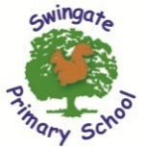
Swingate Primary School

FS2 Newsletter Term 5
April 2026


We hope you had a lovely Easter break and didn’t eat too much chocolate. Term 5 is here and with it will hopefully bring warmer weather. Over the coming weeks could we ask that children begin to bring in named sunhats. On particularly sunny days, those children without a sunhat will not be allowed on the playground during play and lunchtimes. Could we also ask that sun cream be applied before school. Most sun creams are now 24 hours but if you wish sun cream to be reapplied to your child, they can bring in their own named sun cream. This will need to be labelled and your child will need to apply it themselves. We will be spending plenty of time learning outside investigating, exploring, creating and playing!

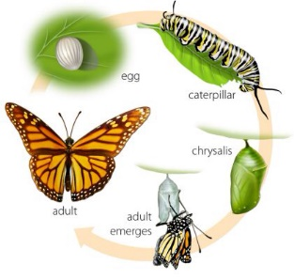
Our topic this term is ‘Let’s Grow’. We have already begun to investigate life cycles and what that means. To start our term we have shared the familiar story of ‘The Very Hungry Caterpillar’ and created the life cycle of a butterfly. We will explore the life of a bean and hopefully growing our own. I wonder who can grow the tallest beanstalk?
For the final weeks of term we will be looking at “How we have changed?”. We will be looking at the book ‘When I was little’ and discussing what we couldn’t do as a baby and what we can do now. We will also be looking at similiarities and differences between familiar things in the past and now. This will also link with our Jigsaw and History learning. In Math’s we are looking at numbers to 20 and beyond as well as rotating shapes and repeating patterns.
Important Dates
4th May – Bank Holiday
Last day of term Friday 22/05/2026
1st June – Staff Inset Day (Children not in school)
Children back in school Tuesday 2nd June

