
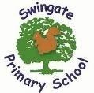


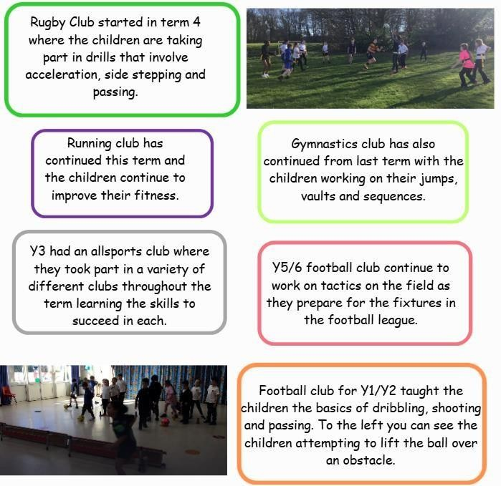

Club

News

In term three there were a total of 17 extra
-
curricular
clubs

available

to

the

children

with

8

of

them

being

sports
clubs. New clubs this term included Y1/2 football club,
basketball club and rugby club.

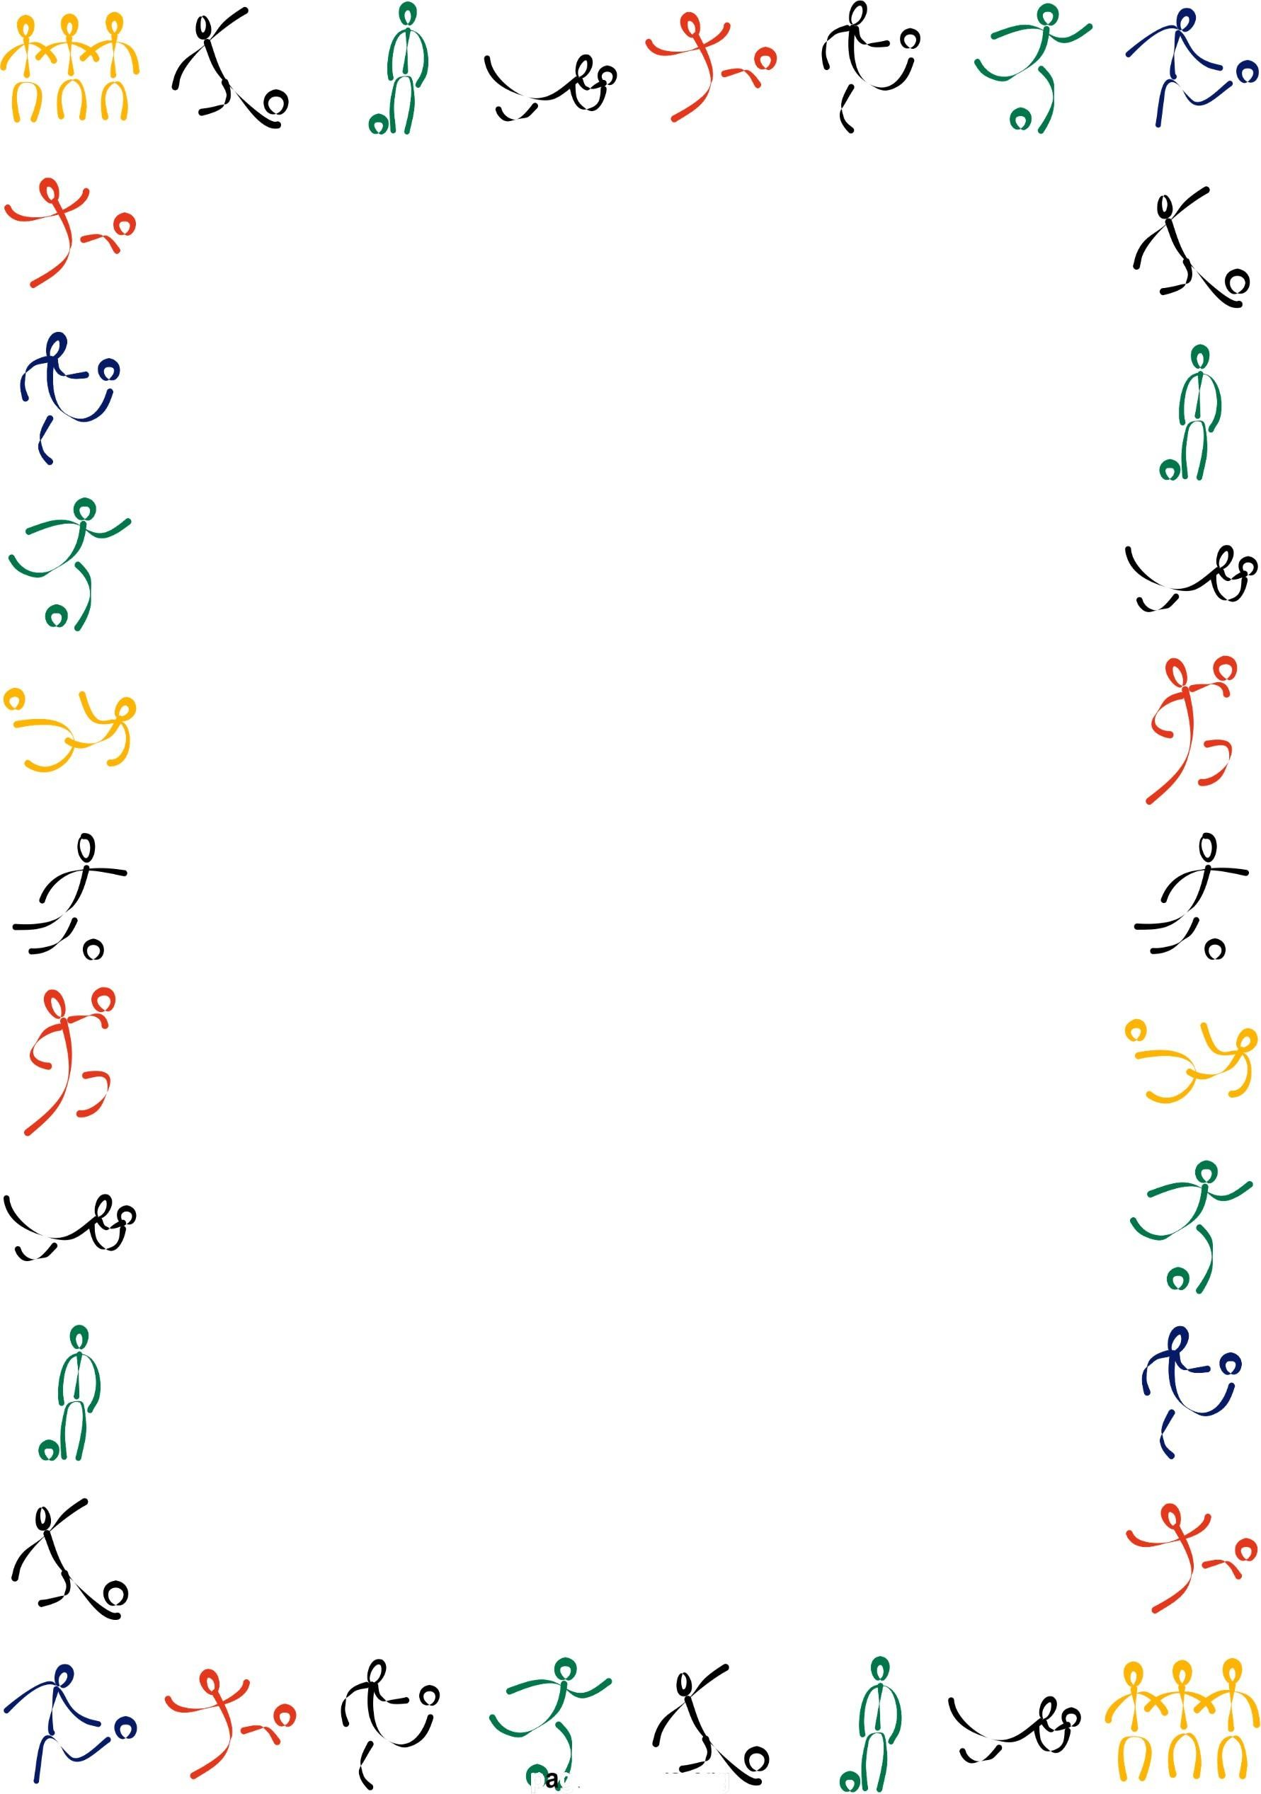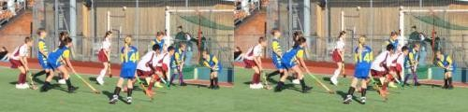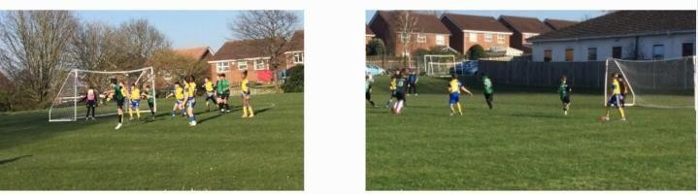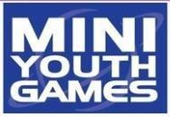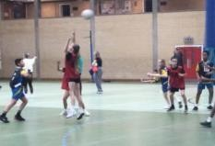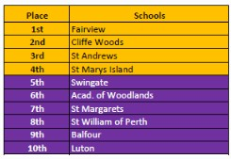

On
Thursday 12th March our netball team took part in the MYG at
Medway Park. The first game was a close 3
-

2
loss to Cliffe Woods
followed

by

a

big

8

-

0

win

against

St

William

of

Perth.

Another

close

1

-

0
loss to Fairview followed and then we got a huge 8
-

0
victory
against

St

Margarets.

Our

next

opponents

were

Balfour

who

we

beat

9

-

0
,

then

we

beat

St

Margarets

6

-

3

and

finished

with

a

6

-

1

victory
against Woodlands. This mixture of results meant we finished in 5th
position overall.

In our match against

Warren Wood, we dominated the first half with
lots of shots at their goal. Finally making the breakthrough from an
audacious

free

kick

just

beyond

the

half

way

line

from

Hudson.

Moving
into the second half we started taking advantage of our dominance in
t
he form of further goals from Darcie, Harvey and a brace from
Tucker. Late in the game Warren Wood played well and brought back
two goals of their own to make for an enticing finish. The match
finished 5
-
2
with a strong showing from both teams.


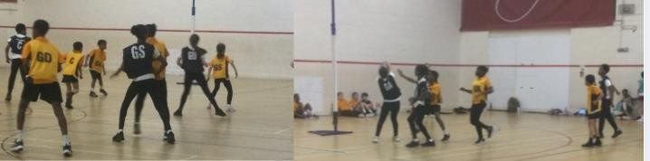



Well done to the netball squad who took part in a friendly at Kings
Rochester Sports Centre with St Andrews, Gadds Hill and St Mary’s
Island.

It

was

valuable

practise

to

help them

get

ready

for the netball
MYG. Mrs

Smith was in her element umpiring the matches.

On

Wednesday

25
th

March,

our Y4/Y5/Y6

team

took

part

in

the

final
cross
-
country event held at Medway Park. Elliott was out highest
places year 4 child finishing in 6th position only 10.5 seconds beh
ind
the winner. Connor was the highest placed Y5 child finishing in 8th
position finishing 26.6 seconds behind the winner. Ronnie was our
highest placed Y6 child finishing in 10th position 44.4 seconds behind
the winner.

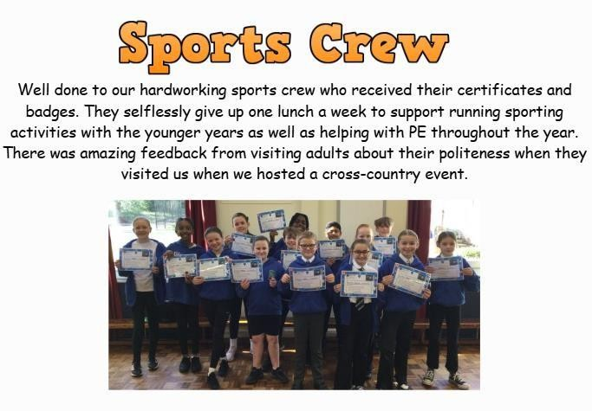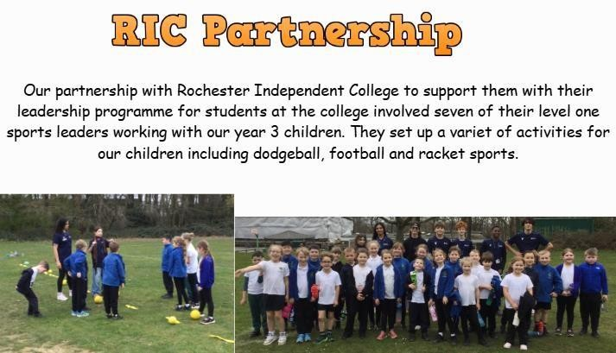

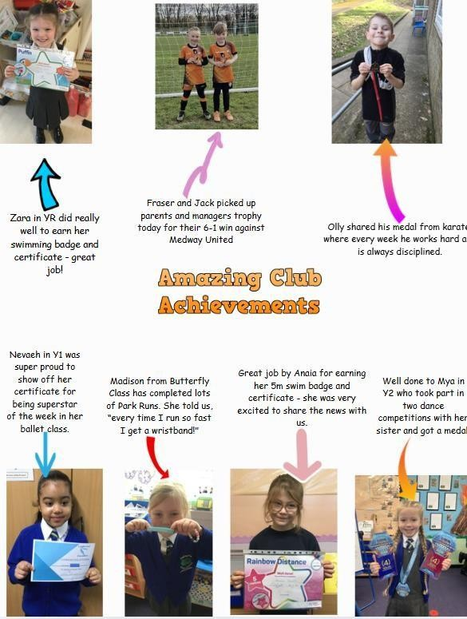

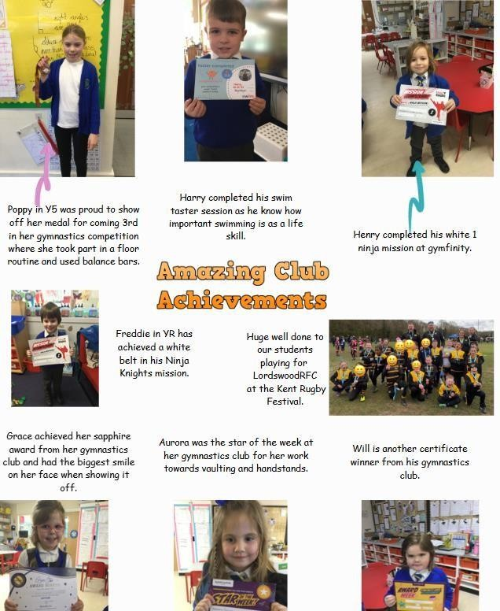

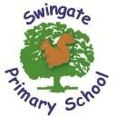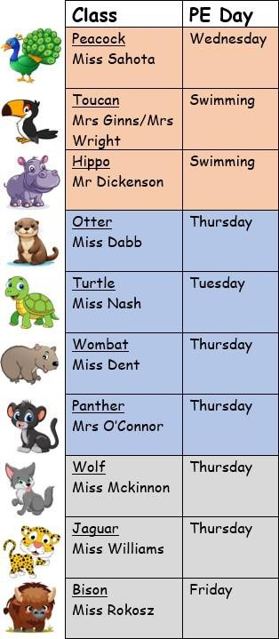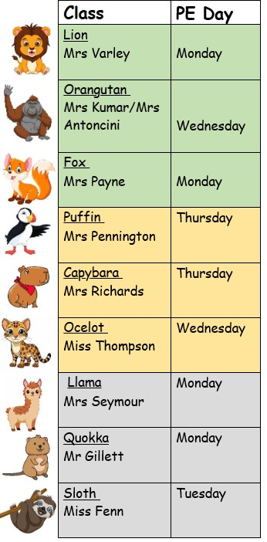
PE

Kit

Days

Please

can

you

ensure your

child

wears

their

PE kit

to

school
on the correct day in term 5. During the term children will
be taking part in striking sports which includes cricket,
rounders and football rounders.

