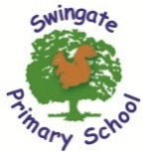

Swingate Primary School
Year 5 Newsletter Term 4
February 2026

We welcome you all back to school and hope you had an excellent half term! We are looking forward to all the learning we have lined up for Term 4.
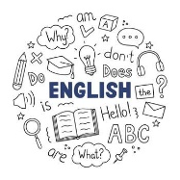
English:
English learning will cover objectives from the curriculum and will be based on a variety of genres, including newspaper report, speaking and listening and balanced argument. Please continue to support your children at home in using Spelling Shed, we will continue our weekly testing after the half term break. Their first test will be at the end of week 2.

Reading:
In year 5, we expect the children to read at least 4 times per week and record this in their reading record. Their reading book and reading contact book need to be brought in daily. Daily reading has a huge impact on reading skills and we strongly urge you to support your child with this aspect of their learning. Reading at home does not have to be reading the school reading book, you can share newspapers, magazines etc. This term we are reading ‘Clockwork’ by Philip Pullman.

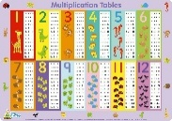
Maths:
Maths this term will be applying and extending children’s knowledge of place value and use of fractions, decimals and percentages; area and perimeter and statistics. This term’s Rocking Recall will focus on factor pairs of a given number, for example the factor pairs of 8 would be 1 x 8 and 2 x 4. Multiplication facts and number bonds play such a big part to the whole of the maths curriculum, so all children will be expected to play at least 10 sessions on TT Rockstars every week. Please see the QR codes for useful links to support alongside TTRS.

 Times tables.co.uk 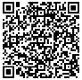 Top Marks.co.uk


Science - This term we will be learning about life cycles and reproduction of plants and animals. The children will be learning about animal and plants, mammals, birds, amphibians and insect life cycles. We will also look at the different parts of plants and how they reproduce.

P.E. days: Swimming Days:
Panther class: Thursday
Otter class: Thursday
Turtle class: Tuesday Wednesday (25.02.26 last session)
Wombat class: Thursday

The children will need to come to school dressed in their PE kits on their PE day and ensure earrings are removed/covered and long hair is tied up.
Other important term dates:
World Book Day – Thursday 5th March
British science week – w/c Monday 9th March
Parent Meetings – Wednesday 11th March
Red nose day- Friday 20th March

Last day of term – Thursday 2nd April

Thank you for your continued support.
Year 5 team – Mrs O’Connor, Miss Dabb, Mrs Nash and Miss Dent

