Swingate Primary School

Year 1 Newsletter – Term 4- February 2026


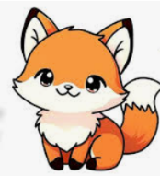


Welcome back, we hope you had a lovely break and are ready for Term 4. Once again, we would like to thank you for all your support through Year 1 so far!
In English, we are already very happy with the progress that is being made with handwriting, we have not yet learnt all the cursive letters and will continue learning these this term. Please keep practicing where to start our capital letters and lower-case lettering. Prospective parents have visited the school and have admired the Year 1’s beautiful writing lines. This term, we will be writing a narrative for the story ‘Three Little Pigs and the Big Bad Book’ and a set of instructions on how to sneak a monster into school! How may you sneak a monster into school without anyone noticing?
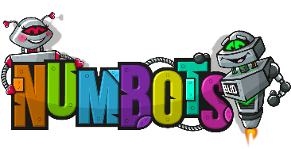


In Maths, we are learning numerals and number bonds to 20. We will be moving onto addition and subtraction as well as place value to 50 and length and measure. We would like to thank you for all your support at home with playing ‘Numbots’, lots of children have been moving up levels. Numbots is a great resource and we encourage you to continue to use this throughout the year. We have a special prize for the child who reaches diamond first in each class so get playing!
In Science we are learning about classifying animals and looking at the similarities and differences between them. We will then be moving onto carnivores and herbivores and looking closely at how scientists observe animals.


In Geography, this term we will be looking at the North and South Pole. We will be comparing the geographical features of the polar regions and the UK. We will be looking at similarities and differences between Antarctica and the Arctic Circle answering our key question: Would you rather live in the Arctic or Antarctica?
We have a fantastic opportunity to experience some ways people may move around on the snow. We will be going Snowtubing at Capstone from the week commencing Monday 16th March. Teachers will be sending out more information as to when your child will be visiting Capstone. You will then be advised as to what your child will need to wear to ensure they are safe on the slopes.

DON’T FORGET- Parents Evening will be set over two days so please make sure you book an appointment so you can speak to your child’s teacher about their progress so far. Bookings open Monday 23rd February at 10am.
As Easter will be upon us soon, we have the opportunity to be involved in an Easter Egg hunt around the local Church. We cannot wait as this was such a success last year!
Important dates
Monday 23rd February – First Day of Term
Thursday 5th March- World Book Day (Dress up as your favourite book character)
Wednesday 11th March (1:20pm-2:50pm) & Thursday 12th March (3:30pm- 6:30pm)- Parents Evening
Monday 16th March- Thursday 19th March- Year 1 snowtubing at Capstone (See info above)
Friday 20th March- Red Nose Day
Thursday 2nd April- Last Day of Term
Friday 3rd April- Good Friday- School CLOSED

Thank you for your continued support.
Mrs Payne, Mrs Varley, Mrs Kumar, Mrs Antoncini, Mrs Turpie, Mrs McBride, Mrs Hutchings and Mrs Marriott

