Swingate Primary School 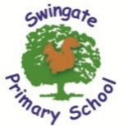
FS2 Newsletter Term 4
February 2026


Can you believe it’s term 4 already! The year seems to be flying by and there is still so much fun learning to be had. Our topic this term is Out of this World! We will be looking at a variety of books both fiction and non-fiction that will explore our solar system and the world around us. We will use our creative skills to make rockets! Let your child take you on a journey through outer space.
British Science Week 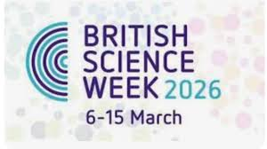
During this week, we will celebrate science and learn about otolaryngology. We will become scientists and take part in a sense of smell investigation.
World Book Day
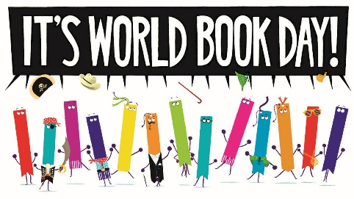
World Book Day is on Thursday 5th March. The children are invited to dress up as their favourite book/ book character if they wish to on this day. Over the course of this week, the children will be immersed into the world of reading and will be taking part in lots of fun activities.

Important Dates
5th March – World Book Day
6th – 15th March – British Science Week
11th March – Parents Afternoon
12th March – Parents Evening
13th March – Phonics Workshop/MANGO
20th March – Red Nose Day
25^{th/}26thMarch – Easter Session at Liberty Christian Fellowship
2nd April – Last Day of Term

