
Learning Activities
Year 2019-20

Self-Isolation Learning Week 12
 | Topic Under the Sea – Billy’s Bucket | Additional comments
Monday | Reading- Read /Watch ‘Billy’s Bucket’: https://www.youtube.com/watch?v=KQyFMEQV8fo  Would you like a bucket for your birthday? What one would you choose?  Writing/Phonics: Draw a bucket and write a sentence about what bucket you would choose? Would it be red or blue? Would it have a pattern on it or would it be a football or unicorn one? Write ‘My bucket is ……………because………  Don’t forget that ‘my’ and ‘is’ we have learnt before so think about how you might spell these. Your adult can give you the word ‘because’ as a spelling- this is a very grown up word that we haven’t learnt to spell yet!  Maths: For this activity you will need various sizes of empty bottles, funnels, scoop or cut bottle and coloured water as it is more visible (it may be that you leave this activity for another day)  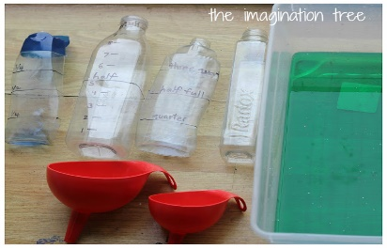  Onto the bottles draw very simple markings, different on each one to show a range of potential measuring scales i.e. 1 to 10 marking off the hallway point, another with quarter, half, three quarters and full and another with the same scale but numerically instead 1/4, 1/2, 3/4, 1. The idea is to give a large a range as possible and introduce lots of learning and vocabulary possibilities.  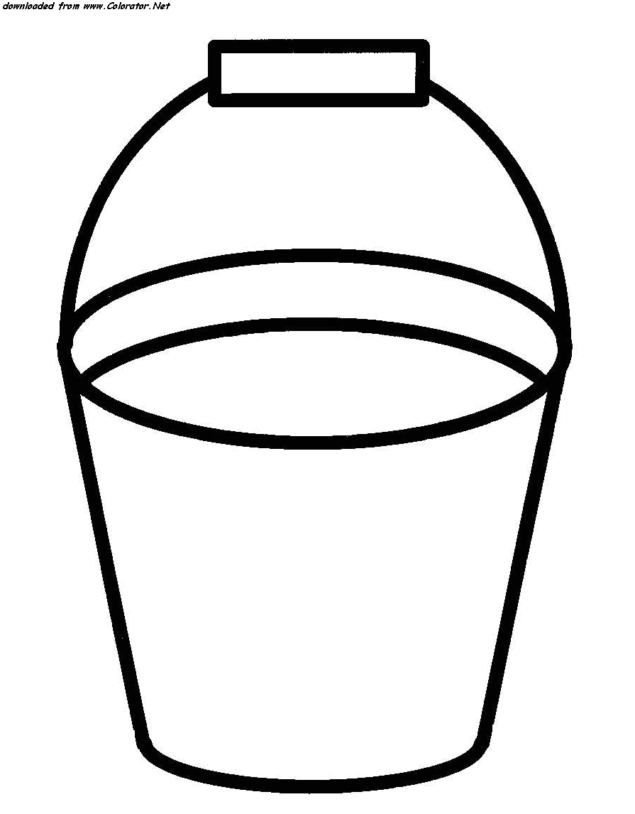  Then allow them to play talk about the half way mark on each bottle and what it represents, then challenge them to fill the bottles with water to meet the line exactly which is harder than it seems and a real test of co-ordination and control when pouring.  Art/ Construction: Draw and colour your bucket.  Imaginative play: Can you build a bucket from Lego or any construction toys you may have at home?  Handwriting: Follow this link to practice the ‘tunnel cursive letters: n, m, h, p, b, u: Focus on the height of h and b, as well as the length of the tail on the letter p. https://www.teachhandwriting.co.uk/cursive-letters-beginners-choice-3.html | Join the daily Joe Wicks PE challenge on his YouTube challenge to burn some excess energy.  Or any of the Cosmic Kids Yoga Disco videos (these can be found on YouTube)  Daily reading – choose a story to read together as a family. Ask your child to find specific words (maybe words from their most recent word list) or read a page each. Talk about the pictures. Ask the children what they think will happen at the end before you reach the final pages.  Or you can use the Oxford Reading Tree website which has lots of free E-Books for you to share:  https://home.oxfordowl.co.uk/books/free-ebooks/  Handwriting practice:  https://www.teachhandwriting.co.uk/route-c-letter-choice-3-fs.html  So far in Reception we have practised all of the letter shapes. However, we have found the following letters have proved to be the trickiest:  g, y, j – because the tails loop over and go underneath the line  p, q, - because they need to go underneath the line.  h,b,d,k – because they are taller than the rest of the other letters  f – has proved to be the most difficult! Because it loops but is also tall AND long.  Dough disco: Early Years Emily on Youtube or Shontelle Bason do great videos.
Tuesday | Reading: Revisit the story and talk about some of the things that Billy saw in his bucket.  Writing Draw a bucket and draw inside your favourite thing that Billy saw. Write ‘I liked the ……..because…..’  Maths: For this activity you will need small plastic cups or any smaller containers you may have at home as well as a packet of rice or any form of dry food you may have in the cupboard. Allow your child to explore capacity as yesterday. Can they use any of the language introduced i.e. quarter full, half full, etc.  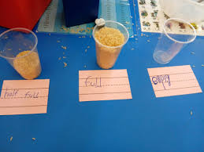  Phonics:  Practice writing the Phase 2 high frequency words: the, to, no, go I, into  Practice reading the Phase 3 high frequency words: he, she, we, me, be, they, are, all, my, her (any words that you get stuck on can be practiced throughout the week.)  Now you need to write the following words and draw a picture to match. Use your sound mat to help you find the digraphs you need:  queen, ring, star, fish, feet  Art/ Construction: Design a bucket for your Friend. What does he/she like? What is there favourite thing i.e. Dinosaurs /Mermaids?  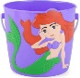  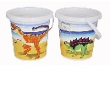  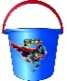  Imaginative play: Free choice  Handwriting: Follow this link to practice the ‘hooks, loops and lines’ cursive letters: j, y, f, k https://www.teachhandwriting.co.uk/cursive-letters-beginners-choice-3.html  Don’t forget that these letters have looped tails!
Wednesday | Reading- Re-read /Watch story. What would you collect in your bucket?  Writing: Draw and write a list of the things you would put in your bucket. Don’t forget to use your word lists and sound mat to help you.  Maths: Using the plastic cups/containers from yesterday complete the capacity challenges provided below  https://www.twinkl.co.uk/resource/maths-mastery-capacity-home-learning-challenge-ordering-cups-tf-n-1182  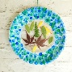  Phonics: Join in with the blending song: https://www.youtube.com/watch?v=qWn-qxUddqo  Try reading some of the Phase 3 captions and match them to the pictures. You can practice with 2 to begin with to find the corresponding picture if it is a bit tricky to start with.  Art/ Construction: Fill a small bucket/cup and make a  sun-catcher for your window with two paper plates and  some cling film.  Imaginative play: Go on a hunt around the house and see  how many objects you can find that are your favourite colour! Miss Dent’s favourite colour is yellow!  Handwriting: Follow this link to practice the ‘straight line’ cursive  letters: i, l, t, x, z. Focus on how tall l and t should be in comparison to the other letters: https://www.teachhandwriting.co.uk/cursive-letters-beginners-choice-3.html
Thursday | Reading Read/watch ‘Sophie’s Bucket’ and talk about the similarities and differences between the two stories: https://www.youtube.com/watch?v=T6gXH6hur1Y  Writing: Which story do you like best …Draw a picture and write ‘I like ………..because  Maths: Using the bottle worksheet provided. Can you paint, colour the bottles to show the correct capacity?  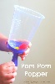  Phonics: Continue with reading and matching some of the Phase 3 captions and pictures you used yesterday. Practice writing some of the Phase 3 high frequency words: he, she, we, me, be, my, all, they are, her. Can you write a sentence with one of the words in?  Art/ Construction: Using a plastic cup you can create a  Pompom popper. You will need a balloon as well to make them  pop out of the top of your plastic cup!  Imaginative play: Can you fill up a bucket or washing up bowl  with water and pretend your toys are at the sea-side.  Handwriting: Follow this link to practice the ‘curves to start cursive letters: c,a,d,g Focus on how tall d should be and long the tail is on the letter g: https://www.teachhandwriting.co.uk/cursive-letters-beginners-choice-3.html
Friday | Reading: Read /Watch –‘Have you filled your bucket today’ is this the same sort of story as Billy’s Bucket? What is different about it?  https://www.youtube.com/watch?v=JEg38zCOMgk  Writing: Can you write some kind notes to fill your bucket? What things can you say to make someone smile?  Maths: Can you sort the objects into the correct area using the resources found below  https://www.twinkl.co.uk/resource/au-n-753-capacity-sort-maths-centre-activity  Phonics: Watch the blending video: https://www.youtube.com/watch?v=skKpz1Xi1iw  Practice writing words that rhyme with following: cat, man, pig, dog – highlight that the last two sounds are the same.  Art/ Construction: Draw a seaside picture. Don’t forget to put your bucket in the picture!  Imaginative play Make a game using your bucket. How can you score it? What are the rules?  Handwriting: Follow this link to practice the ‘curves to start cursive letters: q,o,e,s Focus on the leaving lines of the letters o and s, and the length of the tail on the letter q: https://www.teachhandwriting.co.uk/cursive-letters-beginners-choice-3.html

Learning Activities
Year 2019-20

Self-isolation learning Week 13
 | Topic – Under the Sea: Pirate week 1 | Additional comments
Monday | Reading- What are Pirates? Who are they and what do they do?  Read Pirate Pete and go over the story, what events happened? https://www.youtube.com/watch?v=quNt9nFYGlU  Writing Swingate Squirrel has been kidnapped! There is a note and a video from the kidnapper! Watch the video – what has happened? Who took Swingate Squirrel? What could we do to get him back? Show the children different wanted posters. How could we make own? Wanted poster – Choose a kidnapper and write a description.  Maths: https://www.youtube.com/watch?v=GiLySC_emj0  Can you make your own 10 little Pirates and act out the story.  Challenge: Can you record your story as number sentences i.e. 10-1=9, etc  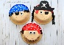  Phonics: Recap the ‘ar’ sound today so you can sound just like a pirate! https://www.youtube.com/watch?v=0Vywhf7cF7Q Can you write the following words that have the ‘ar’ sound in them: arm, jar, far, part, star. Can you put your sound buttons in the words?  Art: Make a pirate using a paper plate if you have any at home  Imaginative play: The day I went to sea’ Pirate song:  https://www.youtube.com/watch?v=x7MgOk6ZdlQ  Handwriting: Follow this link to practice the ‘top exit’ cursive letters: r, v, w: https://www.teachhandwriting.co.uk/cursive-letters-beginners-choice-3.html  Construction: Use a box or washing basket to make a Pirate ship. | Daily reading – choose a story to read together as a family. Ask your child to find specific words (maybe words from their most recent word list) or read a page each. Talk about the pictures. Ask the children what they think will happen at the end before you reach the final pages.  Or you can use the Oxford Reading Tree website which has lots of free E-Books for you to share: https://home.oxfordowl.co.uk/books/free-ebooks/  Handwriting practice:  https://www.teachhandwriting.co.uk/route-c-letter-choice-3-fs.html  So far in Reception we have practised all of the letter shapes. However, we have found the following letters have proved to be the trickiest:  g, y, j – because the tails loop over and go underneath the line  p, q, - because they need to go underneath the line.  h,b,d,k – because they are taller than the rest of the other letters  f – has provied to be the most difficult! Because it loops but is also tall AND long.  Dough disco: Early Years Emily on Youtube or Shontelle Bason do great videos.  Join the daily Joe Wicks PE challenge on his YouTube challenge to burn some excess energy.  Or any of the Cosmic Kids Yoga Disco videos (these can be found on YouTube)  Jigsaw  Growing up. Looking at how we have grown. How have we changed from when we were babies? Look at a baby picture of yourself, has your hair grown?
Tuesday | Reading: Read Pirates Love Underpants and talk about the story. How does this differ from yesterday’s story? Which one did you like best? https://www.youtube.com/watch?v=Vd8_Y1bEzA8v  Writing: Can you write a message in a bottle. What would Swingate squirrel write to his rescuers? What would he say?  Maths: Using resources you can find at home can you practice your double numbers.  How much treasure do you have?  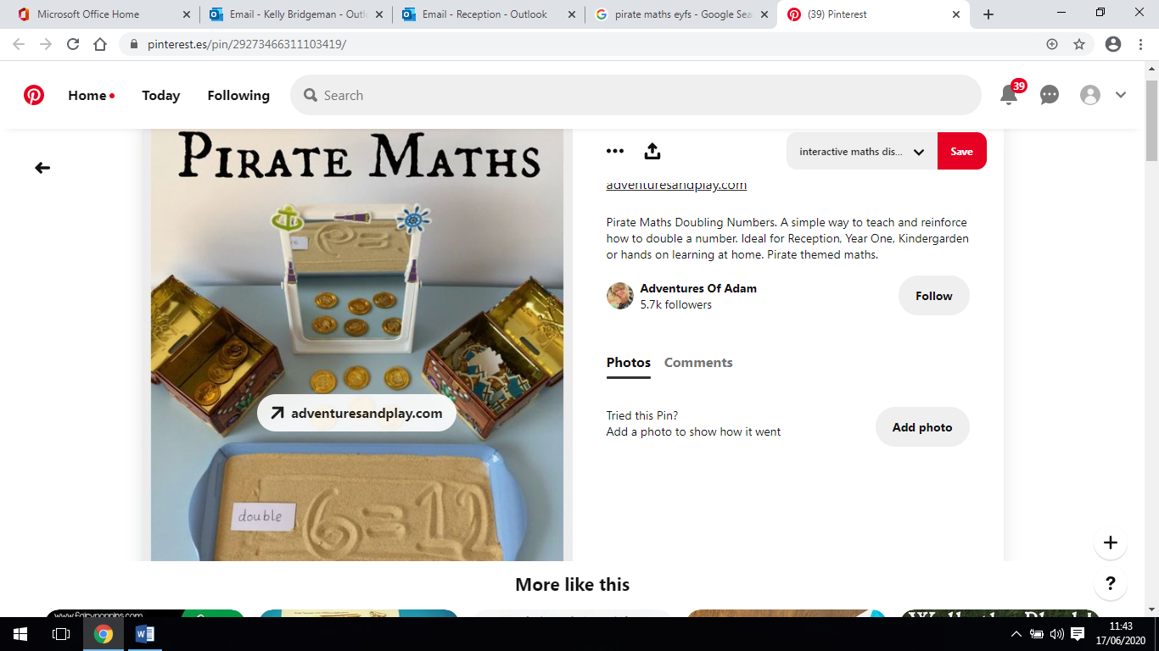  Phonics: Play on Phonics Play and revise all the sounds you have learnt in Phase 2 and 3 using the Flashcard Speed Trial. Ask your adult to make a note of any sounds you do not know to practice throughout the week.  Play Phase 2 Buried Treasure on Phonics Play.  Can you use used our blending and segmenting skills to  Read the words and decide if they are real or not real?  Art: Make your own pirate hat and patch so you can  Look like a real pirate!  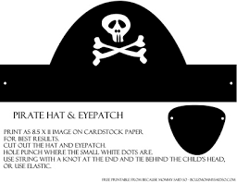  Imaginative play: What else can you make a Pirate ship  out of? Can you use Lego or Duplo?  Handwriting: Follow this link to practice the ‘tunnel cursive letters: n, m, h, p, b, u: Focus on the height of h and b, as well as the length of the tail on the letter p. https://www.teachhandwriting.co.uk/cursive-letters-beginners-choice-3.html
Wednesday | Reading. Watch on YouTube Captain Flinn and the Pirate Dinosaurs Missing Treasure:  https://www.youtube.com/watch?v=3a7PJLqPfBA  Did you like this story? What was the same as the other stories and what was different? What one did you like best so far? Why?  Writing: If I were a Pirate … What would be your pirate name? What would you do? Draw a picture of yourself as a pirate and write a sentence about yourself. We cannot wait to see your pirate portraits!  Maths: Using the resources from yesterday can you half your Pirate treasure? How much treasure do you have now? Do you have more or less than yesterday?  Phonics: Can you write the following pirate words and add in  the sound buttons>? Map, ship, boat, coin, hat, peg-leg.  Can you write a sentence using some of these words?  Art: Can you create a pirate side kick?  Today you are going to make a paper plate parrot!  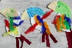  Imaginative play: Wearing your Pirate hat … Can you make your toys walk the plank?  Handwriting: Follow this link to practice the ‘hooks, loops and lines’ cursive letters: j, y, f, k https://www.teachhandwriting.co.uk/cursive-letters-beginners-choice-3.html
Thursday | Reading: Watch ‘How I became a Pirate’ on You Tube and compare to the other stories this week: https://www.youtube.com/watch?v=y4m_BW5yddU  Writing/Phonics: Create a treasure map of the island and label it. Do you have any rocks or sharks or trees? Is there an X marks the spot? Do not forget to use your sound mat to help you with sounding out the words you need!  Maths:  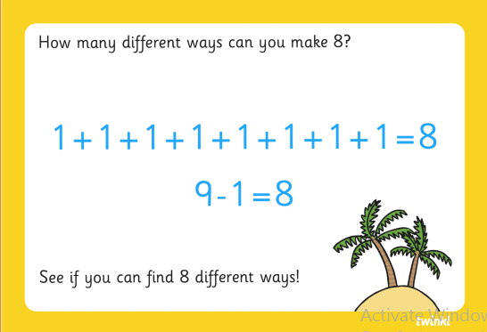  Art: Create a pirate telescope to look out to sea  for other swashbuckling pirates!  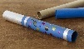  Imaginative play: Now you have your Pirate hat,  your treasure map, your telescope, and  pirate name you can go and find your desert island and create your flag.  Handwriting: Follow this link to practice the ‘straight line’ cursive  letters: i, l, t, x, z. Focus on how tall l and t should be in comparison to the other letters: https://www.teachhandwriting.co.uk/cursive-letters-beginners-choice-3.html
Friday | Reading: Revisit briefly all the stories this week. Which one was your favourite and why? Can you think of any words that were common to all the books that can maybe help you with your writing?  Writing: Pirate picture writing picture!  Maths:  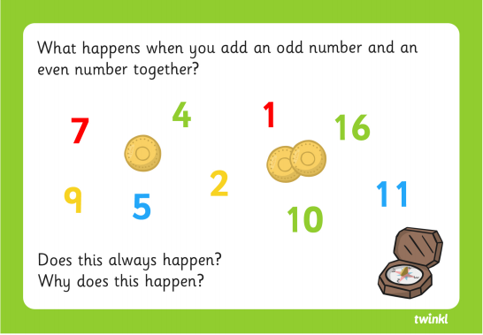  Phonics: Play the Buried Treasure game on Phonics Play again today. If you found this a little tricky on Wednesday, stick with Phase 2. If you would like a challenge, move onto Phase 3. Can your adult challenge you to write some nonsense words using the sounds you know? Doing things like this means you can apply your sounds in any word you see!  Art: It is time to make a Skull and Crossbones Flag like a real pirate!  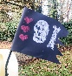  Imaginative play: Use all your props to create your own desert island and pirate ship? Maybe your bed could be the ship?  Handwriting: Follow this link to practice the ‘curves to start cursive letters: c,a,d,g Focus on how tall d should be and long the tail is on the letter g: https://www.teachhandwriting.co.uk/cursive-letters-beginners-choice-3.html

