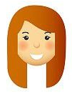
By Mrs Davies

Celebrations
Term 3 – 2026 here we go…
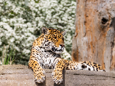
Here are just SOME of the things we have been up to this term…
Year R – Big Cat Sanctuary Trip
Year R had a wonderful visit to The Big Cat Sanctuary. Although the focus was on learning about different types of cats, the children also enjoyed spotting lions and tigers—and they were the only school there! It truly was a special day and one we know they will remember.
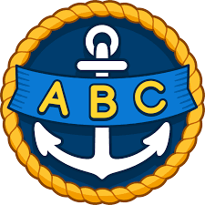
Year 2 – Mosque Visit
Year 2 enjoyed their trip to the Nasir Mosque and were able to share all the fantastic things they learned during their visit. They represented Swingate brilliantly.
Foundations for Success: Midyear Parent Workshop
Thank you to all the families who attended the Year R Workshop this term. The turnout was incredible, and we really appreciate you working in partnership with us to support your children’s learning.

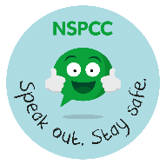
NSPCC Number Day
Last week we celebrated NSPCC Number Day, and the school was filled with numbers everywhere you looked! Thank you for your generosity—we raised an amazing £479.89. Your donations will help the NSPCC continue supporting children who need it.
Young Voices at the O2
Mrs Clarke was thrilled to take the Swingate Choir to the O2 Arena to perform in Young Voices. It is always such a breath-taking event and a fantastic opportunity for our choir. They did us proud!
Cross-Country Success
We were excited to host our second Cross-Country Event, welcoming over 200 children from schools across Medway. A huge well done to Mr Moreea for organising a brilliant team of Press Release reporters, door Bouncers, medal presenters, and of course, our amazing runners! Despite the slippery conditions, they kept going and showed fantastic determination.
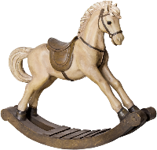

Year 1 – Grandparents’ Toy Session
Year 1 had a wonderful time welcoming their grandparents into school to share toys from their own childhoods. The hall was buzzing with excitement as children explored and compared toys from the past.
Welcome to Our New Rainbows
A warm welcome to the new children who joined our Rainbows nursery this term. We are so proud of how well they are settling in and becoming part of our Swingate family.

Celebration Assembly
Here are our names for our Celebration Assembly Golden Squirrel Stars:

EYFS: Timo, Miley, Tilly, Kai, Will, Ayla, Savannah, Freddie, Freya, Callum, Freddie, Carter, Mia, Mason, Ahmed, George, Emily, Alfie
Year 1: Virat, Elliott, Tommy, William, Amelia, Taya, Rosie, McKenzie, Harper, Luca, Lissie, Mason, Fraser, Zachary, Hope, Eiden, Rory, Ayda
Year 2: Adam, Rosie, Adesola, Reggie, Rhona, Casey, Janelle, Ruby, Lucas, Frankie, Archie, Jaden, Hudson, Harley, Hudson, Ella, Sienna, Dolly
Year 3: Conor, Athena, Hunter, Lola, Eliza, Jenson, Kyle, Flynn, Rory, Jake, Ajai, Charlie, Ronnie-Ray, Kate, Razvan, Phoebe, Alexa, Caiden, Jude, Lola
Year 4: Ralph, Riley, Frank, Willow, Millie, Jake, Olly, Jack, Lexi, Amelia, Lukas, Lewie, Tommy, Darlie, Martin, Jack, Daisy, Jaxon, Ephraim, Adarsh
Year 5: Freddie, Bella, Eliana, Belle, Oliver, Vinnie, Enaissa, Nia, Skyla, Ronnie, Denzel, Layla, Amelia, Eliza, Darcie, Connie, Charlotte, Alice, Jasleen, Sophia,
Year 6: Finley, Freddie, Mason, Harvey, Isaac, Ava, Louie, Harrison, Zak, Riley, Lukas, Blake, Albert, Evie, Sianna

Hot Chocolate Friday
Here are the names of the children who have been nominated for Hot Chocolate Friday this term: Phoebe, Dottie, Remy, Luca, Sophie, Lylah, Archie, Freddie, Hallie, Michael, Tabitha, Kadey, Amelia, Sofia, Mia, Scott, Louie, Holly, Sienna, Beau, Evie, Daisy, Madison, Jaxxon, Jack, Evie, Olly, Ruby, Annie, James, Annie, Athina, Lois, Jaxon, Ethan, Lyra, Chase, Parker, Charlie, Isaac, Fraser, Isla, Oluwasemilore, Connie, Sophia, Noah, Amiyah-Rose, Roman, Lois, Evie-Rose, Nevaeh, Jacob, Hunter, Blue-Belle, Grace, Ella, Olivia, Laynie, Leyton, Hudson, Nora, Beau, Laurice, Kai, Scarlett

House Points

Well done to children in J.K Rowling across the school who won the most house points this term. They all were allowed to come into school in their own clothes to celebrate. We can’t wait to find out what the end of term treat will be next term.

Jigsaw Update
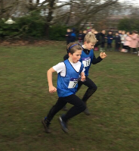
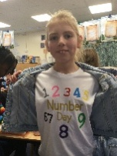
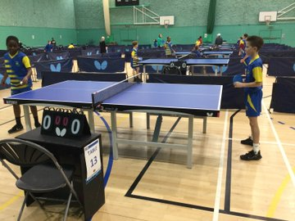
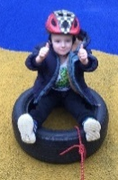
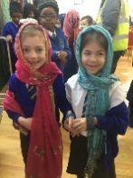
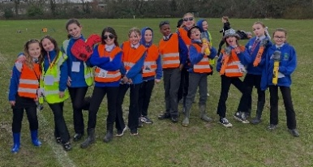
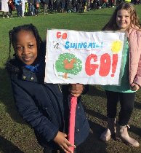
Next term our Jigsaw topic will be ‘Healthy Me’. This topic explores two main areas of health: Emotional Health and Physical Health. Children will learn about the things that help to keep them healthy and safe, and they will discuss how foods and medicines can be good for their bodies. They will also compare these with choices that may be less healthy or unsafe. Older children will be learning how to recognise when others may be putting them under pressure, exploring strategies to resist this, and identifying who they can talk to for help. In Year 5 and 6, the unit also includes age-appropriate discussions about alcohol and drugs, as well as body image, relationships with food, and managing stress.
We look forward to seeing you on Monday 23rd February.

