
Learning Activities
Year 2019-20

Self-Isolation Learning Week 10
 | Topic Under the Sea –Nonfiction | Additional comments
Monday | Reading- What lives under the sea? Create a list of creatures that they think live under the sea. Youtube: Alphabet sea and water animals. What other things did they notice, was there anything they had not thought of?  Writing/Phonics: Using their sounds can they make a list of the animals they have seen. Practice segmenting and blending the words, focus on digraphs for specific words such as:  sh in fish  er in lobster  ee in eel  sh and ar in shark  Maths: How many sea creatures can you see? Circle the correct number  Work sheet can be found at bottom of this learning  Art/ Construction Lets create an Under water Seascape in a box . Today lets colour/collage the blue sea background , remember the sea gets darker at the bottom as less light is coming down from the sun. A seascape picture at the bottom of this weeks planning.  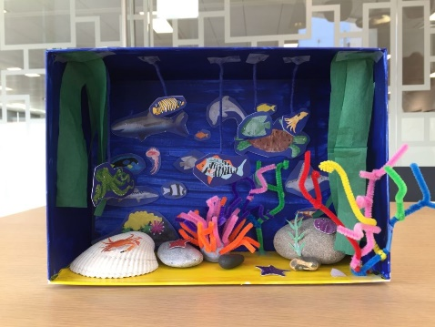  Imaginative play- Join in some underwater songs and rhymes you can find on YouTube to build up to a performance at the end of the week. Let your imagination run wild dress up etc.  Handwriting: Follow this link to practice the ‘straight line’ cursive  letters: i, l, t, x, z. Focus on how tall l and t should be in comparison to the other letters: https://www.teachhandwriting.co.uk/cursive-letters-beginners-choice-3.html  Remember always leave time for free play activities. Your toys will get lonely if you do not play with them. | Join the daily Joe Wicks PE challenge on his YouTube challenge to burn some excess energy.  Or any of the Cosmic Kids Yoga Disco videos (these can be found on YouTube)  Daily reading – choose a story to read together as a family. Ask your child to find specific words (maybe words from their most recent word list) or read a page each. Talk about the pictures. Ask the children what they think will happen at the end before you reach the final pages.  Or you can use the Oxford Reading Tree website which has lots of free E-Books for you to share:  https://home.oxfordowl.co.uk/books/free-ebooks/  Handwriting practice:  https://www.teachhandwriting.co.uk/route-c-letter-choice-3-fs.html  So far in Reception we have practised all of the letter shapes. However, we have found the following letters have proved to be the trickiest:  g, y, j – because the tails loop over and go underneath the line  p, q, - because they need to go underneath the line.  h,b,d,k – because they are taller than the rest of the other letters  f – has proved to be the most difficult! Because it loops but is also tall AND long.  Dough disco: Early Years Emily on Youtube or Shontelle Bason do great videos.
Tuesday | Reading: Revisit yesterday’s list (maybe your adult can write some flash cards to read) Talk about what is your favourite creature and why?)  Writing Choose a creature and write about it Today we are going to Create a Fact file. Choose your favourite sea creature and write one sentence about it. Remember this sentence has to be a fact, which is something that is true.  Maths: Draw more sea creatures. How many do you have now?  Work sheet can be found at bottom of this learning  Phonics: What digraphs can you identify in these words? Remember you can use your sound mats to help you: sharp, teeth, fish, lobster, eel. How many sounds are in each word?  Art/ Construction: Put some seaweed and plants made from paper and card to enhance your backdrop.  Imaginative play: Join in some underwater songs and rhymes you can find on YouTube  Handwriting: Follow this link to practice the ‘curves to start cursive letters: c,a,d,g Focus on how tall d should be and long the tail is on the letter g: https://www.teachhandwriting.co.uk/cursive-letters-beginners-choice-3.html  Remember always leave time for free play activities. Your toys will get lonely if you do not play with them.
Wednesday | Reading- Look at a picture of a sea creature. Let us look at what it tells us What would it eat? How does it move?  Writing: Choose another creature and write about it. Remember to use the sounds you know, not Mummy or Daddy. It is important to show everyone what you can do.  Maths: What sea creatures can you see? How many are there?  https://www.twinkl.co.uk/resource/t-tp-1237-under-the-sea-i-spy-and-count-activity to 10  https://www.twinkl.co.uk/resource/t-tp-1329-under-the-sea-i-spy-and-count-activity-to-20  Phonics: Practice your segmenting and blending skills by reading the facts about different under the sea creatures (this can be found on the Reception Learning page). There are sound buttons there to help you if you need them. What digraphs can you see in each sentence?  Art/ Construction: Let us begin to draw and cut out some coloured fish to go in your box you might want to include an octopus at this point  Imaginative play: Join in some underwater songs and rhymes you can find on YouTube  Handwriting: Follow this link to practice the ‘curves to start cursive letters: q,o,e,s Focus on the leaving lines of the letters o and s, and the length of the tail on the letter q: https://www.teachhandwriting.co.uk/cursive-letters-beginners-choice-3.html  Remember always leave time for free play activities. Your toys will get lonely if you do not play with them.
Thursday | Reading: Look at pictures of animals either in a book or on a computer. Which ones are fish and which ones are Mammals? What is the difference? Look at the different animals and list them.  Writing: Choose another creature and write about it. Do not forget your full stop, finger spaces and capital letters.  Maths: How many sea creatures can you see? How many do you have altogether?  https://www.twinkl.co.uk/resource/under-the-sea-i-spy-and-count-activity-to-10-t-n-2546854 to 10  https://www.twinkl.co.uk/resource/under-the-sea-i-spy-and-add-to-20-activity-t-tp-69749  Phonics: Practice segmenting and blending CVC words using this song - https://www.youtube.com/watch?v=OJWJx0ILwV8 Practice writing the following Phase 3 tricky words: he, she, we, me, be, they, are, all, her  Art/ Construction: Maybe now add a moving Shark or whale.  Imaginative play: Join in some underwater songs and rhymes you can find on YouTube  Handwriting: Follow this link to practice the ‘top exit’ cursive letters: r, v, w: https://www.teachhandwriting.co.uk/cursive-letters-beginners-choice-3.html  Remember always leave time for free play activities. Your toys will get lonely if you do not play with them.
Friday | Reading: Look at strange creatures that live deep down. Why do they look like that? Watch a David Attenborough clip on YouTube: https://www.youtube.com/watch?v=UXl8F-eIoiM  Writing: Choose another creature and write about a fact about it. Please email your fact file to your teacher – we would love to see them!  Maths: Search for the sea creatures. Colour and count them  https://www.twinkl.co.uk/resource/t-t-18486-under-the-sea-find-colour-and-count-activity-sheet  Phonics: Play this game at home to practice your segmenting and blending. Remember practice makes perfect! You can always start on Phase 2 and move onto digraphs in Phase 3: https://www.ictgames.com/mobilePage/helpAHedgehog/index.html  Art/ Construction: Create a strange ‘Under the Sea’ creature and give it a name.  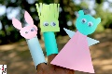  Imaginative play: Join in some underwater songs and rhymes you can find on YouTube at the end of the week you should have a bank of songs and rhymes that your adult could film and email or put on twitter for your teacher to see.  Handwriting: Follow this link to practice the ‘tunnel cursive letters: n, m, h, p, b, u: Focus on the height of h and b, as well as the length of the tail on the letter p. https://www.teachhandwriting.co.uk/cursive-letters-beginners-choice-3.html  Remember always leave time for free play activities. Your toys will get lonely if you do not play with them.

Learning Activities
Year 2019-20

self-isolation learning Week 11
 | Topic – Under the Sea: Barry the Fish with Fingers | Additional comments
Monday | Reading- Read book or watch on you tube the story of Barry the Fish with Fingers  What is the story about? What happens in this story? Concentrate on the Puffer fish.  Writing: Draw a picture of the Puffer fish and write a description. For example: He has/is…  Maths: Design a new scarf for Puffy  https://www.twinkl.co.uk/resource/t-t-2548655-stripy-scarves-repeating-patterns-activity-sheet  Phonics: Watch this phonics song about digraphs: https://www.youtube.com/watch?v=aNcBWSBxSp0 What words can your write that have digraphs in? You can use your sound mat to help you.  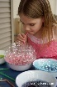  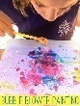  Art: Using bubbles and straws (washing up liquid) and paint or food colouring you can create bubble pictures. BLOW DON’T SUCK.  Imaginative play:  Handwriting: Follow this link to practice the ‘hooks, loops and lines’ cursive letters: j, y, f, k https://www.teachhandwriting.co.uk/cursive-letters-beginners-choice-3.html  Construction: Make a bubble wand from an old coat hanger/pipe cleaner /fuse wirer and blow or wave some bubbles | Daily reading – choose a story to read together as a family. Ask your child to find specific words (maybe words from their most recent word list) or read a page each. Talk about the pictures. Ask the children what they think will happen at the end before you reach the final pages.  Or you can use the Oxford Reading Tree website which has lots of free E-Books for you to share: https://home.oxfordowl.co.uk/books/free-ebooks/  Handwriting practice:  https://www.teachhandwriting.co.uk/route-c-letter-choice-3-fs.html  So far in Reception we have practised all of the letter shapes. However, we have found the following letters have proved to be the trickiest:  g, y, j – because the tails loop over and go underneath the line  p, q, - because they need to go underneath the line.  h,b,d,k – because they are taller than the rest of the other letters  f – has provied to be the most difficult! Because it loops but is also tall AND long.  Dough disco: Early Years Emily on Youtube or Shontelle Bason do great videos.  Join the daily Joe Wicks PE challenge on his YouTube challenge to burn some excess energy.  Or any of the Cosmic Kids Yoga Disco videos (these can be found on YouTube)  Jigsaw  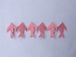  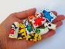  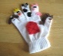  How can we keep healthy?  Make a healthy lunch -  Using a paper plate can you draw what healthy food you are going to have for lunch
Tuesday | Reading: Read/Watch the story again. Look at Barry, remind yourselves about what Barry has got that other fish have not got?  Writing: Draw Barry and write some sentences about what Barry can do with his fingers.  Maths: Can you continue the pattern? What sea creature comes next?  Worksheet can be found at the bottom of this learning.  Phonics: Can you put sound buttons in the following words: rain, man, queen, dog, boat, cup. Can you put one of these words into a sentence using finger spaces, a capital letter and a full stop?  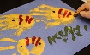  Art: Finger painting/ Fill in a fish with coloured finger scales or create an underwater picture using finger painting.  Imaginative play:  Handwriting: Follow this link to practice the ‘straight line’ cursive  letters: i, l, t, x, z. Focus on how tall l and t should be in comparison to the other letters: https://www.teachhandwriting.co.uk/cursive-letters-beginners-choice-3.html
Wednesday | Reading. Thinking about what Barry can do with fingers. Can you think of all the things that you can do with your fingers?  Writing: Write a list using your sounds, of all the things you can do with your fingers?  Maths: Create your own sea creature repeated pattern  Phonics:  Art: Create finger puppets using paper, cello tape, colouring pencils  create some finger puppets to complement the story.  Imaginative play:  Handwriting: Follow this link to practice the ‘curves to start cursive letters: c,a,d,g Focus on how tall d should be and long the tail is on the letter g: https://www.teachhandwriting.co.uk/cursive-letters-beginners-choice-3.html
Thursday | Reading: Re read the story. What did Barry do for Puffer fish? What did they find? Talk about something you could do to help someone?  Writing: Write about how you could help someone using the sentence starter: I can help by…  Maths: Can you repeat the pattern? What comes next?  https://www.twinkl.co.uk/resource/t-t-5522-under-the-sea-complete-the-pattern-worksheet  Phonics: Practice segmenting and blending words with the ‘ch’ digraph using this video: https://www.youtube.com/watch?v=pqddT5Z1uVo Practice writing some of these words when you have finished watching.  Art- Cutting skills – Try cutting out a Fish paper chain. Was it easy?  Imaginative play:  Handwriting: Follow this link to practice the ‘curves to start cursive letters: q,o,e,s Focus on the leaving lines of the letters o and s, and the length of the tail on the letter q: https://www.teachhandwriting.co.uk/cursive-letters-beginners-choice-3.html
Friday | Reading: Revisit the story together and pick out the main points along the way to remind yourselves when re writing.  Writing: Re-write your favourite part of the story about Barry. Remember you have your word lists to help you and also your sound mats. You can also draw a picture to illustrate your favourite part of the story. Please send this to your teachers to see so we can see if our favourite part is the same as yours!  Maths: Paint one half of the sea creature to create a symmetrical pattern https://www.itsybitsyfun.com/wp-content/uploads/2017/05/Symmetry-Worksheets-Sea-Animals.pdf  Phonics: Practice segmenting and blending these CVC words to read: https://www.youtube.com/watch?v=zIuS2L6yhFc Get your adult to ask you to write a range of different digraphs, they can use your sound mat to help them choose. (Start with the sounds: qu, th, ng, ch, sh.)  Art: Create a sea-creature glove puppet using an old glove you can stick things on or a rubber glove (you can draw on this with felt tip pens).  Imaginative play:  Handwriting: Follow this link to practice the ‘top exit’ cursive letters: r, v, w: https://www.teachhandwriting.co.uk/cursive-letters-beginners-choice-3.html

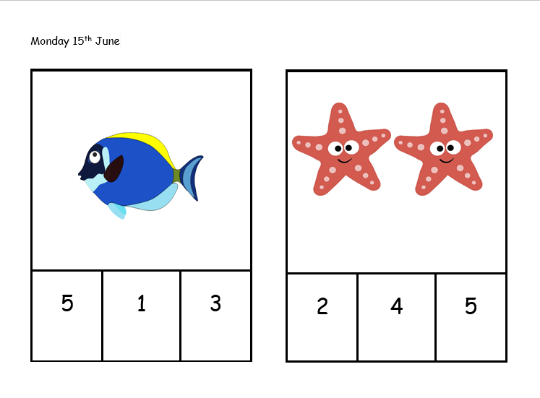

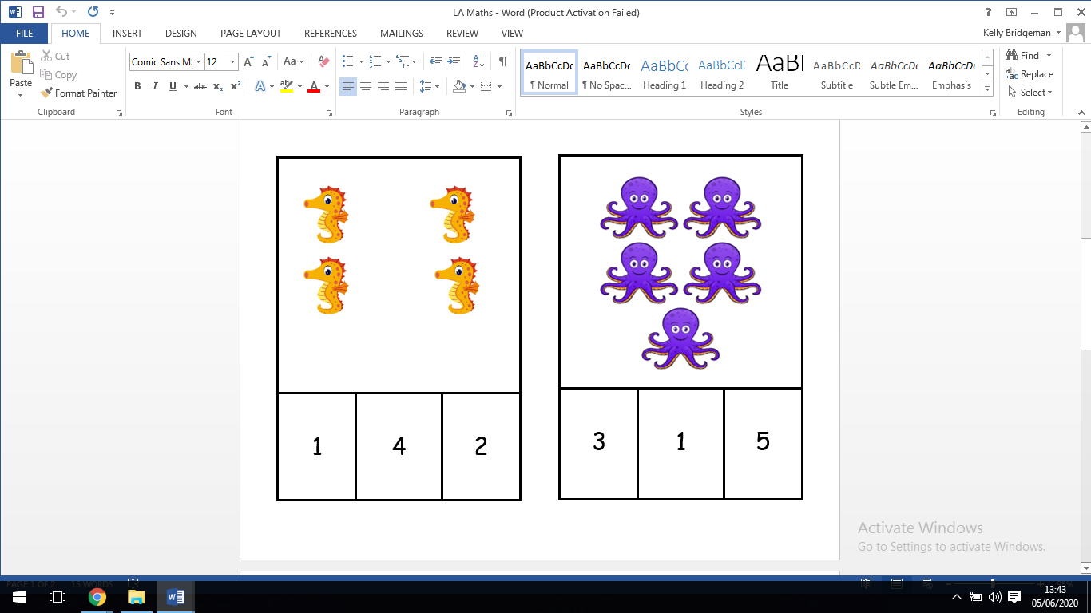

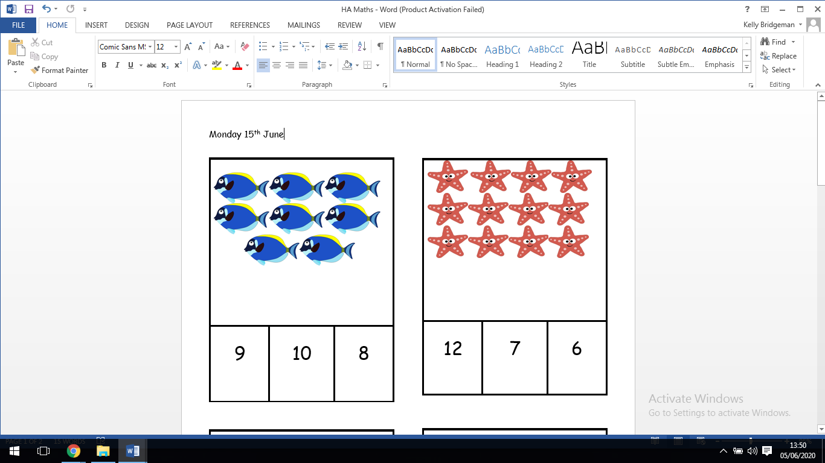

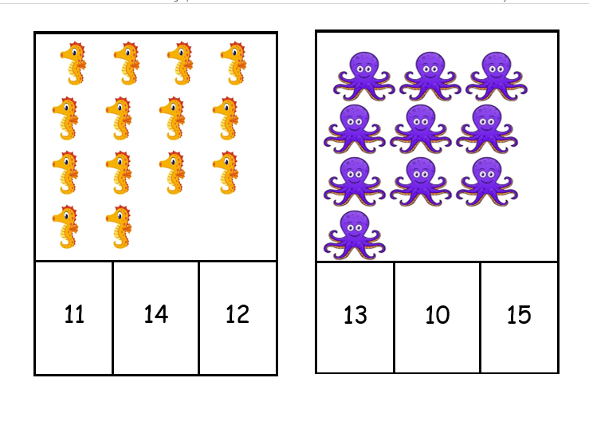

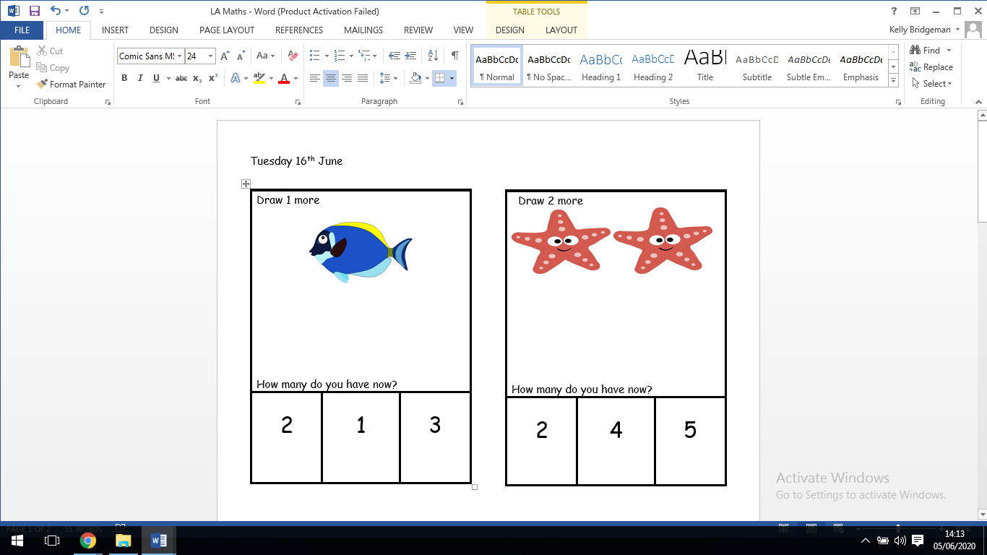
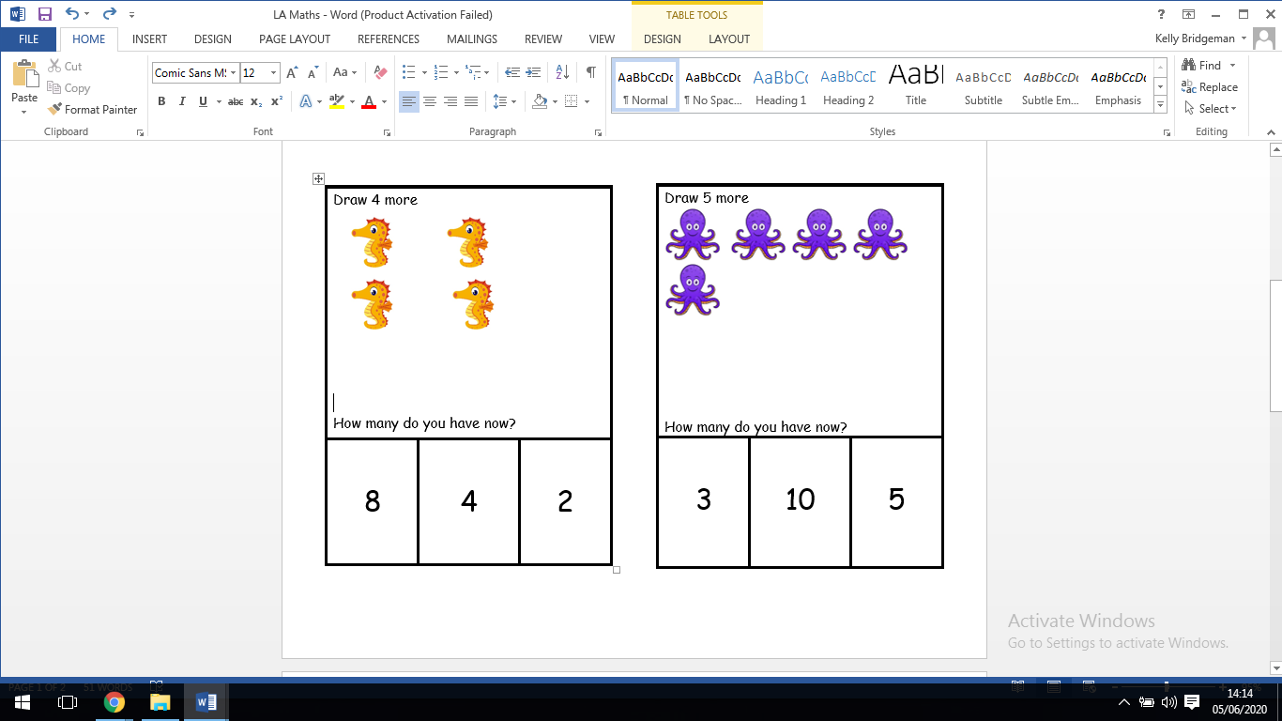

Tuesday 23rd June



