


FS2 mID yEAR eXPECTATIONS
Our wonderful FS2 team led a parent workshop to highlight mid year expectations across
the curriculum.
In Reception, fostering a love of reading and sharing a book with your child will encourage them to become an active participant in reading.
At Swingate, our expectations are that all children
read 4 times per week.
Reading with your child and
sharing their book from school
will continue
to
develop their fluency.
ReADing UPATeS
AT SwingATe!
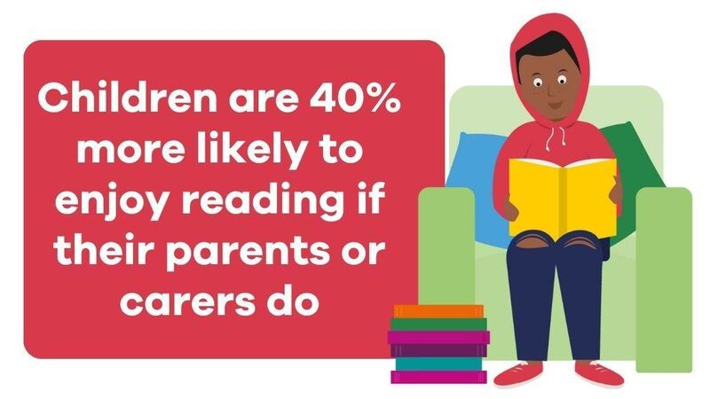
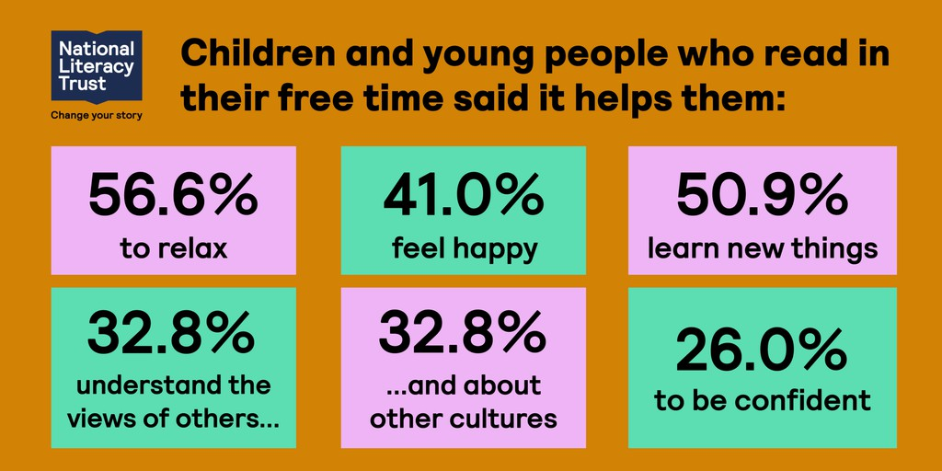

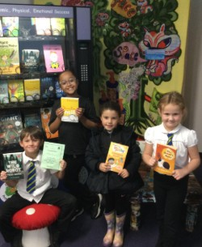
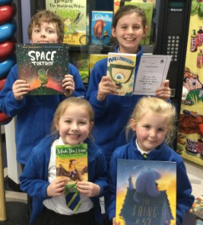
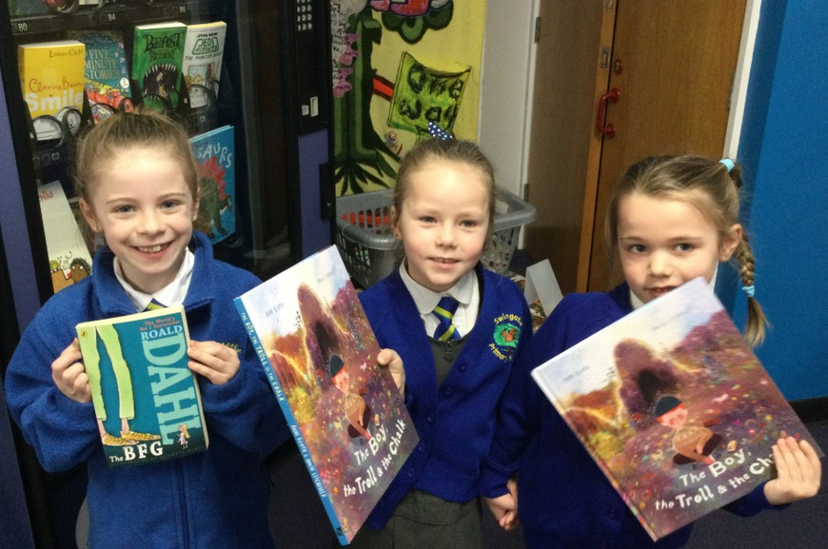
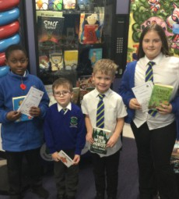
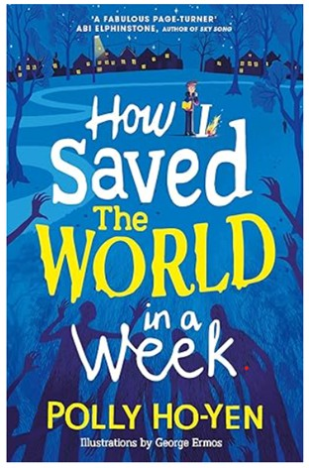
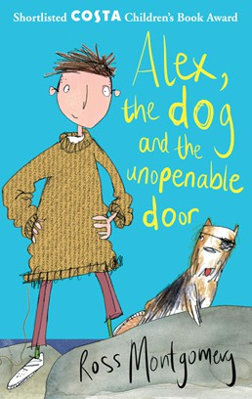
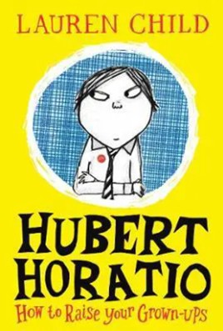
VenDing MAChine ViSiTORS
At Swingate, we continue to celebrate our wonderful children who show a passion for reading in all of its many forms.
AUThORS OF ThE TERM
Each term an author is promoted in our termly reading assemblies.
Here are the wonderful authors that have been included so far!
Term 1 - Lauren Child
Term 2 - Ross Montgomery
TeRm 3 - POlly hO-yen

wORLD BOOK DAY 2026
Swingate will be celebrating World Book Day on
Thursday 5th March.
YOUR ChilD iS welCOme TO DReSS UP AS TheiR FAVOURiTe BOOk ChARACTeR OR COme TO SChOOl in TheiR USUAl UniFORm.
CAUTION: Online author experiences, creative
activities and lots of book talk will be happening!

nATIONAL STORyTelling Week
At Swingate we are celebrating NSW from 2nd-6th February.
2026 is the National year of Reading and
story-telling is at the heart of sharing books!
NATiOnAl ReAD AlOUD DAy - 04/02/26
We celebrated National Read Aloud day in assembly this week with the wonderful Miss Dabb and Mrs Hudspeth reading to all of the children and staff.

