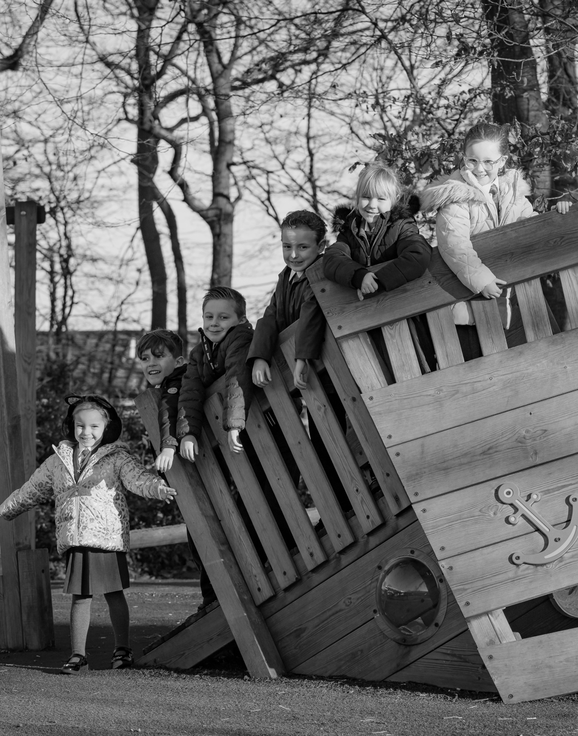

POLICY
Complaints Policy



POLICY DETAILS

Policy Title: |  |  | Complaints Policy
Version: |  |  | 1.0
Date created: |  |  | Summer 2025
Approved by FGB:
Next Review: |  |  | Summer 2026
POLICY HISTORY
Version: | Date: | Changes:
1.0 | Summer 2025 | New policy template

CONTENTS

1. DEFINITIONS AND AIMS 4
1.1 DEFINITIONS 4
1.2 AIMS 4
2. LEGISLATION AND GUIDANCE 5
3. SCOPE 5
4. ROLES AND RESPONSIBILITIES 5
4.1 THE COMPLAINANT 6
4.2 THE INVESTIGATOR 6
4.3 THE COMPLAINTS CO-ORDINATOR 6
4.4 CLERK TO THE GOVERNING BOARD 7
4.5 COMMITTEE CHAIR 7
5. PRINCIPLES FOR INVESTIGATION 7
5.1 TIMESCALES 7
5.2 COMPLAINTS ABOUT OUR FULFILMENT OF EARLY YEARS REQUIREMENTS 8
6. INFORMAL CONCERNS 8
7. STAGES OF COMPLAINT (NOT COMPLAINTS AGAINST THE HEADTEACHER OR GOVERNORS) 9
7.1 STAGE 1: FORMAL 9
7.2 STAGE 2: SUBMIT THE COMPLAINT TO THE REVIEW PANEL 10
8. COMPLAINTS AGAINST THE HEADTEACHER, EXECUTIVE HEADTEACHER, A GOVERNOR OR THE GOVERNING BOARD 12
8.1 STAGE 1: FORMAL 12
8.2 STAGE 2: REVIEW PANEL 13
9. REFERRING COMPLAINTS ON COMPLETION OF THE SCHOOL’S PROCEDURE 13
10. UNREASONABLE AND PERSISTENT COMPLAINTS 14
10.1 UNREASONABLE COMPLAINTS 14
10.2 SERIAL/PERSISTENT COMPLAINTS 16
10.3 DUPLICATE COMPLAINTS 16
10.4 COMPLAINT CAMPAIGNS 16
11. RECORD KEEPING AND CONFIDENTIALITY 17
12. LEARNING LESSONS 17
13. MONITORING ARRANGEMENTS 18
14. LINKS WITH OTHER POLICIES 18

Definitions and aims

Definitions

The DfE guidance explains the difference between a concern and a complaint:

- A concern is defined as “an expression of worry or doubt over an issue considered to be important for which reassurances are sought”
- A complaint is defined as “an expression or statement of dissatisfaction however made, about actions taken or a lack of action”

In most cases, a concern can be resolved through informal means. A complaint will follow formal procedures.

Aims

Our school aims to meet its statutory obligations when responding to complaints from parents/carers of pupils at the school, and others.

When responding to complaints, we aim to:
- Be impartial and non-adversarial
- Facilitate a full and fair investigation by an independent person or panel, where necessary
- Address all the points at issue and provide an effective and prompt response
- Respect complainants’ desire for confidentiality
- Treat complainants with respect and courtesy
- Make sure that any decisions we make are lawful, rational, reasonable, fair and proportionate, in line with the principles of administrative law
- Keep complainants informed of the progress of the complaints process
- Consider how the complaint can feed into school improvement evaluation processes

We try to resolve concerns by informal means wherever possible. Where this is not possible, the formal complaints procedures will be followed.

The school will aim to give the complainant the opportunity to complete the complaints procedure in full.

To support this, we will make sure we publicise the existence of this policy and make it available on the school website.

Throughout the process, we will be sensitive to the needs of all parties involved, and make any reasonable adjustments needed to accommodate individuals.

Legislation and guidance

This document meets the requirements of section 29 of the Education Act 2002, which states that schools must have and make available a procedure to deal with all complaints relating to their school and to any community facilities or services that the school provides.

It is also based on guidance for schools on complaints procedures from the Department for Education (DfE), including the model procedures for complaints and for managing serial and unreasonable complaints.

In addition, it addresses duties set out in the Early Years Foundation Stage statutory framework with regards to dealing with complaints about the school’s fulfilment of Early Years Foundation Stage (EYFS) requirements.

Scope

This policy does not cover complaints procedures relating to:

- Admissions
- Statutory assessments of special educational needs (SEN)
- Safeguarding matters
- Suspension and permanent exclusion
- Whistle-blowing
- Staff grievances
- Staff discipline
- School re-organisation proposals
- Curriculum
- Collective worship

Please see our separate policies for procedures relating to these types of complaint.

Complaints about services provided by other providers who use school premises or facilities should be directed to the provider concerned.

Roles and responsibilities

The complainant

The complainant will get a more effective and timely response to their complaint if they:

- Follow these procedures
- Co-operate with the school throughout the process, and respond to deadlines and communication promptly
- Ask for assistance as needed
- Treat all those involved with respect
- Do not approach individual governors about the complaint
- Do not publish details about the complaint on social media

The investigator

An individual will be appointed to look into the complaint and establish the facts. They will:

- Interview all relevant parties, keeping notes
- Consider records and any written evidence and keep these securely
- Prepare a comprehensive report to the executive headteacher, headteacher or complaints committee, which includes the facts and potential solutions

The complaints co-ordinator

The complaints co-ordinator can be:

- The executive headteacher
- The headteacher
- The designated complaints governor
- Any other staff member providing administrative support

The complaints co-ordinator will:

- Keep the complainant up to date at each stage in the procedure
- Make sure the process runs smoothly by liaising with staff members, the executive headteacher, the headteacher, chair of governors, clerk and local authority (LA)
- Be aware of issues relating to:
  - Sharing third-party information
  - Additional support needed by complainants; for example, interpretation support or where the complainant is a child or young person
- Keep records

Clerk to the governing board

The clerk will:

- Be the contact point for the complainant and the complaints committee, including circulating the relevant papers and evidence before complaints committee meetings
- Arrange the complaints hearing
- Record and circulate the minutes and outcome of the hearing

Committee chair

The committee chair will:

- Chair the meeting, ensuring that everyone is treated with respect throughout
- Make sure all parties see the relevant information, understand the purpose of the committee, and are allowed to present their case

Principles for investigation

When investigating a complaint, we will try to clarify:

- What has happened
- Who was involved
- What the complainant feels would put things right

Timescales

The complainant must raise the complaint within 3 months of the incident. If the complaint is about a series of related incidents, they must raise the complaint within 3 months of the last incident.

We will consider exceptions to this timeframe in circumstances where there were valid reasons for not making a complaint at that time and the complaint can still be investigated in a fair manner for all involved.

When complaints are made out of term time, we will consider them to have been received on the first school day after the holiday period.

If at any point we cannot meet the timescales we have set out in this policy, we will:

- Set new time limits with the complainant
- Send the complainant details of the new deadline and explain the delay

Complaints about our fulfilment of early years requirements

We will investigate all written complaints relating to our school’s fulfilment of the Early Years Foundation Stage requirements (EYFS) and notify the complainant of the outcome within 28 days of receiving the complaint. The school will keep a record of the complaint (see section 10) and make this available to Ofsted on request.

Parents and carers can notify Ofsted if they believe that our school is not meeting the Early Years Foundation Stage requirements, by:

- Calling 0300 123 4666
- Emailing enquiries@ofsted.gov.uk
- Using the online contact form available at https://www.gov.uk/government/organisations/ofsted#org-contacts

We will notify parents and carers if we become aware that our school is to be inspected by Ofsted. We will also supply a copy of the inspection report to parents and carers of children attending the setting on a regular basis.

Informal concerns

Our school will take informal concerns seriously and make every effort to resolve the matter quickly. It may be the case that the provision or clarification of information will resolve the issue.

The complainant should raise the concern as soon as possible within the timescales set out in section 5.1.

The concern should be addressed to the relevant member of school staff or the headteacher, either in person or by letter, telephone or email. If the complainant is unclear who to contact or how to contact them, they should contact the school office.

The school will acknowledge informal concerns within five school days, which will confirm how the school intends to proceed, including an indication of the anticipated timescale.

The informal stage will involve a meeting between the complainant and the headteacher and/or the subject of the concern, if appropriate. A written response will be provided by the school within five school days following the informal meeting.

If the concern is not resolved informally, it will be escalated to a formal complaint.

Stages of complaint (not complaints against the headteacher or governors)

We have adopted a 2-stage process for dealing with complaints:

- Stage 1 – formal investigation
- Stage 2 – review panel

Stage 1: formal

Formal complaints can be raised:

- By letter or email (this is preferred)
- Over the phone
- In person
- By a third party acting on behalf of the complainant

The complainant should provide details such as relevant dates, times, and the names of witnesses of events, alongside copies of any relevant documents, and what they feel would resolve the complaint.

If complainants need assistance raising a formal complaint, they can contact the school office.

The headteacher will record the date the complaint is received and will acknowledge receipt of the complaint in writing (either by letter or email) within five school days.

The headteacher (or designated member of the senior leadership team) will call a meeting to clarify the complaint and seek a resolution. The complainant may be accompanied to this meeting, and should inform the school of the identity of their companion in advance.

In certain circumstances, the school may need to refuse a request for a particular individual to attend any such meeting – for example, if there is a conflict of interest. If this is the case, the school will notify the complainant as soon as they are aware, so that the complainant has the opportunity to arrange alternative accompaniment.

The headteacher (or other person appointed by the headteacher for this purpose) will then conduct their own investigation. The written conclusion of this investigation will be sent to the complainant within five school days.

How to escalate a complaint

If the complainant wishes to proceed to the next stage of the procedure, they should inform the clerk to the governing board within five school days. Requests received outside of this timeframe will be considered in exceptional circumstances.

Complaints can be escalated by contacting the clerk to the governing board:

- By letter or email
- Over the phone
- In person
- Through a third party acting on behalf of the complainant

The clerk will need the details of the complaint as set out above, as well as details from the complainant on how they feel the previous stage of the procedure has not addressed their complaint sufficiently, and what they feel would resolve the complaint.

The clerk will acknowledge receipt of the request within five school days.

Stage 2: submit the complaint to the review panel

Convening the panel
The review panel consists of the first 3 members of the governing board available who don’t have direct knowledge of the complaint. These individuals will have access to the existing record of the complaint’s progress (see section 10).

The governors will select a panel chair from among themselves.

If not enough impartial governors are available, we will seek panel members from other schools or the local authority.

We will make sure the governors we source are suitably skilled and can demonstrate that they are independent and impartial.

The complainant will be given reasonable notice of the date of the review panel. The clerk will aim to find a date within ten school days of the request, where possible.

If the complainant rejects the offer of 3 proposed dates without good reason, the clerk will set a date. The hearing will go ahead using written submissions from both parties.

Any written material will be circulated to all parties at least three school days before the date of the meeting.

The board will ensure that the hearing is properly minuted.

At the meeting
The meeting will be held in private. Electronic recordings of meetings or conversations are not normally permitted unless required as part of reasonable adjustments. Prior knowledge and consent of all parties attending will be sought before meetings or conversations take place. Consent will be recorded in any minutes taken.

At the review panel meeting, the complainant and representatives from the school, as appropriate, will be present. Each will have an opportunity to set out written or oral submissions prior to the meeting.

The complainant must be allowed to attend the panel hearing and be accompanied by a suitable companion if they wish. We don’t encourage either party to bring legal representation, but will consider it on a case-by-case basis. For instance, if a school employee is called as a witness in a complaint meeting, they may wish to be supported by their union.

Representatives from the media are not permitted to attend.

At the meeting, each individual will have the opportunity to give statements and present their evidence, and witnesses will be called as appropriate to present their evidence.

The panel, the complainant and the school representative will be given the chance to ask and reply to questions. Once the complainant and school representatives have completed presenting their cases, they will be asked to leave, and evidence will then be considered.

The panel will then put together its findings and recommendations from the case. The panel will also provide copies of the minutes of the hearing and the findings and recommendations to the complainant and, where relevant, the subject of the complaint, and make a copy of the findings and recommendations available for inspection by the headteacher.

The outcome
The committee can:

- Uphold the complaint, in whole or in part
- Dismiss the complaint, in whole or in part

If the complaint is upheld, the committee will:

- Decide the appropriate action to resolve the complaint
- Where appropriate, recommend changes to the school’s systems or procedures to prevent similar issues in the future

The school will inform those involved of the decision in writing within five school days.

Complaints against the headteacher, executive headteacher, a governor or the governing board

Stage 1: formal

Complaints that involve or are about the headteacher should be addressed to the executive headteacher, via the school office, marked as private and confidential.

Complaints about the executive headteacher should be addressed to the chair of the governing board via the school office, marked as private and confidential.

Complaints about the chair of governors, any individual governor or the whole governing board should be addressed to the clerk to the governing board via the school office, marked as private and confidential.

If the complaint is about the headteacher, the executive headteacher will carry out the steps at stage 1 (set out in section 7 above).

If the complaint is about the executive headteacher or 1 member of the governing board (including the chair or vice-chair), a suitably skilled and impartial governor will carry out the steps at stage 1 (set out in section 7 above).

If the complaint is:

- Jointly about the chair and vice-chair
- The entire governing board
- The majority of the governing board

An independent investigator will carry out the steps in stage 1 (set out in section 7 above). They will be appointed by the clerk to the governing board and will write a formal response at the end of their investigation.

How to escalate a complaint
If the complainant wishes to proceed to the next stage of the procedure, they should inform the clerk to the governing board in writing within five school days. Requests received outside of this timeframe will be considered in exceptional circumstances.

Complaints can be escalated by contacting the clerk to the governing board:

- By letter or email
- Over the phone
- In person
- Through a third party acting on behalf of the complainant

The clerk will need the details of the complaint as set out above, as well as details from the complainant on how they feel the previous stage of the procedure has not addressed their complaint sufficiently, and what they feel would resolve the complaint.

The clerk will acknowledge receipt of the request within five school days.

Stage 2: review panel

If the complaint is about the headteacher, executive headteacher or 1 member of the governing board (including the chair or vice-chair), a committee of members of the governing board will hear the complaint. They will carry out the steps at stage 2 (set out in section 7 above).

If the complaint is:

- Jointly about the chair and vice-chair
- The entire governing board
- The majority of the governing board

A committee of independent governors will hear the complaint. They will be sourced from local schools, the local authority and will carry out the steps at stage 2 (set out in section 7 above).

Referring complaints on completion of the school’s procedure

If the complainant is unsatisfied with the outcome of the school’s complaints procedure, they can refer their complaint to the DfE.

The DfE will not re-investigate the matter of the complaint. It will look at whether the school’s complaints policy and any other relevant statutory policies that the school holds were adhered to. The DfE also looks at whether the school’s statutory policies adhere to education legislation.

The DfE will intervene where a school has:

- Failed to act in line with its duties under education law
- Acted (or is proposing to act) unreasonably when exercising its functions

If the complaints procedure is found to not meet regulations, the school will be asked to correct its procedure accordingly.

For more information or to refer a complaint, see the following webpage:

- www.gov.uk/complain-about-school

We will include this information in the outcome letter to complainants.

Unreasonable and persistent complaints

Unreasonable complaints

Most complaints raised will be valid, and therefore we will treat them seriously. However, a complaint may become unreasonable if the person:

- Refuses to articulate their complaint or specify the grounds of a complaint or the outcomes sought by raising the complaint, despite offers of assistance
- Refuses to co-operate with the complaints investigation process
- Refuses to accept that certain issues are not within the scope of the complaints procedure
- Insists on the complaint being dealt with in ways which are incompatible with the complaints procedure or with good practice
- Introduces trivial or irrelevant information that they expect to be taken into account and commented on
- Raises large numbers of detailed but unimportant questions, and insists they are fully answered, often immediately and to their own timescales
- Makes unjustified complaints about staff who are trying to deal with the issues, and seeks to have them replaced
- Changes the basis of the complaint as the investigation proceeds
- Repeatedly makes the same complaint (despite previous investigations or responses concluding that the complaint is groundless or has been addressed)
- Refuses to accept the findings of the investigation into that complaint where the school’s complaint procedure has been fully and properly implemented and completed, including referral to the Department for Education
- Seeks an unrealistic outcome
- Makes excessive demands on school time by frequent, lengthy and complicated contact with staff regarding the complaint in person, in writing, by email and by telephone while the complaint is being dealt with
- Uses threats to intimidate
- Uses abusive, offensive or discriminatory language or violence
- Knowingly provides falsified information
- Publishes unacceptable information on social media or other public forums

Please note: the above list is not intended to be exhaustive and is for guidance purposes only. It is at the discretion of the school what is deemed to be unreasonable.

Complainants should try to limit their communication with the school while the complaint is being progressed. It is not helpful if repeated correspondence is sent (either by letter, phone, email or text), as it could delay the outcome being reached.

Steps we will take
We will take every reasonable step to address the complainant’s comments and give them a clear statement of our position and their options. We will maintain our role as an objective arbiter throughout the process, including when we meet with individuals. We will follow our complaints procedure as normal (as outlined above) wherever possible.

Whenever possible, the headteacher or chair of governors will discuss any concerns with the complainant informally before applying an ‘unreasonable’ marking. If the behaviour continues, the headteacher will write to the complainant explaining that their behaviour is unreasonable, refer them to this policy and remind them to act in accordance with it. For complainants who excessively contact the school causing a significant level of disruption, we may:

- Give the complainant a single point of contact via an email address
- Limit the number of times the complainant can make contact, such as a fixed number per term
- Ask the complainant to engage a third party to act on their behalf, such as Citizens Advice
- Put any other strategy in place as necessary

In response to any serious incident of aggression or violence, we will immediately inform the police and communicate our actions in writing. This may include barring an individual from school premises and ensuring appropriate measures of support are provided to staff where they are the subject of aggression and/or violence.

Serial/persistent complaints

If the complainant contacts the school again on the same issue, the correspondence may then be viewed as ‘serial’ or ‘persistent’. We may stop responding to the complainant when the following conditions are met:

- We have taken every reasonable step to address the complainant’s concerns
- The complainant has been given a clear statement of our position and their options
- The complainant contacts the school repeatedly, making substantially the same points each time

The case to stop responding is stronger if:

- The complainant’s communications are often or always abusive or aggressive
- The complainant makes insulting personal comments about or threats towards staff
- We have reason to believe the individual is contacting the school with the intention of causing disruption or inconvenience

Where we decide to stop responding, we will inform the individual that we intend to do so. We will also explain that we will consider any new complaints they make provided the concerns raised are materially different to those raised previously and/or are unconnected to the previous concern.

Duplicate complaints

If we have resolved a complaint under this procedure and receive a duplicate complaint on the same subject from a partner, family member or other individual, we will assess whether there are aspects that we hadn’t previously considered, or any new information we need to take into account.

If we are satisfied that there are no new aspects, we will:

- Tell the new complainant that we have already investigated and responded to this issue, and that the local process is complete
- Direct them to the DfE if they are dissatisfied with our original handling of the complaint

If a duplicate complaint is raised, which in the view of the school, warrants further consideration, the procedure outlined in section 6 or 7 (as appropriate) will be repeated.

Complaint campaigns

Where the school receives a large volume of complaints about the same topic or subject, especially if these come from complainants unconnected with the school, the school may respond to these complaints by:

- Publishing a single response on the school website
- Sending a template response to all of the complainants

If complainants are not satisfied with the school’s response, or wish to pursue the complaint further, the normal procedures will apply.

Record keeping and confidentiality

Our school will record the progress of all complaints, including information about actions taken at all stages, the stage at which the complaint was resolved, and the final outcome. The records will also include copies of letters and emails, and notes relating to meetings and phone calls.

This material will be treated as confidential and stored securely, and will be viewed only by those involved in investigating the complaint or on the review panel.

This is except where the secretary of state (or someone acting on their behalf) or the complainant requests access to records of a complaint through a freedom of information (FOI) request or through a subject access request under the terms of the Data Protection Act, or where the material must be made available during a school inspection.

Records of complaints will be kept securely, only for as long as necessary and in line with data protection law, our privacy notices and record retention schedule.

The details of the complaint, including the names of individuals involved, will not be shared with the whole governing board in case a review panel needs to be organised at a later point.

Where the governing board is aware of the substance of the complaint before the review panel stage, the school will (where reasonably practicable) arrange for an independent panel to hear the complaint.

Complainants also have the right to request an independent panel if they believe there is likely to be bias in the proceedings. The decision to approve this request is made by the governing board, who will not unreasonably withhold consent.

Learning lessons

The governing board will review any underlying issues raised by complaints with the headteacher, where appropriate, and respecting confidentiality, to determine whether there are any improvements that the school can make to its procedures or practice to help prevent similar events in the future.

Monitoring arrangements

The governing board will monitor the effectiveness of the complaints procedure in making sure that complaints are handled properly. The governing board will track the number and nature of complaints, and review underlying issues as stated in section 11.

The complaints records are logged and managed by the executive headteacher.

This policy will be reviewed by the federation business manager every year.

At each review, the policy will be approved by the full governing board.

Links with other policies

Policies dealing with other forms of complaints include:

- Child protection policy
- Admissions arrangements
- Exclusions policy
- Staff grievance and harassment procedures
- Staff disciplinary policy
- Special educational needs policy and information report
- Privacy notices

