
By Mrs Davies

Celebrations
Term 2 – Another fantastic term!
There has been so much to celebrate this term… take a look at just some of the things we have been up to...
The SCC organised a fantastic Christmas light switch on and fayre. Lots of money was raised and the children had a great time.
Swingate Runners took part in their first Cross Country race. They did a great job!
The school choir have been travelling around Medway singing at different events spreading Christmas joy.

Year R have been learning to zoom around on their balance bikes during Balance-ability training.
Year 1 had a visit to the Swingate Polar Express
Santa had a great time at Swingate meeting our EYFS, Year 1 and 2 children.
Our Nursery and Year R children took part in their first Swingate Nativity for their grown-ups to watch.

Year 2 sang their hearts out at the Christmas sing-a-long.

The Teachers surprised the kids at the Christmas teacher show. It was lots of fun!

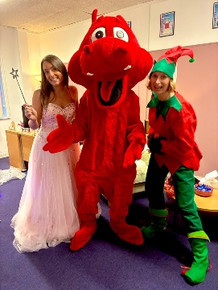
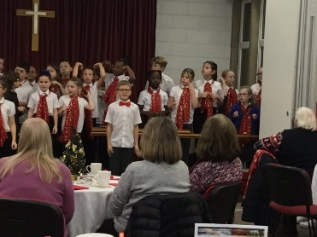
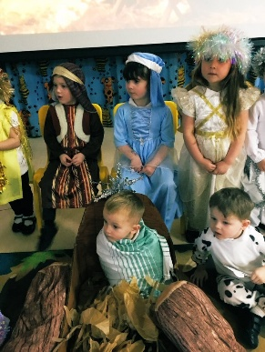
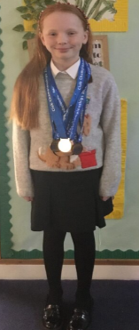
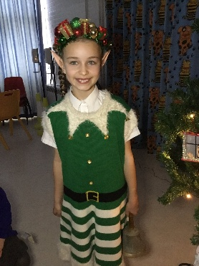
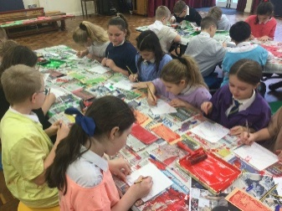


Celebration Assembly
This term we welcomed our year R children into celebration assembly.

Here are our names for our Celebration Assembly Golden Squirrel Stars:

EYFS: Roman, Henry, Madison, Emilie, Skye, Zoe, Finley, Seth, Phoebe, Ava, Archie, Summer, Piper, Freddy, Troy, Jaxxon, Sophia, Archie,
Year 1: Reehan, Darcey, George, Edgar, Olivia, Nola, Teo, Isla-Rose, Arlo, Daria, Luca, George, Samuel, Owan, Skylar, George, Rhys, Savannah,
Year 2: Sebastian, Ryan, Harley, Erin, Ben, Ellie, James, George, Louie, Archie, Harper, Lloyd, Bobby, Jacob, Lottie, Dexter, Rhys, Ruby, Maisie,
Year 3: Elana, Emma, Emily, Alfie, Josh, Phoebe, Vinnie, Sophia, Jensen, Ella, Josh, Charles, Ida, Ellie, Penny, Louisiana, Cleo, Annie,
Year 4: Jake, Sofia, Mia, Oscar, Parker, Jimmy, Zak, Ella, Kehinde, Elliyana, George, Benny, Harmony, Rome, Lyra, Grace, Alice, Carter
Year 5: Hudson, Alice, Oliwia, Owen, Isla, Millie, Savannah, Jasleen, Summer, Leo, Chase, Mila, Ian, Charlie, Amelia, Tiffany, Albie, Sophie, Toby, Ronnie, George,

Year 6: Lukas, Oliver, Marie, Isla, Lexie, Sianna, Ellie, Santiago, Sophie, Faye, Kristijanas, Mischa, Faith, George, Nelson, Matilda, Harley

Hot Chocolate Friday
Here are the names of the children who have been nominated for Hot Chocolate Friday this term: Jake, Scarlett, Logan, Archie, Victor, Oliver, Oliver, Jake, Charlotte, Kayden, Jack, Freddie, Jasraj, Mason, Troy, George, Isla, George, Amelia, Millie, Ella, Melah, Grace, Elana, Lennon, Perrie, Timothy, Harper, Jacob, Bella, Albie, Oliver, Ruby, Harrison, Laurice, Talia, Chloe, Niharika, Nevaeh, Eiden, Oliver, Maddox, Lennox, Orson, Grace, Isabelle, Bella, Toby, Elijah, Lillie, Jimmy, Fraser, Lilah, Bailey, Leilah, Sianna, Riley.

House Points
Each week we total up the house points throughout the school. We have some fantastic children in years 3 and 6 who have been busy putting their maths skills to the test to count up everyone’s points.
House Point Winners at the end of this term:
Year 4 – 6:
David Attenborough

Year R – 3:
Anthony Joshua



Jigsaw Update
Next term our Jigsaw topic will be 'Dreams and Goals'.
In this topic, children will discuss their hopes and dreams for the future both in school and outside of school. How we persevere to reach those goals by recognising and overcoming obstacles we may face on the way. Finally, celebrating our achievements and how success makes us feel. Children will be learning to work together as a team and understanding how to manage their feelings.
We know that with the pressure of Christmas things can be very difficult. We just want to remind you that if you require a food bank voucher, we can issue them here at Swingate. Please just ask to speak to Tina in the new year. Please know this is all kept strictly confidential. Please let us help you. #TeamSwingate

We hope everyone has an incredible Christmas break. Remember this time of year is not about what is under the tree but about those you spend it with and creating special memories. We hope you all get to have a nice time with your families. We look forward to seeing you on Monday 5th January.

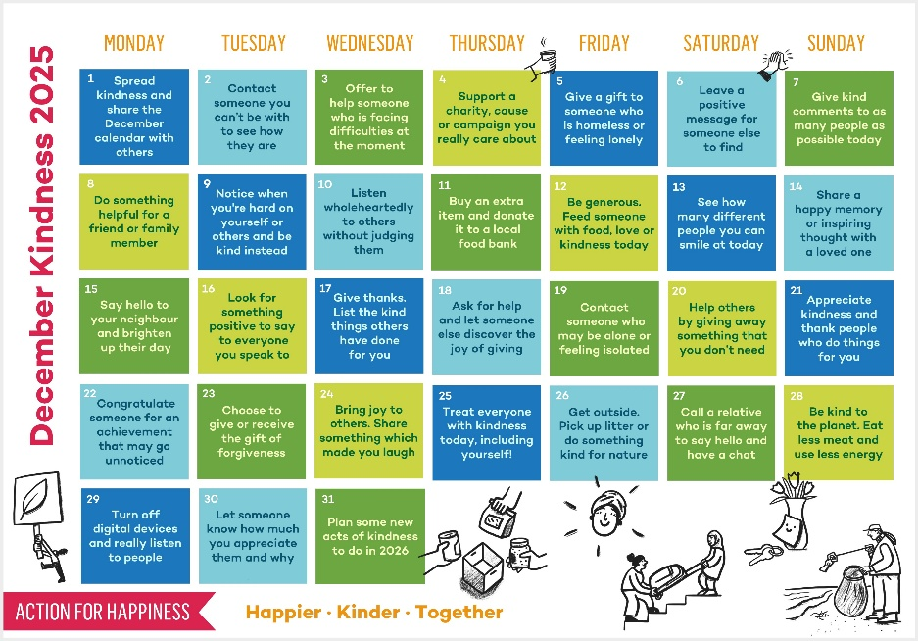


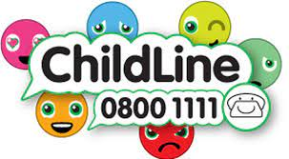
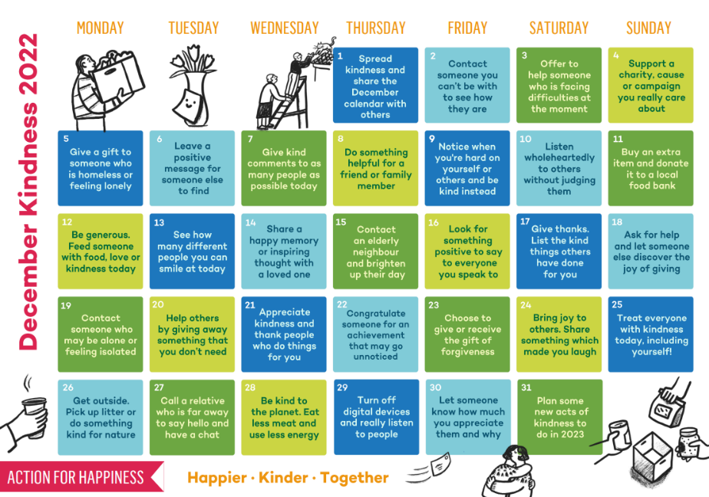
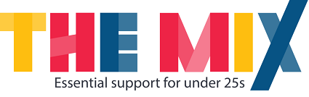

Support this Christmas
Please see information below about lots of great charities that can support if you are suffering with poor mental health or just need someone to talk to.
Childline is a counselling service for parents, children and young people.
Call: 0800 1111
childline.org.uk
We know December can be a tricky time of the year for many. There are lots of great mental health charities which can offer advice and support. Please take a look at a few of them above and remember to reach out if you feel you or someone you know needs help.
The Mix is the UKs leading supports service for young people. They are there to help you take on any challenge you may be facing.
Call: 0808 808 4994
themix.org.uk
YoungMinds provides young people with tools to look after their mental health. They also empower parents and adults who work with young people to be the best support they can be.
Text: YM to 85258
Call: 0808 802 5544
youngminds.org.uk
Samaritans supports those who are having a difficult time. They can also help you if you are worried about someone else.
Call: 116 123
samaritans.org
Mind supports people with mental health problems providing support and reliable information.
Call: 0300 123 3393
mind.org.uk

