
Learning Activities
Year 2019-20

Self-Isolation Learning Week 8
 | Topic Under the Sea—The Rainbow Fish | Additional comments
Monday | Reading- Read or watch on YouTube ‘The Rainbow Fish’ recap the story i.e. who are the main characters? Where is the setting? What has happened?  Think of some actions together to remind us of the story so we can tell someone else. Introduce story language. i.e. Once upon a time, One day etc  Writing: Draw a picture of the rainbow fish and write a description. i.e. He has shiny scales, he is beautiful etc  Maths: What sea creatures can you see? How many are there? How many do you have altogether?  https://themumeducates.com/wp-content/uploads/2018/03/rainbow-fish_addition_1.pdf  Phonics: Learn all about ‘air’ with Geraldine the Giraffe:  https://www.youtube.com/watch?v=NcHIX2xK--A  Practice writing the words: pair, hair, air, lair  Write the sentence: I have long red hair.  Art: To make own rainbow fish  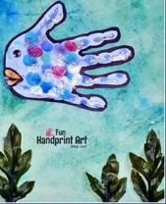  Imaginative play. Sharing toys with your mini-me/ with your toys at home –what does sharing mean?  Handwriting: Follow this link to practice the ‘curves to start cursive letters: q,o,e,s Focus on the leaving lines of the letters o and s, and the length of the tail on the letter q: https://www.teachhandwriting.co.uk/cursive-letters-beginners-choice-3.html  Construction: Make your own Fishpond for your Rainbow fish –you can use any construction toy that you have at home. | Join the daily Joe Wicks PE challenge on his YouTube challenge to burn some excess energy.  Or any of the Cosmic Kids Yoga Disco videos (these can be found on YouTube)  Daily reading – choose a story to read together as a family. Ask your child to find specific words (maybe words from their most recent word list) or read a page each. Talk about the pictures. Ask the children what they think will happen at the end before you reach the final pages.  Or you can use the Oxford Reading Tree website which has lots of free E-Books for you to share:  https://home.oxfordowl.co.uk/books/free-ebooks/  Handwriting practice:  https://www.teachhandwriting.co.uk/route-c-letter-choice-3-fs.html  So far in Reception we have practised all of the letter shapes. However, we have found the following letters have proved to be the trickiest:  g, y, j – because the tails loop over and go underneath the line  p, q, - because they need to go underneath the line.  h,b,d,k – because they are taller than the rest of the other letters  f – has proved to be the most difficult! Because it loops but is also tall AND long.  Dough disco: Early Years Emily on Youtube or Shontelle Bason do great videos.  Jigsaw Ask an adult to draw around you. This could be on a large piece of paper or outside. How many body parts can you label? i.e. head, eyes, ears, etc
Tuesday | Reading- Rainbow Fish-Draw some pictures to create a story map using the actions from yesterday and then use it to retell the story.  Writing: Begin to write the story of the Rainbow fish using ‘Once upon a time’ to start. (one or two sentences will be enough for each section)  Maths: How many sea creatures can you see? Would you have the same if you took them away?  https://themumeducates.com/wp-content/uploads/2018/03/rainbow-fish-addition-2.pdf  Phonics: Learn all about ‘ure’ with Geraldine the Giraffe:  https://www.youtube.com/watch?v=YwCzf71flBA  Find the digraph ‘ure’ in these words: pure, cure, endure.  Practice writing the tricky words: you, they, all, my, her.  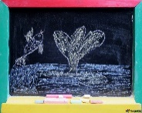  Art- Water and brushes, chalks, Draw your own Rainbow fish outside in the garden or on the pavement. Think about what colours you would need?  Imaginative play: Pretend to be a sea creature!  Handwriting: Follow this link to practice the ‘top exit’ cursive letters: r, v, w: https://www.teachhandwriting.co.uk/cursive-letters-beginners-choice-3.html  Construction: Can you make some fish from your Lego for your pond!
Wednesday | Reading: Using the selection of actions -can they remember what these ones are for?  Writing: Continue to develop the middle part of the story. Recap on yesterday and discuss what comes next ….  Maths: How many sea creatures do you have? How many would you have if you double the number?  https://themumeducates.com/wp-content/uploads/2018/03/Double-rainbow-fish.pdf  Phonics: Learn all about ‘er’ with Geraldine the Giraffe  https://www.youtube.com/watch?v=KK8_kUg3454  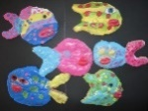  Can you find the ‘er’ in the following words: her, taller, faster, slower  Practice reading the sentence: The cat has a rat on her back.  Art: Playdough /Salt dough make and bake your own fish and then paint.  Imaginative play: Sea creature dress up. Using things in your house what sea creature can you be?  Handwriting: Follow this link to practice the ‘tunnel cursive letters: n, m, h, p, b, u: Focus on the height of h and b, as well as the length of the tail on the letter p. https://www.teachhandwriting.co.uk/cursive-letters-beginners-choice-3.html  Construction: Make a boat for your pond!
Thursday | Reading- A letter/email has arrived from the Rainbow fish explaining that she has lost her scales. Who could have taken them? What can we do?  Writing: Last part of the story now. Recap on what has been written already and then talk about the ending.  Math: How many sea creatures can you see? How many will you have if you take some away?  https://themumeducates.com/wp-content/uploads/2018/03/rainbow-fish-subtraction-1.pdf  Phonics: We have now practiced all the sounds in Phase 3! Well done everyone!  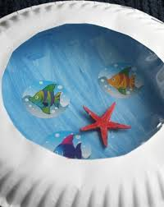  Practice all phase 2 and 3 sounds using the Flashcard Game on https://new.phonicsplay.co.uk/resources (you can sign up for a free account)  Can you write the following sentences (remembering finger spaces, capital letters and full stops):  I have a big hat.  The cat is on the mat.  It is hot in the sun.  Art- Porthole sea creature  Imaginative play: Playdough fish!  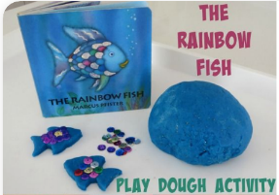  Handwriting: Follow this link to practice the ‘hooks, loops and lines’ cursive letters: j, y, f, k https://www.teachhandwriting.co.uk/cursive-letters-beginners-choice-3.html  Construction: Make a crab for your pond!
Friday | Reading- Recap What is the story telling us? Have a chat about the sharing aspect of the book and how it makes the Rainbow fish feel when he eventually shares his scales.  Writing: Writing a friendship scale, what makes a good friend?  Maths: Can you make your own number challenge? Will you add, take away or double?  Phonics: Sing along to the tricky word song: https://www.youtube.com/watch?v=R087lYrRpgY Can you practice writing the words after you have listened to the song? You could challenge your child to put some of these words into a sentence!  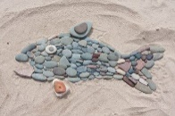  Art: Create a fish sculpture with stones from your garden  Imaginative play: Free choice  Handwriting: Follow this link to practice the ‘straight line’ cursive  letters: i, l, t, x, z. Focus on how tall l and t should be in comparison to the other letters: https://www.teachhandwriting.co.uk/cursive-letters-beginners-choice-3.html  Construction: Make an octopus!

Learning Activities
Year 2019-20

self-isolation learning Week 9
 | Topic Under the Sea—Tiddler the story telling fish | Additional comments
Monday | Reading- We are going to look at Alliteration this week which means when words start with the same sound i.e. crusty crab, swimming seal etc. What creatures can you think of that live under the sea? What words can you use to describe them that start with the same sound?  Read or listen to on YouTube the book ‘Tiddler’ by Julia Donaldson can they remember some words that started with the same letter? i.e. Diving with a dolphin, swimming round a ship wreck…  Writing: Using their sounds can they make a list of the animals they have seen.  Maths: Learn and sing along to the days of the week song.  https://www.youtube.com/watch?v=mXMofxtDPUQ  What happens to Tiddler on Monday? Can you draw a picture of Tiddler and his friends? How many sea creatures have you drawn?  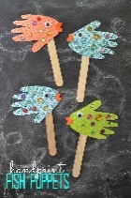  Phonics: Practice blending with this song: https://www.youtube.com/watch?v=qWn-qxUddqo Challenge your child to write the following words from the song: queen, ink, up, fish, jog, goat, hen. You could also ask the children to put their sound buttons in to check if there are any digraphs or just phonemes in each word!  Art: This week we can make a selection of puppets to retell the story  with our Family on Friday . Today make Tiddler.  He looks a bit like this:  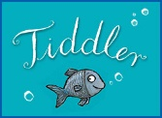  Imaginative play: Think about how you are going to make your puppet show. May be practise with toys you have already.  Handwriting: Follow this link to practice the ‘curves to start cursive letters: c,a,d,g Focus on how tall d should be and long the tail is on the letter g: https://www.teachhandwriting.co.uk/cursive-letters-beginners-choice-3.html  Construction: What under the sea creatures can you create from Lego or Duplo?  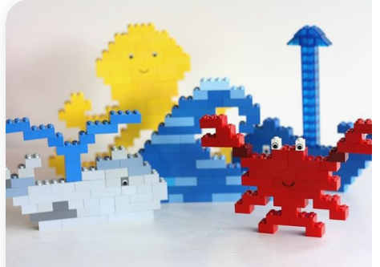 | Daily reading – choose a story to read together as a family. Ask your child to find specific words (maybe words from their most recent word list) or read a page each. Talk about the pictures. Ask the children what they think will happen at the end, before you reach the final pages.  Or you can use the Oxford Reading Tree website which has lots of free E-Books for you to share: https://home.oxfordowl.co.uk/books/free-ebooks/  Handwriting practice:  https://www.teachhandwriting.co.uk/route-c-letter-choice-3-fs.html  So far in Reception we have practised all of the letter shapes. However, we have found the following letters have proved to be the trickiest:  g, y, j – because the tails loop over and go underneath the line  p, q, - because they need to go underneath the line.  h,b,d,k – because they are taller than the rest of the other letters  f – has provied to be the most difficult! Because it loops but is also tall AND long.  Dough disco: Early Years Emily on Youtube or Shontelle Bason do great videos.  Join the daily Joe Wicks PE challenge on his YouTube challenge to burn some excess energy.  Or any of the Cosmic Kids Yoga Disco videos (these can be found on YouTube)  Jigsaw  https://www.youtube.com/watch?v=UxnEuj1c0sw  Watch the keeping healthy clip and draw a picture of all the ways you can keep healthy
Tuesday | Reading: Revisit story and choose a favourite character, why do you like this character? What is it that makes it special for you?  Writing: Draw your character and give him an Alliterative name: i.e. Silly shark. Scary Squid.  Maths: https://www.youtube.com/watch?v=mXMofxtDPUQ Do you like this song? Have you found a better days of the week song? What day comes after Monday? What happened to Tiddler on that day? How many legs does the squid have? Can you draw a squid with that many legs?  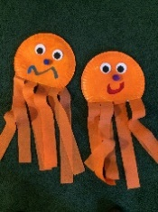  Phonics: This is the phase 4 tricky words song (your child will have heard this song before/seen these words on their word lists): https://www.youtube.com/watch?v=3NOzgR1ANc4 Play Pick a Picture on Phonics Play. You can choose which level you think is most appropriate or work through them all if you are feeling super clever! This will help with your segmenting and blending, as well as recognising the digraphs we have learnt: https://new.phonicsplay.co.uk/resources/phase/3/pick-a-picture  Art: Continue to make your puppets … do not forget to colour both  sides as you will be swimming them back and forth.  Imaginative play: Continue to prep your ‘puppet stage’ you may  want to draw a picture to remind you what you want it to look like.  Handwriting: Follow this link to practice the ‘curves to start cursive letters: q,o,e,s Focus on the leaving lines of the letters o and s, and the length of the tail on the letter q: https://www.teachhandwriting.co.uk/cursive-letters-beginners-choice-3.html  Construction: Can you create your own boat for yourself to sit in?  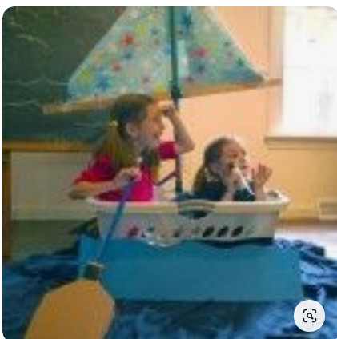
Wednesday | Reading: Recap the story …what was Tiddler doing? What excuses was he giving about not going to school on time?  Writing: If you were late what excuse would you make up for your teacher? This can be as silly as you like...  Maths: Pick a days of the week song to sing. What day comes after Tuesday? What happened to Tiddler on this day? How many fishermen were on the boat? How many seagulls were there? How many altogether?  Phonics: Join in with this CVC blending song: https://www.youtube.com/watch?v=OJWJx0ILwV8 Choose a picture and sentence matching activity for your child to try. Start with Phase 2 if Phase 3 seems a little tricky to begin with.  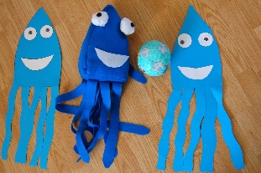  Art: Carry on with those puppets. Make sure you look  at how you are going to work them.  Imaginative play: Have you used a chair or a  small table to create your Puppet theatre. You may need some blue things to represent the sea. If you have created a picture may be colour it in so you have an idea of some of the things you may need.  Handwriting: Follow this link to practice the ‘top exit’ cursive letters: r, v, w: https://www.teachhandwriting.co.uk/cursive-letters-beginners-choice-3.html  Construction: Can you create a boat out of any construction toy you might have at home? Does it float? What toys fit inside your boat?
Thursday | Reading: Pick a character and create a story around it, for example: How many brothers and sisters do they have? What are their names? I.e. Crusty Crab has a brother Crunchy Crab and a sister Colourful Crab.  Writing: Draw pictures and write the story you have just created.  Maths: Take a look at the song all about time  https://www.youtube.com/watch?v=RBvmO7NgUp0 What did Tiddler do at half past three? What is your favourite time of day and why? Draw a picture.  Phonics: The children love this one: https://www.youtube.com/watch?v=36IBDpTRVNE Beware of the pronunciation of the letter ‘z’! Ask the children to write the following words (use their sound mat to help them to find the correct digraphs to use): fish, chip, ring, queen, goat, rain. You can challenge them by dictating a sentence with the word in: I have a ring on.  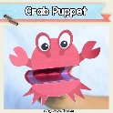  Art: Carry on with those puppets. You should nearly have all your  characters now.  Imaginative play: Have a practise of your play. Have you worked out your voices you might want to use? Who is going to be your audience?  Handwriting: Follow this link to practice the ‘tunnel cursive letters: n, m, h, p, b, u: Focus on the height of h and b, as well as the length of the tail on the letter p. https://www.teachhandwriting.co.uk/cursive-letters-beginners-choice-3.html  Construction: Build a fleet of ships for your toys to go sailing in.
Friday | Reading: Recap over the whole story what did you like? What didn’t you like?  Writing: Write a little review of the story using the ideas you have already voiced … Remember to use your word mat and your word lists to help you.  Maths: Look again at your favourite days of the week song Can you make a diary for the week. What day will you start from? What day will come last? What is your favourite day of the week?  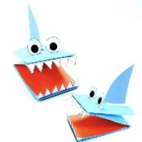  Phonics: Relisten to your child’s favourite phonics song this week.  Play Sentence Substitute on Phonics Play: https://new.phonicsplay.co.uk/resources/phase/3/sentence-substitution-ph3 Change the sentence and ask your child to read it to you. Who can make the funniest sentence?  Art: Finish all your puppets put on all your final decorations…  Imaginative play: Production day!!! Do your Puppet show and maybe Mummy or Daddy can video and upload it to Twitter? It will be fantastic.  Handwriting: Follow this link to practice the ‘hooks, loops and lines’ cursive letters: j, y, f, k https://www.teachhandwriting.co.uk/cursive-letters-beginners-choice-3.html  Construction: Free choice today!

