
Learning Activities
Year 2019-20

Self-Isolation Learning Week 5
 | Lessons set | Additional comments
Monday | Reading- Aliens Love Underpants-by Claire Freedman and Ben Court Read book or watch on you tube this funny story. What did you like about it?  https://www.youtube.com/watch?v=HWbSrmuyptw  Writing: What pair of pants are your favourites, Draw a picture and say why you like them. Don’t forget to use your sound mat.  Maths: Match the pants together. How many do you have altogether?  https://www.twinkl.es/resource/t-t-3564-aliens-love-underpants-matching-pants-activity  Phonics: Help Geraldine the Giraffe learn the ‘ai’ sound.  We have practiced this digraph before at school: https://www.youtube.com/watch?v=LnXaN-CvR9s  Can you practice writing the following words that use ‘ai’: rain, nail, tail, wait  Can you write the following sentence: A rat has a long tail.  Art- Draw a pair of underpants and colour a pattern cut out and do again in adifferent pattern . continue till you have a few pairs  Imaginative play. Put a pair of underpants on your head and pretend to be an alien. Can you make up your own alien words? What would you do if you were an alien?  Handwriting: Follow this link to practice the ‘hooks, loops and lines’ cursive letters: j, y, f, k (these are the trickiest ones!)  https://www.teachhandwriting.co.uk/cursive-letters-beginners-choice-3.html  Construction: Make a flying Alien –draw an alien on a balloon and then attach some toilet tissue streamers blow up and let go!!!! If you don’t have a balloon, can you make an alien in a different way? | Join the daily Joe Wicks PE challenge on his YouTube challenge to burn some excess energy.  Or any of the Cosmic Kids Yoga Disco videos (these can be found on YouTube)  Daily reading – choose a story to read together as a family. Ask your child to find specific words (maybe words from their most recent word list) or read a page each. Talk about the pictures. Ask the children what they think will happen at the end, before you reach the final pages.  Or you can use the Oxford Reading Tree website which has lots of free E-Books for you to share:  https://home.oxfordowl.co.uk/books/free-ebooks/  Handwriting practice:  https://www.teachhandwriting.co.uk/route-c-letter-choice-3-fs.html  So far in Reception we have practised all of the letter shapes. However, we have found the following letters have proved to be the trickiest:  g, y, j – because the tails loop over and go underneath the line  p, q, - because they need to go underneath the line.  h,b,d,k – because they are taller than the rest of the other letters  f – has proved to be the most difficult! Because it loops but is also tall AND long.  Dough disco: Early Years Emily on Youtube or Shontelle Bason do great videos.
Tuesday | Reading- Look again at the book which Alien is your favourite and why?  Writing: Draw your favourite Alien and write about it. Why is he your favourite? What does he look like? What is he wearing? How many eyes does he have? Oes he have long wiggly arms? What sounds can you use?  Maths: Make your own space number line. Here are some ideas  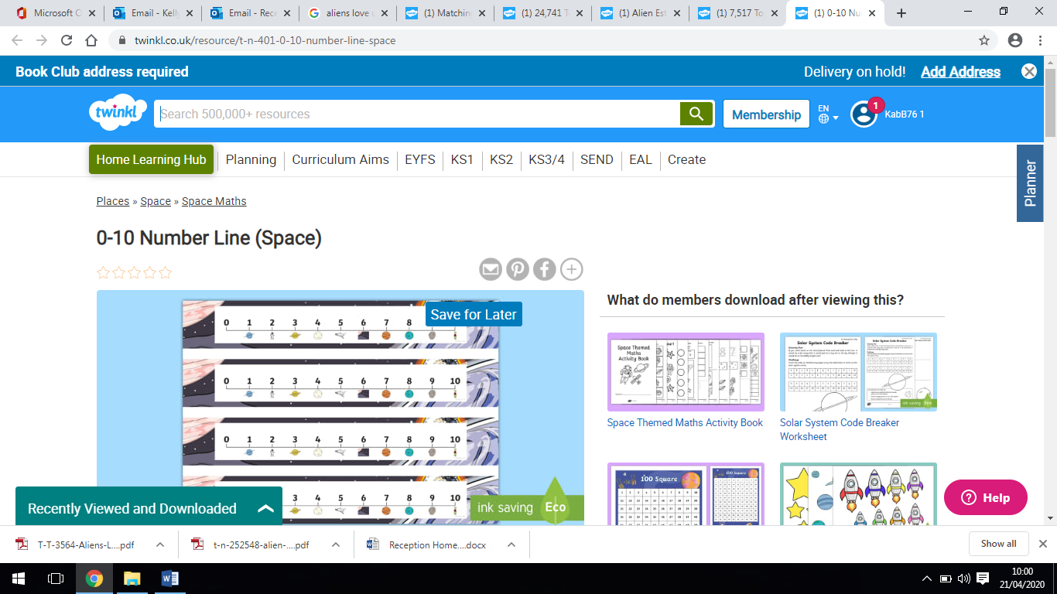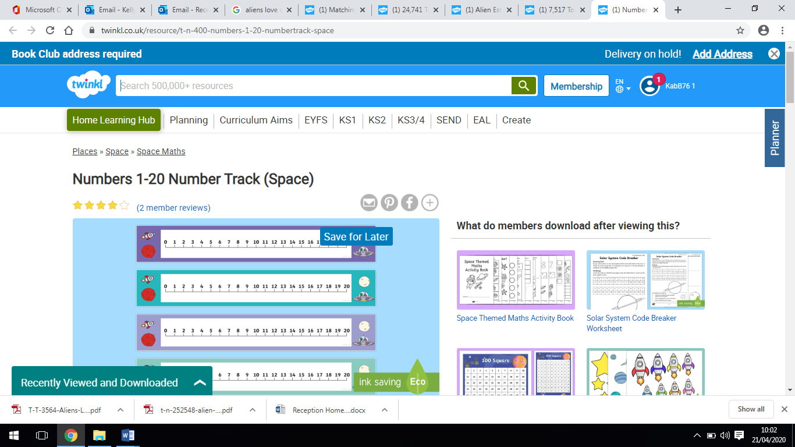  Phonics: Help Geraldine the Giraffe learn the ‘ee’ sound.  We have practiced this digraph before at school:  https://www.youtube.com/watch?v=qfM7Hz7US0U  Can you practice writing the following words that use ‘ai’ and put the sound buttons in the correct place? seen, bee, peel, feed  Can you write the following sentence: The bee has six legs.  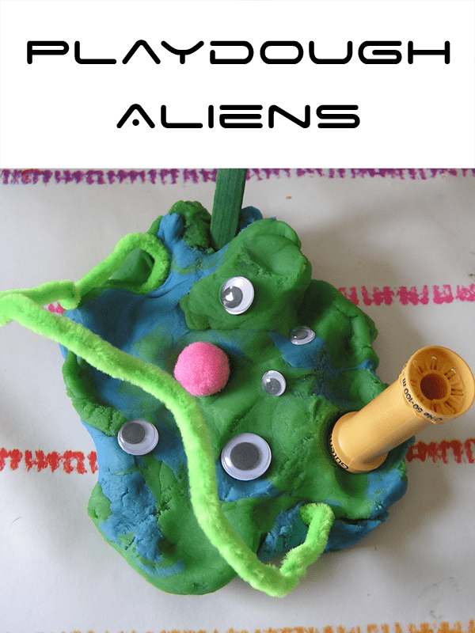  Art- Create your owm Alien use playdough and add things like cotton buds for arms and strange eyes using pasta or create with apaper cup or on paper. If you don’t have these things, be as creative as you can with the things in your house.  Imaginative play: Set up an Alien planet using your own toys. What are your planets called? Do they move? Are they hot or cold?  Handwriting: Follow this link to practice the ‘straight line’ cursive  letters: i, l, t, x, z. Focus on how tall l and t should be in comparison to the other letters: https://www.teachhandwriting.co.uk/cursive-letters-beginners-choice-3.html  Construction: Make a paper aeroplane. How far does it go? How big is your aeroplane?
Wednesday | Reading: Can you retell the story to your alien friend. What words from the story can you use?  Writing: Design your own Alien friend! What is his name and super power?  Maths: Can you find the missing number? Use your space number line to help you?  https://www.twinkl.co.uk/resource/t-n-252548-alien-pants-missing-number-line  Phonics: Help Geraldine the Giraffe learn the ‘igh’ sound. This is a trigraph where 3 letters are pushed together to make one sound.  We have practiced this trigraph before at school:  https://www.youtube.com/watch?v=OYCR2RZ4ZYY  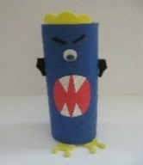  Can you practice reading the following words: light, night, high, fight  Talk to the children about where the ‘igh’ is in the words you have practiced reading. Is the trigraph at the beginning, middle or end?  Art: Make an Alien out of a toilet roll tube  Imaginative play: Free choice – If you could go anywhere or be anything what would it be? Don’t forget to show us!  Handwriting: Follow this link to practice the ‘curves to start cursive letters: c,a,d,g Focus on how tall d should be and long the tail is on the letter g: https://www.teachhandwriting.co.uk/cursive-letters-beginners-choice-3.html  Construction: Make an alien spaceship out of lego or any building blocks you have. How tall is it? Can you explain how you made it so someone else can try and make it?
Thursday | Reading- Look at the book and describe Aliens from the book to someone else in your house. Can you guess which one? Can we guess which one it is? How do you know?  Writing: Guess Who? Describe Alien and draw a picture with a flap so someone has to guess which one it is.  Maths:  https://www.twinkl.co.uk/resource/t-t-6318-aliens-love-underpants-alien-counting-activity  Phonics: Help Geraldine the Giraffe learn the ‘oa’ sound.  https://www.youtube.com/watch?v=KCJyHN0IFE8  Can you practice writing the following words: boat, coat, oat, soap  Can you write the sentence: I went on a big boat  Art- Draw some planets and add some aliens to stick on. By drawing and cuttng out.  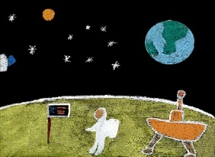  Imaginative play; Create your own puppets draw cut out and stick to spoons to make up your own story.  Handwriting: Follow this link to practice the ‘curves to start cursive letters: q,o,e,s Focus on the leaving lines of the letters o and s, and the length of the tail on the letter q: https://www.teachhandwriting.co.uk/cursive-letters-beginners-choice-3.html  Construction: Free choice What can you build? How tall will it be? What does it do? Show us what it is. Can you add labels?
Friday | Reading- Re-cap on the whole story. Which bit was your favourite? Why?  Writing: Write a letter to the Aliens asking them to leave the underpants alone!! We will all get cold bottoms is one good reason. What other reasons can you tell them?  Maths:  https://www.twinkl.co.uk/resource/t-t-7513-aliens-love-underpants-counting-worksheet to 10 or download higher ability for a challenge  Phonics: Practice the sounds that you have been learning this week: ai, ee, igh, oa.  Practice writing the following words: rain, bee, high, boat  Can the children find the different digraphs/trigraph in these words?  Practice writing the phase 3 high frequency words: they, my, all, are, her  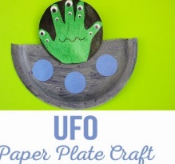  Art- Hand Alien in a space ship  Imaginative play: Free choice  Handwriting: Follow this link to practice the ‘top exit’ cursive letters: r, v, w: https://www.teachhandwriting.co.uk/cursive-letters-beginners-choice-3.html  Construction: Anything space related. Early years is all about using your imagination. If you went on a journey to space what would you see? What would it look like up there? What would you go in? Use these questions to help you think about what to construct.

Learning Activities
Year 2019-20

self-isolation learning Week 6
 | Lessons set – Space Theme PLANETS | Additional comments
Monday | Reading- Looking at any factual books what is different to a story book and talk about the contents page etc. and how you find out facts? What is a fact book? Why is it different to other books? What fact books have you got in the house?  https://www.youtube.com/watch?v=U3J-HHD7ggQ  Watch this video of the book ‘Me and My place in Space by Joan Sweeney’ It tells us lots of information about space and the planets and there are lots of new words. What do you find out about the planets?  Listen to the Planet song on you tube: https://www.youtube.com/watch?v=BZ-qLUIj_A0  Writing: Draw the planets and write the names – don’t forget to use those sound mats  Maths: Can you count the objects?  https://www.twinkl.co.uk/resource/t-n-2546512-space-aliens-counting-poster  Now make your own counting poster  Phonics: Help Geraldine the Giraffe learn the short ‘oo’ sound.  https://www.youtube.com/watch?v=-3UUnmNk1UM  Can you practice writing the following words: book, hood, cook, took  Read the following sentence: I took the cookbook to the park.  Art- Can you paint the night sky this could be a backdrop for the planets.  Imaginative play: Free choice – Maybe you are living on one of the planets?  Handwriting: Follow this link to practice the ‘tunnel cursive letters: n, m, h, p, b, u: Focus on the height of h and b, as well as the length of the tail on the letter p. https://www.teachhandwriting.co.uk/cursive-letters-beginners-choice-3.html  Construction: Make some air tanks for an Astronaut 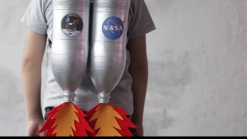 | Daily reading – choose a story to read together as a family. Ask your child to find specific words (maybe words from their most recent word list) or read a page each. Talk about the pictures. Ask the children what they think will happen at the end, before you reach the final pages.  Or you can use the Oxford Reading Tree website which has lots of free E-Books for you to share: https://home.oxfordowl.co.uk/books/free-ebooks/  Handwriting practice:  https://www.teachhandwriting.co.uk/route-c-letter-choice-3-fs.html  So far in Reception we have practised all of the letter shapes. However, we have found the following letters have proved to be the trickiest:  g, y, j – because the tails loop over and go underneath the line  p, q, - because they need to go underneath the line.  h,b,d,k – because they are taller than the rest of the other letters  f – has provied to be the most difficult! Because it loops but is also tall AND long.  Dough disco: Early Years Emily on Youtube or Shontelle Bason do great videos.  Join the daily Joe Wicks PE challenge on his YouTube challenge to burn some excess energy.  Or any of the Cosmic Kids Yoga Disco videos (these can be found on YouTube)
Tuesday | Reading: Have you got a planet/space book? If not look on YouTube Storyville The solar system.  Writing: Choose a planet and write a fact. Can you form your letters correctly? What sounds can you use?  Maths: Can you solve the problems to find the correct colour?  https://www.twinkl.co.uk/resource/t-n-603-space-addition-and-subtraction-puzzle-0-10  https://www.twinkl.co.uk/resource/t-n-604-space-addition-and-subtraction-puzzle-0-20  Phonics: Help Geraldine the Giraffe learn the long ‘oo’ sound.  https://www.youtube.com/watch?v=atlb2jPdFd0  Can you practice writing the following words: moon, spoon, room, loo  Can you write the sentence: I can see lots of room on the moon.  Art- Draw and collage your planet and cut it out ready for your night sky picture  Imaginative play: Free choice  Handwriting: Follow this link to practice the ‘hooks, loops and lines’ cursive letters: j, y, f, k https://www.teachhandwriting.co.uk/cursive-letters-beginners-choice-3.html  Construction: Make a console/control panel for a rocket 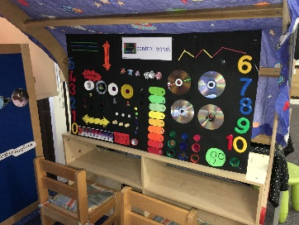 This is what ours would look like if we were at school! What will yours look like?
Wednesday | Reading- Find a fact? Use a book to find a fact … Use the contents page together.  Writing: Choose another planet and write a fact.  Maths: Can you make 10?  https://www.twinkl.co.uk/resource/t-n-1149-mixed-number-bonds-to-10-on-robots-worksheet  Phonics: Help Geraldine the Giraffe learn the ‘ar’ sound.  https://www.youtube.com/watch?v=QXBQDsgRuMo  Can you practice writing the following words: park, car, art, barn  Can you write the sentence: We went to the park in the car.  Art- Draw and collage your planet and cut out as yesterday  Imaginative play: Can you create a space station at home? What instructions will give during take-off? Can you count down?  Handwriting: Follow this link to practice the ‘straight line’ cursive  letters: i, l, t, x, z. Focus on how tall l and t should be in comparison to the other letters: https://www.teachhandwriting.co.uk/cursive-letters-beginners-choice-3.html  Construction: Make a space station
Thursday | Reading: Look at how many new words you have learnt. Can you find them in your book? Could be planet names or words like Glossary or Contents  Writing: Choose another planet and write a fact.  Maths: How many do you have?  https://www.twinkl.co.uk/resource/t-t-6587-space-themed-addition-sheet  Phonics: Help Geraldine the Giraffe learn the ‘or’ sound.  https://www.youtube.com/watch?v=Fm9PRHDJlv4  Can you practice writing the following words: fork, for, born, lord, or  Can the children put the sound buttons in these words and talk about where the ‘or’ sound is in each word.  Art- Draw and collage your planet ready for your picture  Imaginative play: Free choice/space station  Handwriting: Follow this link to practice the ‘curves to start cursive letters: c,a,d,g Focus on how tall d should be and long the tail is on the letter g: https://www.teachhandwriting.co.uk/cursive-letters-beginners-choice-3.html  Construction: Make an Alien mask - maybe a Martian?
Friday | Reading: Compare a factual book to a Story book what one do you like best?  Writing: Choose another planet and write a fact.  Maths: Roll, add and colour  https://www.twinkl.co.uk/resource/t-t-1009-space-roll-and-colour-dice-addition-activity  Phonics: Go over the sounds that you have practiced this week: oo (long), oo (short), ar, or. Write down the following words on strips of paper or post it notes and ask the children to find the digraph in each word: book, zoom, park, fork. Can they make up a sentence with each word in? Can they challenge themselves to write one of the sentences down?  Art- Draw and collage your planet ready for your picture  Imaginative play: Free choice – Can you use your space station to go on an exciting adventure? Where will you go? What will you see? Is it a bumpy journey? Do you get there safely? Does something happen on your journey?  Handwriting: Follow this link to practice the ‘curves to start cursive letters: q,o,e,s Focus on the leaving lines of the letters o and s, and the length of the tail on the letter q: https://www.teachhandwriting.co.uk/cursive-letters-beginners-choice-3.html  Construction: Create a moonscape with any construction you have

