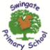

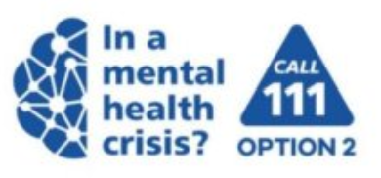


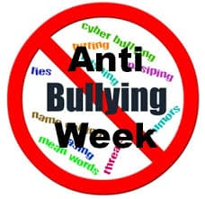
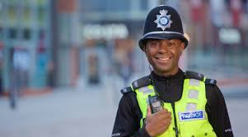
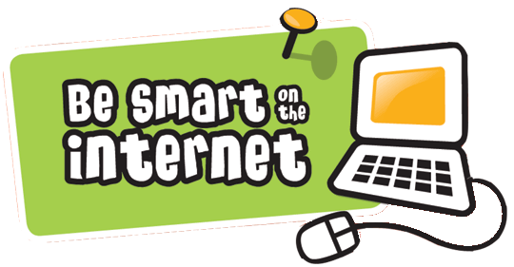
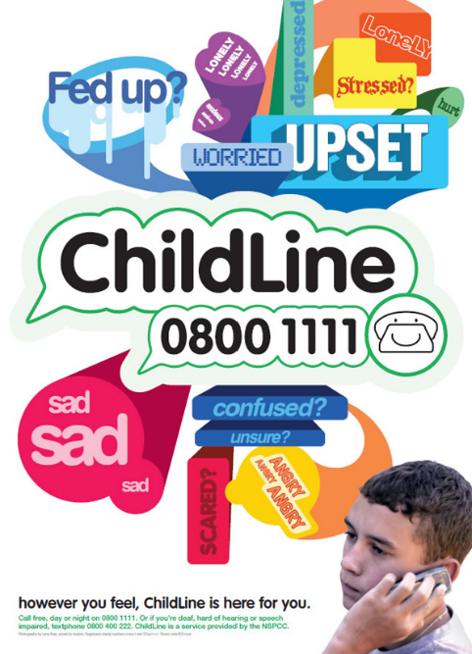

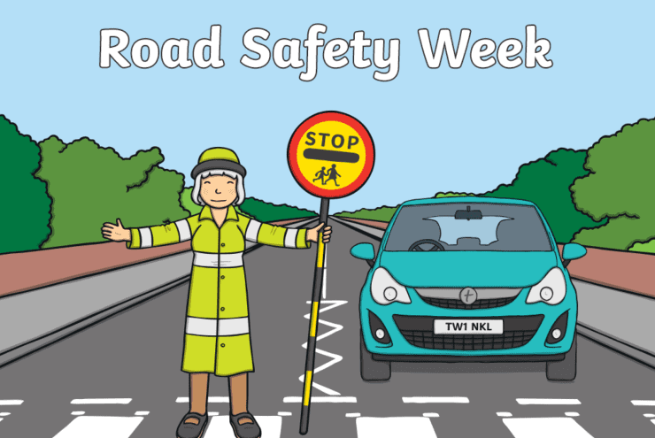
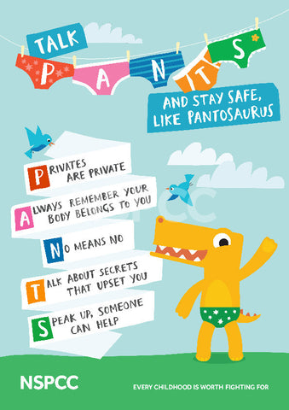

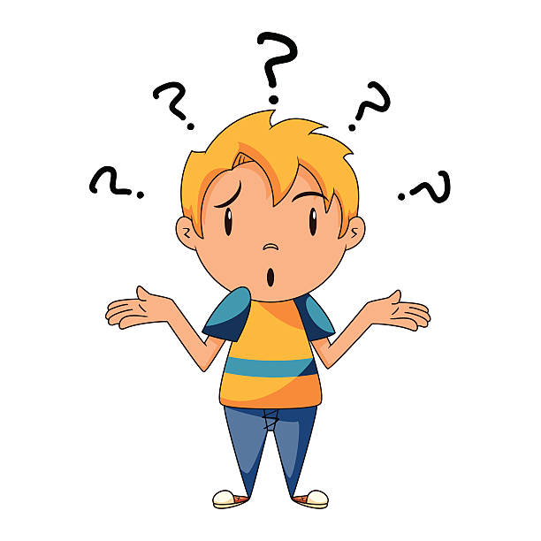
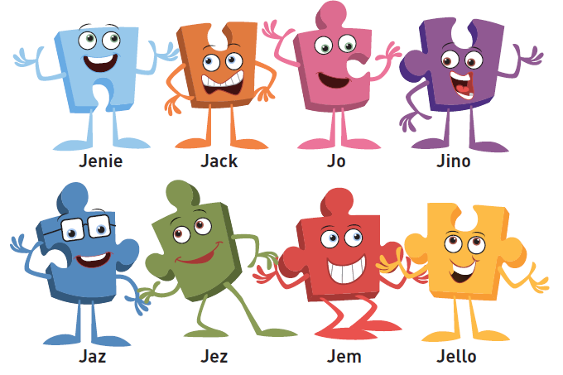
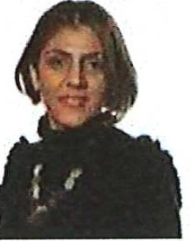


The police keep us safe in and out of school.
9
9
9
We have learnt how to be safe on the internet!

We can call Childline if we need help.

We have learnt how to be safe when crossing the roads!
We have learnt what to do if we think we are being bullied.

How do I stay safe?
We have been reading the Pantosaurus book and know how to keep our bodies safe. We know what the NSPCC does to help us.

Our JIGSAW friends keep us safe. They help us share our worries, help us to express ourselves and teach us how to be safe online and with others.

All of the adults in school are here to keep is safe. These adults make sure that our concerns are listened to so we get the help we need.

