

Mental Health First Aiders
For Youths

Tina Babraa & Penny Davies

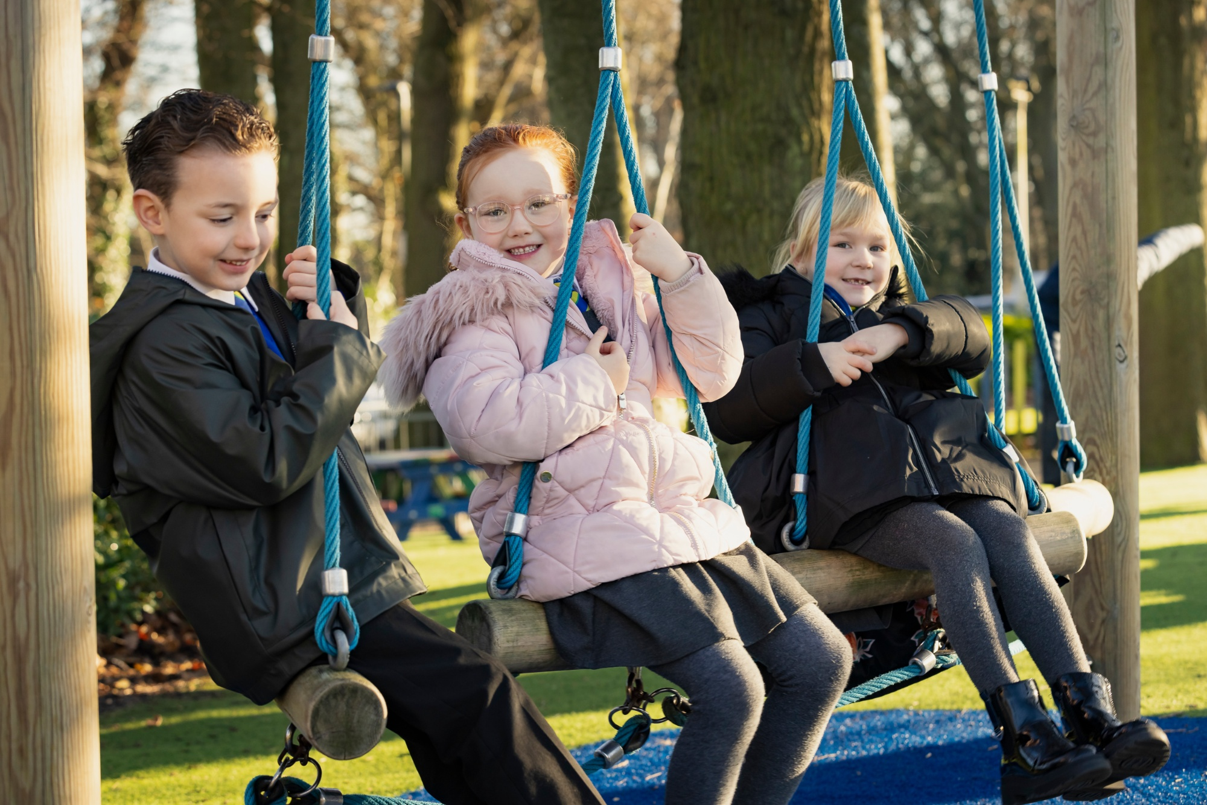

What support do we have in school for children?
- Emotional Literacy Support Assistant (ELSA) is able for children through a referral system made to SLT and the SENCO.
- Pastoral Manager works closely with children to support with concerns or worries in and out of school who can also signpost to outside agencies and charities.
- Mental Health First Aiders work with children across the school as well as staff.
- Jigsaw PSHE with a mindfulness approach to help and calm children as well as giving them an outlet to talk about thoughts and feelings.
- Counsellor who works on site to support individuals across the school.
- SENCO and SEND Team to support SEND and vulnerable children.
- Four DSLs who work across the school to further safeguard and support children and their families.

What support do we have in school for staff?
- SLT are available to speak with you regarding any concerns or queries you have and will always and offer advice or discuss options that are available.
- Supervision is available on a termly basis for all staff. This is on a first come first served basis.
- Care First is available for all staff to use and is private and confidential.

What do Youth Mental Health First Aiders do?
• Spot the early signs of a mental health problem in young people
• Develop confidence helping a young person experiencing a problem
• Provide help on a first aid basis
• Help protect a young person who might be at risk of harm
• Help prevent a mental health illness from getting worse
• Help a young person recover faster
• Guide a young person towards the right support
• Reduce the stigma of mental health problems

What can we all do to support our young children and their mental health?

Why do we have Mental Health First Aiders at Swingate?
- 20% of children and young people aged 8 – 25 years have a mental health condition
- Approximately 63% of mental health conditions develop before the age of 25
- 561 people between the ages of 10–24 died by suicide in 2022 in England and Wales
- 20% of children aged 10–15 years in England and Wales have experienced cyberbullying
- About 18% of students aged 12—17 report self-harming at some point in their life
At Swingate we recognise that there is a number of young people who are struggling. We understand that there are a number of pressures on young people from academics, social media, bullying, poverty, lack of availability of professional mental health support which is contributing to poor mental health problems in young people.
At Swingate our values of Academic, Physical and Emotional Success mean that we understand that children need to have all 3 things in order to succeed.
Who are our Mental Health First Aiders at Swingate?


Tina Babraa Penny Davies
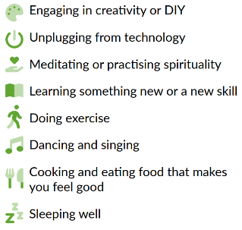
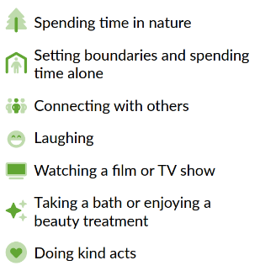
Look after your own wellbeing. Recognise what you need to do to keep yourself healthy. Recognising when you are experiencing poor mental health or having a tough day will impact on your own roles and it will be harder to be empathetic which puts people you are supporting at risk.

Keep up to date with safeguarding training. Speak to DSLs across the school when you have concerns and raise these on CPOMs so that we can all work together to identify concerns so actions can be put in place. Knowing where to signpost can positively impact on individuals’ situations.

