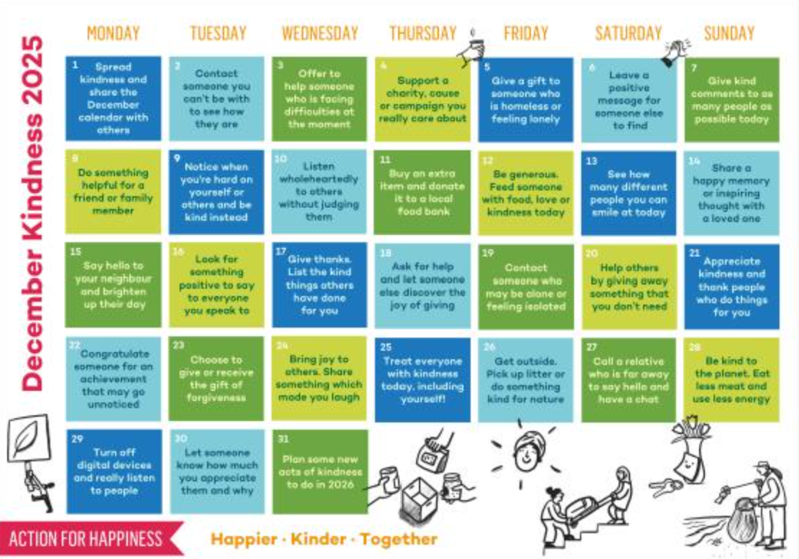
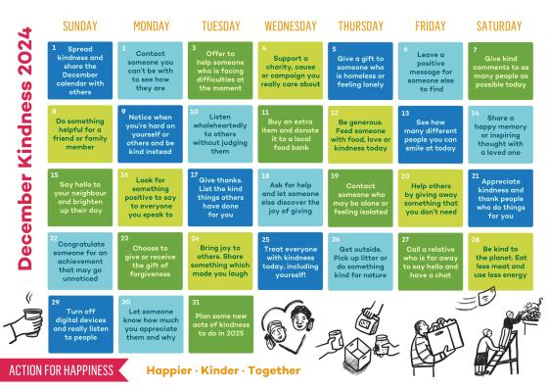
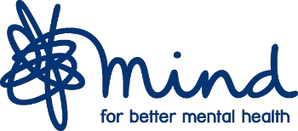

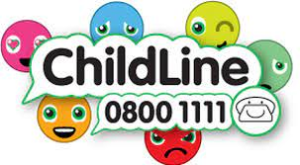
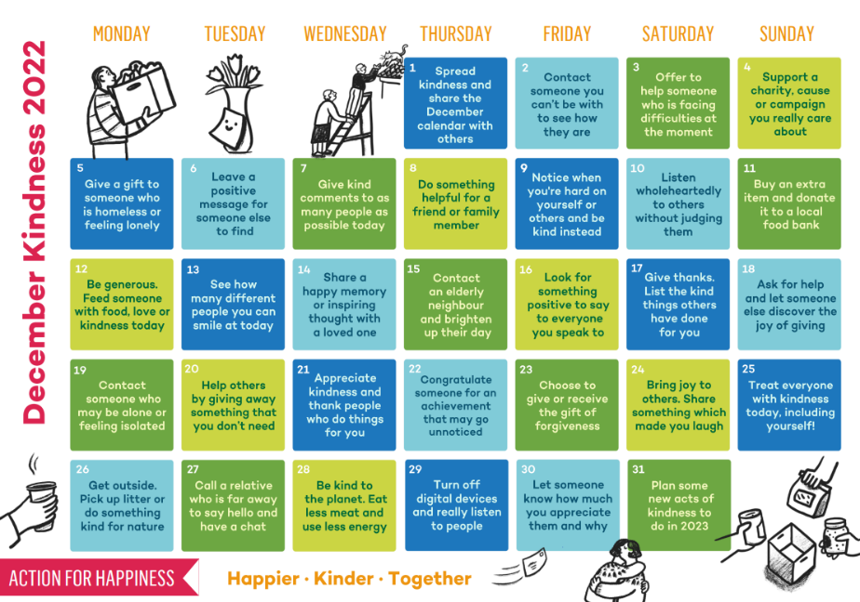
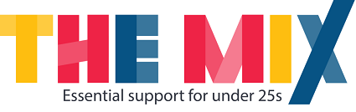

Please see information below about lots of great charities that can support if you are suffering with poor mental health or just need someone to talk to.
Childline is a counselling service for parents, children and young people.
Call: 0800 1111
childline.org.uk
We know December can be a tricky time of the year for many. There are lots of great mental health charities which can offer advice and support. Please take a look at a few of them above and remember to reach out if you feel you or someone you know needs help.
The Mix is the UKs leading supports service for young people. They are there to help you take on any challenge you may be facing.
Call: 0808 808 4994
themix.org.uk
YoungMinds provides young people with tools to look after their mental health. They also empower parents and adults who work with young people to be the best support they can be.
Text: YM to 85258
Call: 0808 802 5544
youngminds.org.uk
Samaritans supports those who are having a difficult time. They can also help you if you are worried about someone else.
Call: 116 123
samaritans.org
Mind supports people with mental health problems providing support and reliable information.
Call: 0300 123 3393
mind.org.uk

