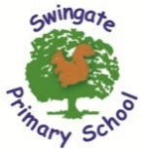



Swingate Primary School
FS2 Newsletter Term 2

October 2025

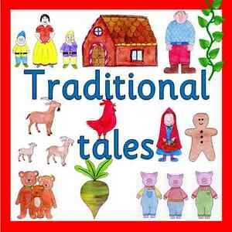
Welcome back! We hope you have had a wonderful Autumn half term break and are ready for a busy but exciting new term. We will be looking at a selection of well known ‘Traditional Tales’ such as Goldilocks and the Three Bears, as well as some alternatives such as ‘Goldilocks and the Three Crocodiles’.

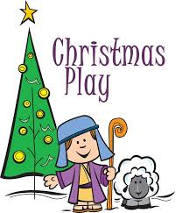
As the term is jam packed full of celebrations and religious festivals we will take the opportunity to look at some that are familiar to us, such as Bonfire Night and some that are not so familiar, like St Andrew’s Day.
Practise for the biggest highlight of the year, our wonderful ‘Nativity’ is soon to begin. Get ready for your children to come home singing many new festive songs. Further information regarding the ‘Christmas Play’ will follow in due course.

All the children have enjoyed changing for their first PE lesson back this term and they did an amazing job. To continue to develop their independence can we ask that the children are encouraged to dress themselves and learn to put on their own coats, as well as, doing up the zips. We know that buttons and zips are tricky but with practice they will get quicker. If your child hasn’t yet brought in their PE kit can we ask that this is in school by Tuesday 4th November 2025.

Balanceablity sessions will start this term, all children will have sessions with a dedicated Balanceablitly instructor. Please ensure your child comes to school with labelled gloves so they can take part when it gets cold.

Reading Books
Now the children are enjoying many opportunities to read in school both independently, in small groups and with an adult could we please ask that all books are placed back into child’s bags for the following school day. This will ensure that all books are available to exchange on our library day and allow reading with an adult to take place regularly. There will be rewards and prizes for those children that do read at least four times a week at home so please take the time to listen to your child read and write this in their contact book.

We appreciate your continued support and look forward to sharing an exciting, fun filled term 2 with you and your children. Team Swingate J


Key Dates
10/11/25 Odd Socks Day
10/11/25 to 14/11/25 Anti-bullying Week
14/11/25 Children in Need Day
14/11/25 Flu Vaccinations
17/11/25 to 21/11/25 Nursery Rhyme Week
27/11/25 Fire Safety Talks
03/12/25 Height and Weight check
05/12/25 SCC Christmas Switch On
10/12/25 The Nativity
12/12/25 Santa Visit
12/12/25 Parent Book look in Class – 14.50pm
15/12/25 to 19/12/25 Christmas Jumpers can be worn with uniform
19/12/25 Last Day of Term

