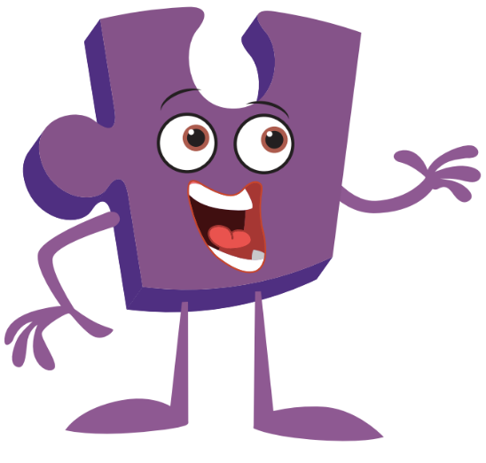
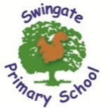
Year 3 Newsletter

Term 2

Welcome back to another term in Year 3 alongside Jigsaw Jino! We hope you have all enjoyed your half term and we are excited for what this term has to offer.

Home Learning:
In Year 3, each child is expected to read 4 times a week. This needs to be recorded in their contact book and signed by an adult.
They are also expected to complete 10 sessions of TTRS Rockstars each week by Friday morning. Please let us know in advance if there are any IT issues.
Likewise, 5 sessions of Spelling Shed are to be completed by Friday too.
Important Dates for Term 2:
5th November – Kent Life Trip
7th November – SCC Cake Sale
W/C 10th November – Anti Bullying Week
10th November – Odd Socks Day
5th December – SCC Christmas Switch On
W/C 15th December – Christmas Jumper Week
W/C 15th December – Book Fayre
17th December – Swingate Christmas Dinner
Foundation Subjects:
We have a whole host of exciting topics to cover this term. In History we are studying the Ancient Egyptians. Science has us exploring Forces. Renowned British artist David Hockney is our artist of the term as we look to replicate pop art style landscapes and in Jigsaw we will be Celebrating Differences. For PE, we are doing focusing on our throwing and catching. The children are required to come into school in their PE kits for their PE day. This will be a Monday for Quokkas, Tuesday for Llamas and on Wednesday for Sloths.
Foundation Subjects:
This term in English we will be exploring texts such as “Perfectly Norman” and “How to Wash a Woolly Mammoth” as well as “The Magic Box”. With Maths, we are looking at Addition and Subtraction alongside Multiplication and Division. We will be delving into the story of “The Girl Who Saved Christmas” in SLOR, focusing on inferencing, retrieval and word meaning.

