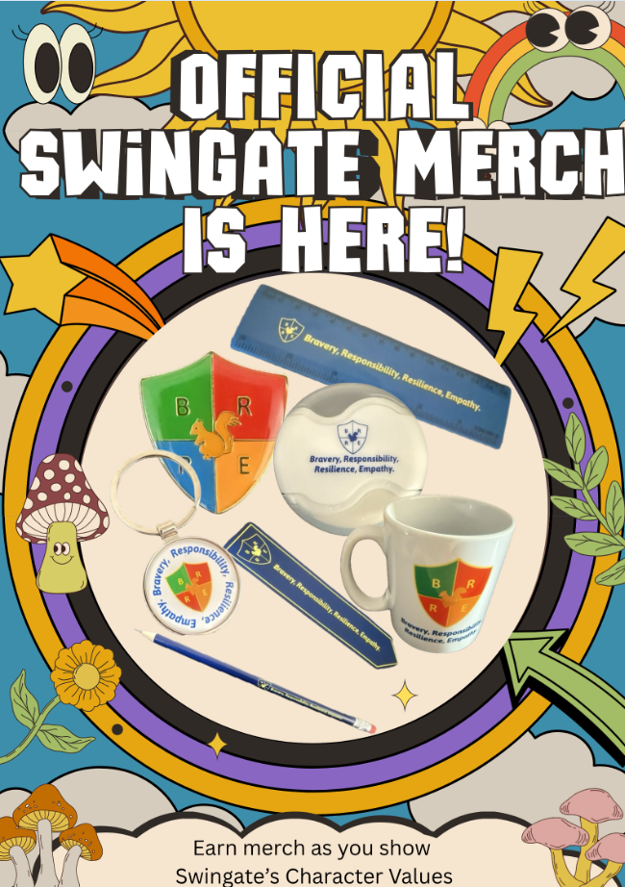
IMPORTANT ANNOUNCEMENT
Keep reading to find out more…


By Mrs Davies

Celebrations
Term 1 – What a fantastic term we have had!

It is hard to believe that we have only been back 1 term. We have welcomed so many new faces. Our new EYFS children have settled in so quickly and are getting used to life at Swingate. Our nursery children are enjoying their time in Rainbows too.
Celebration assemblies have taken place this term and it has been great to see the children collect their Golden Squirrel awards. We have had so much to celebrate this term. The children and staff have been working extremely hard over the last 7 weeks and the number of different rewards being given just shows how fantastic our children are. The children have been collecting: House Points, Hot Chocolate Friday letters, Golden Squirrel certificates, Top Table nominations, Attendance Meerkat as well as our new merch…carry on reading to see what this is!

We are looking forward to Year R joining us for assemblies after half term.
Round up of the term…
Year R enjoyed going pumpkin picking and invited in their grown-ups in today to help them carve them…they looked incredible this afternoon!

Today some children went in the school minibus to the Science Awards over in Sandwich with Miss Thompson. We can’t wait to hear how it all went!

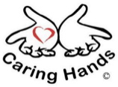
Our Harvest celebrations left us feeling very wholesome – a big well done to years 1 and 3 for the shows they put on. Caring Hands were overwhelmed with all the food which you supplied. Thank you for your generous contributions.

Reading certificates were given out this term with lots of children receiving books from our book vending machine – we have enjoyed our ‘Spin the Wheel’ in assemblies to find out the winners!

This term children chose their School Counsellors as well as other new roles across the school. Well done to everyone chosen and good luck in your new important jobs!

There was a positive buzz across the school this week as lots of grown-ups came to speak to the teachers about their children’s progress. Thank you for attending these meetings so that we can work with you to support your child.

We understand that this term has been particularly tough for our Year 6 pupils as they’ve awaited their Medway and Kent test results. It’s important for every child to remember that with determination and effort, they can achieve anything they set their minds to. Secondary schools are fortunate to welcome Swingate students! 😊


Celebration Assembly
Here are our names for our Celebration Assembly Golden Squirrel Stars:
Year 1: Lux, Eddie, Joshua, Henry, Lylah, Jack, Amiyah-Rose, Hallie, Arabella, Hunter, Phoebe, Rachael, Lois, Jack, Elliot, Sofie, Evie, Sienna, Riley, Isabelle, Ada.
Year 2: Vienna, Mya-Rose, Melah, Nicholas, Lydon, Myla-Grace, Isabella, Rafael, Delilah, Cami, Blake, Charlie, Ivy, Anaia, Xavier, Cade, Orson, Ruby, Isaac, Annie.
Year 3: Tabitha, Finnley, Hudson, Benjamin, Lola, Hayden, Cleopatra, Elsie, Harley, Louisiana, Isabelle, Michael, Bella, Ethan, Freya, Sophia, Llama, Ho Kiu, Oliver, Cruz, Oliver, Teddy.

Year 4: Gemma, Emily, Francesca, Raife, Owen, Elija, Tomiwa, Charlie, Amelia, Timothy, Mia, Perrie, Brody, George, Elia-Grace, Archie, Harlie, Taiwo, Olivia, Mailey, Flynn, Toby, Hudson,
Year 5: Oliver, Ellie, Scott, Sienna, Freddie, Nora, Ava, Izzy, Louie, Mary, Albie, Betsy, Sophie, Holly, Leyton, Max, Albie, Louis, Emilia, Poppy, Ella
Year 6: Leilah, Maicey, Tucker, Oliver, Jack, Asia, Albert, Delilah, Amelia, Ronnie, Alfie, Aaliyah, Fraser, Kacie, Nancy, Amelia, Ever-Lyn, Louie, Jensen, Daisy


Hot Chocolate Friday
Mrs Clarke has been giving the children their hot chocolate every Friday. We hope the children have enjoyed getting their letters of recognition in the post.
Here are the names of the children who have been nominated for Hot Chocolate Friday this term: Eliza, Athena, Elliyana, Carter, Flynn, Georgie, Savannah, Millie, Enaissa, Ruby, Ellie, Mason, Fraser, Lola, Karis, Bobby, Tommy, Cleo, Charlie, Esme, Zac, Capability, Charlie, Tommy, Albie, Tiffany, Bodhi, Darcie, Owen, George, Mischa, Blake, Brody, Laker, Rory, Isla-Rose, Olivia, Rosie, Rhona, Adam, Tabitha, Zara, Milena, Martin, Jack, Madeleine-Rose, Oliwia, Jodie, Nia, Lauren, Jessica, Austin, Harvey, Evie, Mason, Savanna, Jack, Arthur, Mila, Sophie, Taliah, Jacob.

House Points
Each week we total up the house points throughout the school. We have some fantastic children in years 3 and 6 who have been busy putting their maths skills to the test to count up everyone’s points. Here are the winning houses:
KS1 Winners: Anthony Joshua KS2 Winners: Alex Scott

EYFS
Finally, I wanted to finish my newsletter by telling everyone about how incredible our new Reception and Nursery children have been. There have been lots of confident goodbyes. We know it can be hard for both children and grown-ups to wave goodbye in the morning. You have all shown bravery and resilience. This certificate below is for all of our Reception and Nursery children. Cut along the dotted line and stick it to your fridge!

SWINGATE STAR AWARD

Well done for completing your first term at Swingate Primary School
17.10.25 Mrs Davies

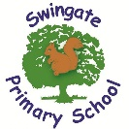

We hope you have a lovely half term. We look forward to seeing you on Tuesday 28th October 2025

Celebrating Positive Behaviour at Swingate!
This term, we launched our exciting new Behaviour Merch initiative! Children will continue to earn their Character Value badges whenever they show Bravery, Resilience, Responsibility, and Empathy.
Once they’ve collected their badge, they’ll work towards earning exclusive merch by collecting all four character value stickers again. It’s a fun and motivating way to celebrate the amazing attitudes we see every day at Swingate!
Take a look at the poster to see how the merch builds up throughout their time at Swingate Primary School — we’re so proud of how our pupils are rising to the challenge!

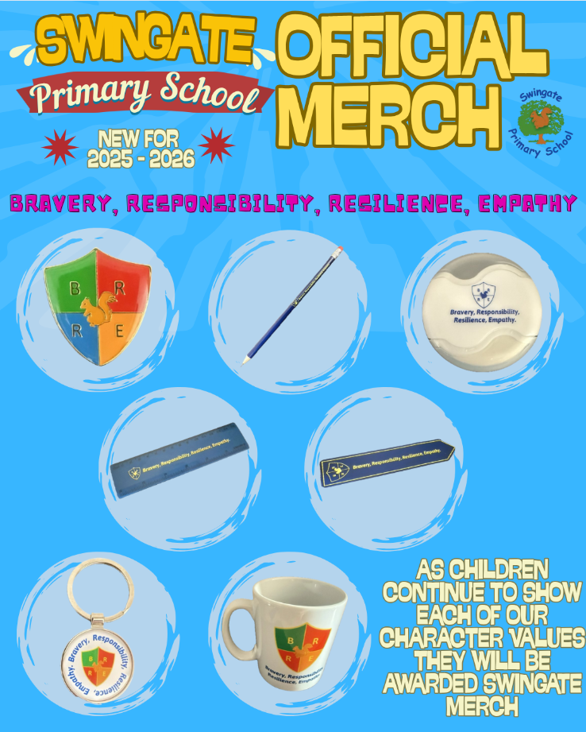
1. Badge 2. Pencil 3. Pencil/Sharpener 4. Ruler 5. Bookmark 6. Keyring 7. Mug

