
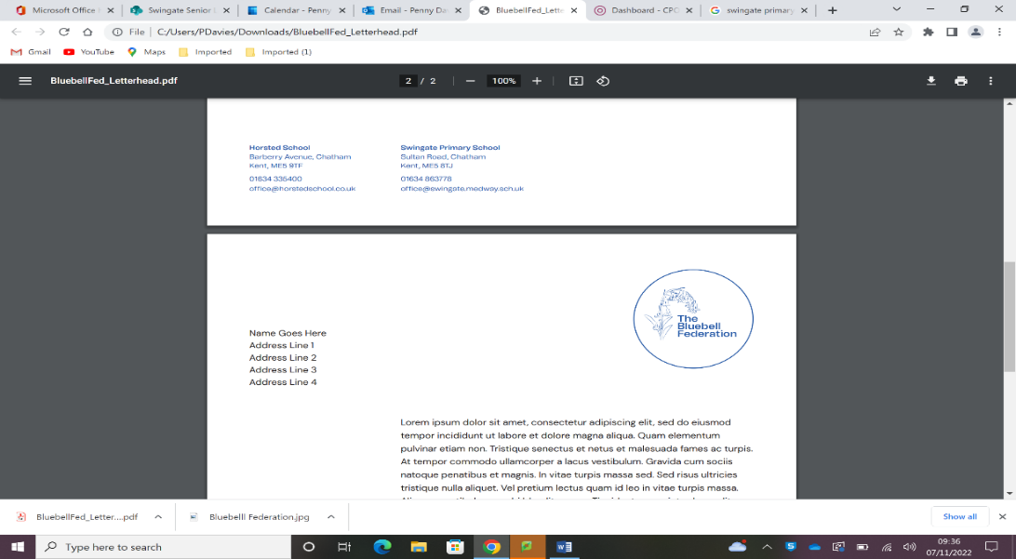
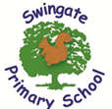
Reading in Foundation Stage
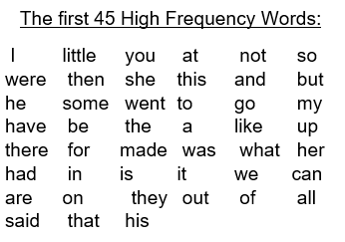

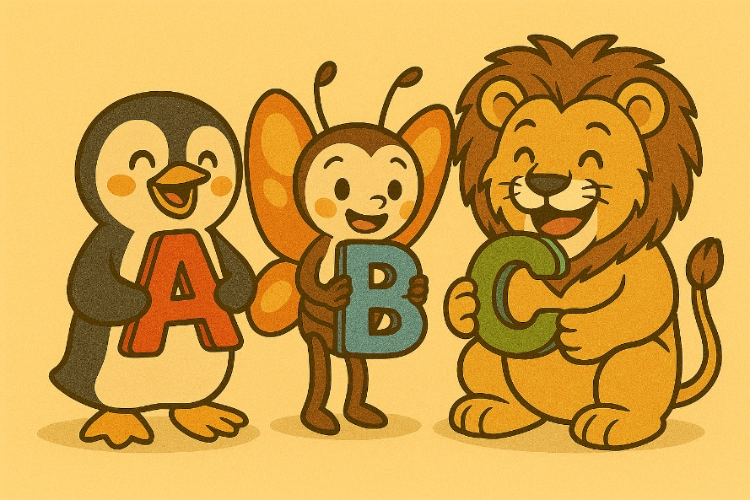
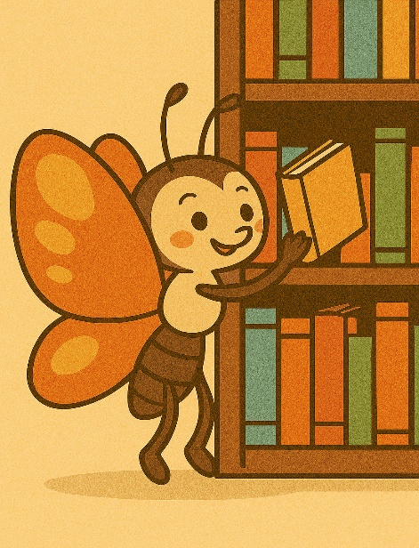
Making phonics and reading fun:
Reading isn’t always everyone’s favourite past time but here are a few ways to keep reading fun AND easily accessible.

- Read a story at bed time. Including reading in your daily routine will develop your child’s love of reading.
- Join the local library (it is free to do!)
- Read in a new place (under the bed does count!)
- Create a secret password for your child to read when they are leaving the house. This could be a high frequency word or a letter your child is learning.
- The BBC Alphablocks series have engaging 3-minute videos of the 26 letters. This is available on iPlayer.
- Playing with magnetic or foam letters and creating words out of playdough.

Teaching reading at Swingate Primary School:
We are very proud of our Guided Reading teaching and learning. Our reading lessons are called ‘SLOR’. This stands for Swingate’s Love of Reading. Here is how we will endeavour to support your child with learning how to read in Foundation Stage:
- SLOR is taught daily and your child will read a book from the PM Scheme.
- Repetition with young readers is key. This is why your child will read their PM book for 5 school days and bring it home to share with their families. This is share what they have learnt at school.
- Your child will read weekly 1-1 with the class Teaching Assistant.
- Your child’s reading contact book will be checked and their reading book changed regularly.
- Your child will have a weekly library slot where they will be encouraged to take a book home of their choice.
Learning how to read at home using phonics:
- At Swingate, we follow the phonics scheme called ‘All Aboard Phonics.’
- As part of the scheme, your child will have access to decodable books. This means that the words in the books can be sounded out using the letter sounds.
- All of the decodable books are available on an app which our parents and families will be able to access from home to support your child with reading. If you have any issues accessing the app, please speak to your child’s class teacher.
- There are some words that cannot be sounded out. These are called High Frequency Words. The first 45 HFW are listed below. We use the letter names to teach the spelling of HFW.
- Encourage your child to follow the words with their fingers – this helps them to keep track of what they are reading.
- Remember, it is okay for reading time to vary each day; a good 5 minutes is better than a difficult 15 minutes.

Supporting reading:
There are lots of activities that you can do at home that support young children to develop their reading and language skills:
- Singing nursery rhymes, counting songs and the alphabet.
- Listening to stories via audio books.
- Making up your own stories using pictures or books with no words in.
- Talking about what you can see around you such as road signs, shop names and letters in the environment.
- Drawing pictures and talking about them can turn into an amazing adventure story.
- Make time for conversation. The language that your child hears at home will form their own vocabulary and the way they communicate with others.

Getting interested in books:
Fostering a love of books when children are young is incredibly important. There are lots of simple ways that you can kick start this at home:
- Local libraries have a wide range of books and it is completely free to join.
- Let your child see you read. Even if you are not an avid reader, your child will be encouraged to pick up a book too just like their adults around them.
- Bedtime stories and making time for sharing a book is vital.
- Create a den and look at books with a torch.
- Read a book in a strange place (under the bed or in the bath is perfectly acceptable!)

