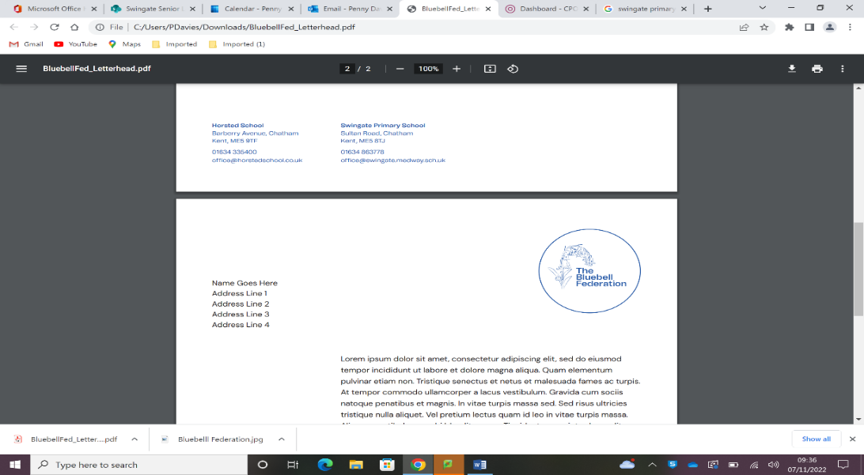
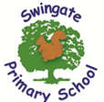
Reading in KS2
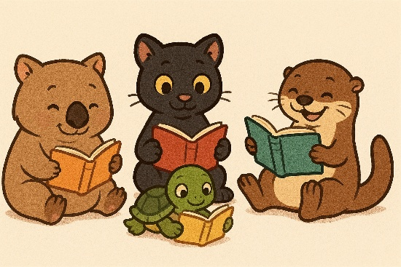
Choosing a book:
Inspire your child to read the blurb, read the first chapter and check out the front cover in detail before they choose a book. It is incredibly important for children to read what they love! Encourage your child to ask for a different book or choose another if they are not engaged with what they are reading.
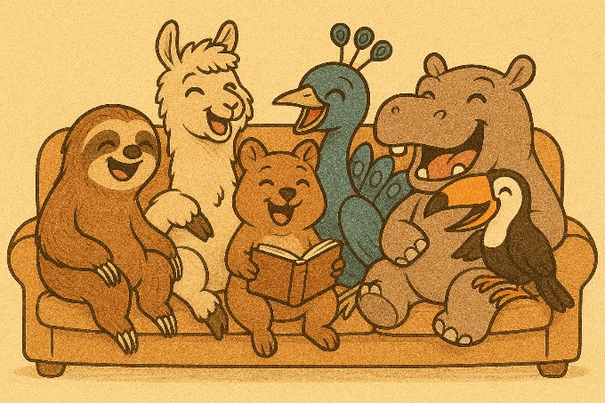
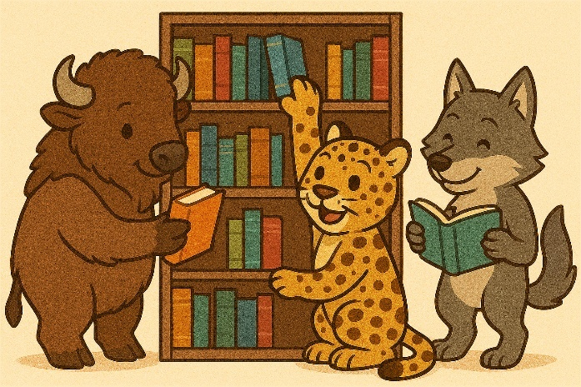
Making reading pleasurable:
Reading isn’t always everyone’s favourite past time but here are a few ways to keep reading fun AND easily accessible.
- Join the local library (this is free to do!)
- Create a reading challenge at home.
- Swap books with friends.
- Read in a new place (under the bed does count!)
- Read the synopsis before watching a film

After reading:
Here are a few examples of questions you could ask your child after reading:
- What was your favourite part of what you read today?
- What do you think might happen to this character?
- What do you think will happen in the next chapter?
- Who is your favourite character that you have met so far?
- Why do you think this character acted in this way?
Boost your child’s confidence in their own abilities with their expression and intonation. Tell them which section you enjoyed listening to the most if they read aloud to you.

Reading at home:
At Swingate, we expect children to read a minimum of 4 times per week at home. This needs to be recorded in the children’s Reading Record Book. Older children are welcome to record their own reading at home however this must still be acknowledged with a parent’s signature.
We understand that family life can be incredibly busy and that unforeseen circumstances cannot be helped. However, if a child continually does not read 4 times per week at home, they will read with an adult during Friday breaktime.

During reading:
Try not to interrupt your child when they are reading if they make a mistake. When they have reached an appropriate place to stop, ask them to re-read the sentence where the error was. If they repeat the error then offer them help. An example of help might be breaking an unknown word into its syllables, discussing what an unknown word might mean or asking them if what they read made sense.

