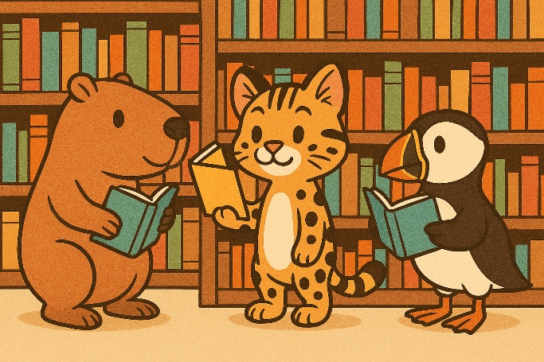
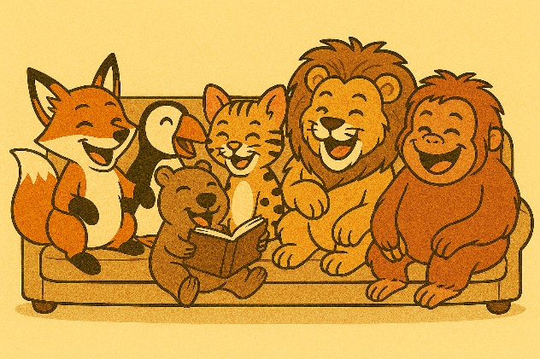
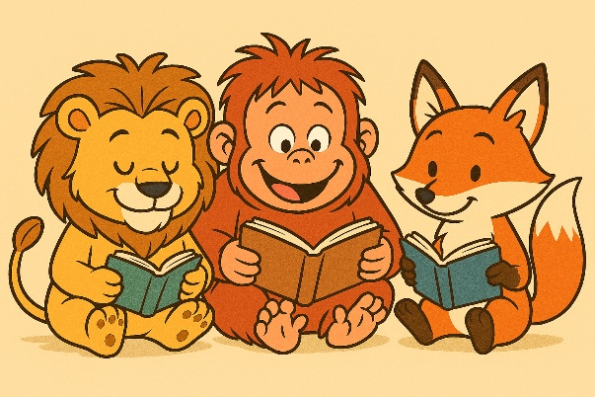
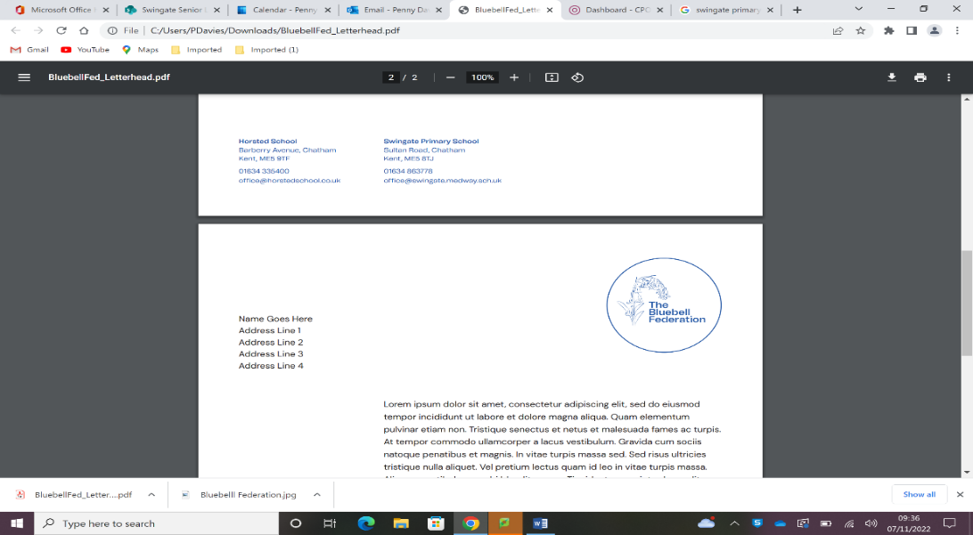

Reading in KS1
After reading:
Here are a few examples of questions you could ask your child after reading:
- What was your favourite part of what you read today?
- Tell me what (insert character’s name) did in this part of the story.
- How do you think (insert character’s name) is feeling?
- What do you think will happen next?

Boost your child’s confidence in their own abilities with their expression and intonation. Tell them which section you enjoyed listening to the most when they read aloud to you.

Reading at home:
At Swingate, we expect children to read a minimum of 4 times per week at home. This needs to be recorded in the children’s Reading Record Book. We understand that family life can be incredibly busy and that unforeseen circumstances cannot helped. However, if a child continually does not read 4 times per week at home, they will read with an adult during Friday breaktime.

Making reading pleasurable:
Reading isn’t always everyone’s favourite past time but here are a few ways to keep reading fun AND easily accessible.
- Join the local library (this is free to do!)
- Create a reading challenge at home.
- Swap books with friends.
- Read in a new place (under the bed does count!)
- Read comics, instructions and shopping lists.
- Read a story together at bed time.

During reading:
It is okay to offer help when your child is reading, some words are difficult to sound out and need to be learnt. Alternatively, you can break the word down into smaller chunks called syllables. Try not to interrupt your child when they are reading if they make a mistake. When they have reached an appropriate place to stop, ask them to re-read the sentence where the error was. If they repeat the error then offer them help. Encourage your child to follow the words with their fingers – this helps them to keep track of what they are reading. As they become more fluent and more confident you will find that the ‘reading finger’ will begin to disappear! It is okay for reading time to vary each day; a good 5 minutes is better than a difficult 15 minutes.
Choosing a book:
It is incredibly important for children to read what they love! Encourage your child to ask for a different book or choose another if they are not engaged with what they are reading. It is also okay if your child would like to re-read their favourite book – practise makes perfect!

