
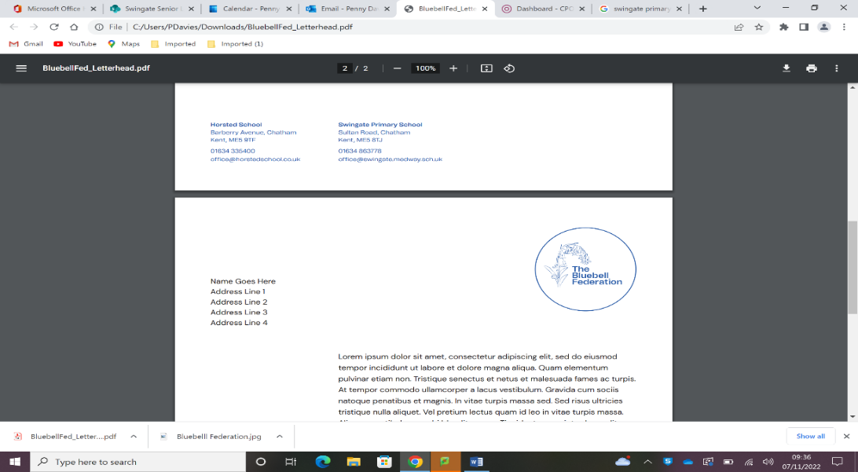
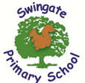
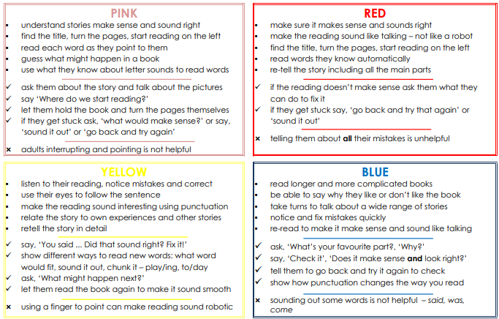
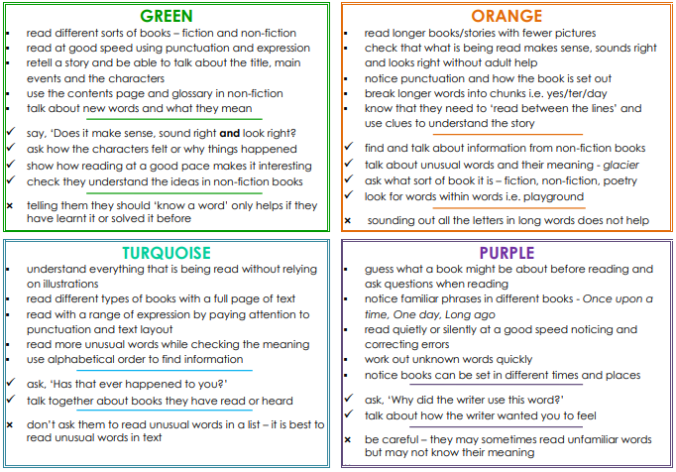
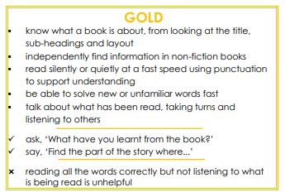
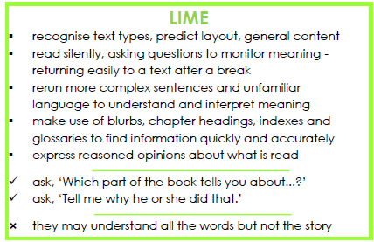
Book Bands at Swingate
Children may choose their own books to read
FREE READER 1
▪ Makes recommendations to other readers but may have a favourite author or series.
▪ Has the capability to read a wide range of genres such as myths, legends, traditional stories, comics, non-fiction and modern fiction
▪ identify and discuss themes, conventions and language across a range of books

✓ ask, ’Find more than one reason to support your opinion’
✓ ask, ‘Why would you recommend this book to others?’

 don’t assume that everything ‘read’ is understood

FREE READER 2
▪ Can read fluently and independently but adults may guide child to ‘easy read’ chapter books to continue to develop their confidence.
▪ May need some support understanding an unfamiliar word in the context of what they are currently reading.
▪ Can read longer texts and search for detailed information.
▪ Can summarise what they have read without retelling the entirety of the chapter.
▪ Beginning to access a wider range of texts but may feel comfortable re-reading books or those of a similar genre.
✓ ask, ‘What makes you think/feel…?’
✓ encourage them to ask questions as they read the text
 but don’t assume that answering questions means they understand the real meaning of the text

▪

