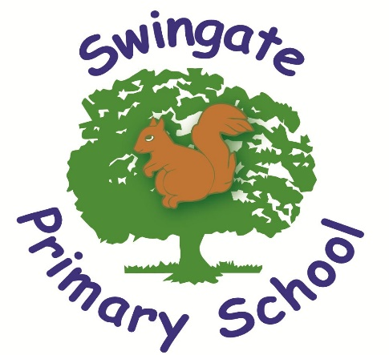

PRIVACY NOTICE

Review | Date | By
Last Reviewed | March 2023
Next Review | September 2025

Signed ………………………………………………………. Chair of Governors

Signed ………………………………………………………. Head of School/Executive Head
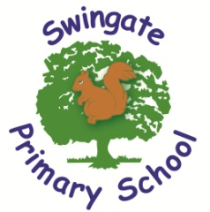

PRIVACY NOTICE
Agreed: March 2023
Review date: September 2025

How we use pupil information? Why do we collect and use pupil information

We collect and use pupil information under section 537A of the Education Act 1996, and section 83 of the Children Act 1989. We also comply with Article 6(1)(c) and Article 9(2)(b) of the General Data Protection Regulation (GDPR).

We use the pupil data:

- to support pupil learning
- to monitor and report on pupil progress
- to provide appropriate pastoral care
- to assess the quality of our services
- to comply with the law regarding data sharing
- to support you to decide what to do after you leave school

Categories of pupil information that we collect, hold and share include:

- Personal information (such as name, unique pupil number and contact details)
- Characteristics (such as ethnicity, language, nationality, country of birth and free school meal eligibility)
- Attendance information (such as sessions attended, number of absences and absence reasons)
- National curriculum assessment results
- Special educational needs information
- Relevant medical information

Collecting pupil information

Whilst the majority of pupil information you provide to us is mandatory, some of it is provided to us on a voluntary basis. In order to comply with the General Data Protection Regulation, we will inform you whether you are required to provide certain pupil information to us or if you have a choice in this.

Storing pupil information

Swingate Primary School keep information about you on computer systems and also sometimes on paper.
We hold your education records securely until you change school. Your records will then be transferred to your new school, where they will be retained until you reach the age of 25, after which they are safely destroyed.

There are strict controls on who can see your information. We will not share your data if you have advised us that you do not want it shared unless it is the only way we can make sure you stay safe and healthy or we are legally required to do so.

Who do we share pupil information with?

We routinely share pupil information with:

- schools or colleges that the pupils attend after leaving us
- our local authority (Medway Council) and their commissioned providers of local authority services
- the Department for Education (DfE)

Why we share pupil information

We do not share information about our pupils with anyone without consent unless the law and our policies allow us to do so.

We share pupils’ data with the Department for Education (DfE) on a statutory basis. This data sharing underpins school funding and educational attainment policy and monitoring.

To find out more about the data collection requirements placed on us by the DfE (for example; via the school census) go to https://www.gov.uk/education/data-collection-and-censuses-for-schools

We are required to share information about our pupils with our local authority (LA) and the Department for Education (DfE) under section 3 of The Education (Information About Individual Pupils) (England) Regulations 2013.

The National Pupil Database (NPD)

The NPD is owned and managed by the Department for Education and contains information about pupils in schools in England. It provides invaluable evidence on educational performance to inform independent research, as well as studies commissioned by the Department. It is held in electronic format for statistical purposes. This information is securely collected from a range of sources including schools, local authorities and awarding bodies.

We are required by law, to provide information about our pupils to the DfE as part of statutory data collections such as the school census and early years’ census. Some of this information is then stored in the NPD. The law that allows this is the Education (Information About Individual Pupils) (England) Regulations 2013.

To find out more about the pupil information we share with the department, for the purpose of data collections, go to https://www.gov.uk/education/data-collection-and-censuses-for-schools.

To find out more about the NPD, go to https://www.gov.uk/government/publications/national-pupil-database-user-guide-and-supporting-information.

The department may share information about our pupils from the NPD with third parties who promote the education or well-being of children in England by:

- conducting research or analysis
- producing statistics
- providing information, advice or guidance

The Department has robust processes in place to ensure the confidentiality of our data is maintained and there are stringent controls in place regarding access and use of the data. Decisions on whether DfE releases data to third parties are subject to a strict approval process and based on a detailed assessment of:

- who is requesting the data
- the purpose for which it is required
- the level and sensitivity of data requested: and
- the arrangements in place to store and handle the data

To be granted access to pupil information, organisations must comply with strict terms and conditions covering the confidentiality and handling of the data, security arrangements and retention and use of the data.

For more information about the department’s data sharing process, please visit:
https://www.gov.uk/data-protection-how-we-collect-and-share-research-data

For information about which organisations the department has provided pupil information, (and for which project), please visit the following website: https://www.gov.uk/government/publications/national-pupil-database-requests-received

Requesting access to your personal data

Under data protection legislation, parents and pupils have the right to request access to information about them that we hold. To make a request for your personal information, or be given access to your child’s educational record, contact the office@swingate.medway.sch.uk in the first instance. In the event of school holidays or weekends please contact dpo@swingate.medway.sch.uk.

You also have the right to:
- object to processing of personal data that is likely to cause, or is causing, damage or distress
- prevent processing for the purpose of direct marketing
- object to decisions being taken by automated means
- in certain circumstances, have inaccurate personal data rectified, blocked, erased or destroyed; and
- claim compensation for damages caused by a breach of the Data Protection regulations

If you have a concern about the way we are collecting or using your personal data, you should raise your concern with us in the first instance or directly to the Information Commissioner’s Office at https://ico.org.uk/concerns/

To contact DfE: https://www.gov.uk/contact-dfe
If you would like to discuss anything in this privacy notice, please contact:
Mr Matthew Wignell dpo@swingate.medway.sch.uk or 01634 863778 -Data Protection Officer

