

Year 1

Home Learning Term 6

English | Maths | Physical | Science | Creative
Write an acrostic poem for Winter, Spring, Summer and Autumn.  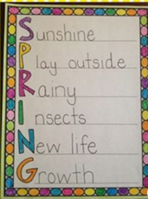 | Create a symmetrical butterfly picture. | Create an obstacle course in your garden. How long does it take you to complete it? Can you beat your time? | Find out which country has the most hours of sunshine in June and July. | Research planes. Then create your own paper planes using different designs. Which one flew the furthest? You may choose to make a small, medium and large paper plane.
The Wright brothers studied birds. Research how a bird flies. List what else can fly. | Create your own clock and learn to tell the time.  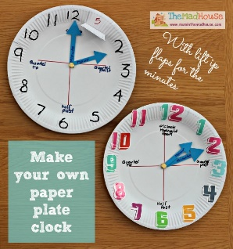 | Go for a walk around your local area. Look at the house numbers on each side. What do you notice? Can you predict the next house number before you look at it? | Research which plants are evergreens and never lose their leaves. | 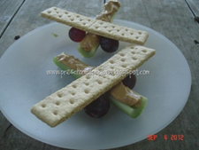  Can you create your own model plane? You might want to use some snacks like the one in the picture or you may use recycled materials! 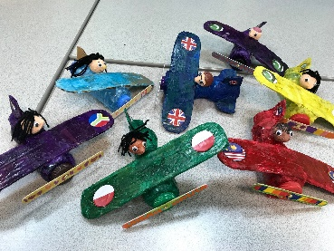
Write a story about an explorer that discovers a new country. | Can you create your own hopscotch with multiples of 2,5,10 or any you want to try?  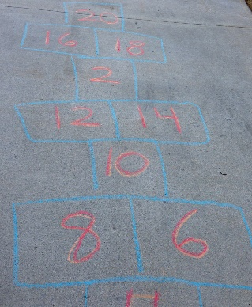 | Create your own sport. What equipment would you need? | Go on a summer walk. What plants, flowers and animals/insects did you see? Can you create a tally chart or bar chart on what you saw? | Bake some delicious food that you would give to an astronaut that was flying to space on a mission.
Research how aeroplanes have changed throughout time. Can you create a poster to present your research? | Can you measure different plants or flowers that you find? Which was the tallest? Which was the shortest? | Complete the Joe Wicks work-out every day for one week. How do you feel after the exercise? | Draw a picture of your favourite outdoor place during each season. | Can you draw, make or create your very own hot air balloon. 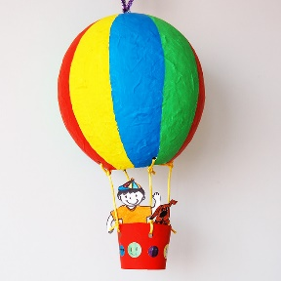
If you could travel around the world in 8 days. Which countries would you visit and why? Can you write a postcard from one of the countries about what you did and saw etc. | Can you create your own tally/bar chart on the types of traffic you see outside your house?  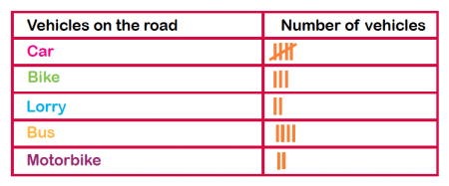 | Set up a mini Olympics/sports day for your family. What are the rules? Can you make a certificate for the winner of each race? | Draw around your hand and turn each hand into a tree from a different season. Add a picture of yourself next to each tree – what do you wear/do during that season?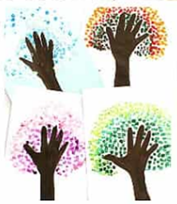 | Create your own pilot license that will allow you to travel around the world in your own aeroplane.

