
Learning Activities
Year 1 2019-20

Self-isolation learning Week 3

Year 1, remember to always try your best, listen to your grown-ups, help with chores and keep active! Enjoy spending time with your family, play games, share books and stories and remember our Swingate motto ‘believe, learn, and achieve’.
 | Lessons set | Additional comments
Monday | Weekly spellings to learn for a spelling test on Friday – children, wild, climb, most, only, both.  https://www.teachhandwriting.co.uk/continuous-cursive-beginners-choice-3.html practise a letter every day. Don’t forget to practise the capital letter as well. Remember capital letters always go to the top and watch out for those ascending letters (letters that go to the top - t, h, k, l, d, b) and descending letters (letters that go below the line - q, y, p, f, g, j)  SLoR – reading for 10 minutes to your puppy. Play the reading game after reading.  English – Look out of the window and write a list of things that you can see. Then use adjectives to describe the things you can see. Put these into sentences. E.g. I can see tall green trees blowing in the warm breeze. The bright coloured flowers look pretty in the sunlight.  Maths – Choose a maths game to play each day. https://www.topmarks.co.uk/Search.aspx?Subject=16&AgeGroup=2  Practise counting forwards and backwards to 20 and then to 100.  Practise writing your numbers to 20. Remember not to write any alien (backwards) numbers!  Represent different numbers - Make your own tens frames or print some off the internet and use counters, or anything you can find to use instead of counters (raisins, grapes, cereal pieces etc…..) Start by using one tens frame to make numbers up to 10, then use a second tens frame to show numbers up to 20. You can also draw them out.  Link to video on using tens frames and counters to make numbers https://www.youtube.com/watch?v=Hur7sKFpKPQ&list=PLWIJ2KbiNEypnO-un0c9IthOv_RGjtEvG&index  Geography - This term’s topic is Unique United Kingdom. You will be identifying the countries of the U.K. and using your geographical skills to read maps. Use the map to locate England, Northern Ireland, Scotland and Wales. Can you label and colour each country in a different colour? Use this website to help support your learning - https://www.bbc.co.uk/bitesize/topics/zyhp34j/articles/z4v3jhv | Each day complete a home learning task.  Each day complete the Ninja maths sheet – 2 minute time limit. You could watch a range of videos to help support your child in answering these key instant recall facts on YouTube.  Link to a blog on maths games:  https://matr.org/blog/fun-maths-games-activities-for-kids/
Tuesday | Practise your spellings ready for Friday’s test – your challenge is to try and put them into a sentence.  https://www.teachhandwriting.co.uk/continuous-cursive-beginners-choice-3.html practise a letter every day. Don’t forget to practise the capital letter as well. Remember capital letters always go to the top and watch out for those ascending letters (letters that go to the top - t, h, k, l, d, b) and descending letters (letters that go below the line - q, y, p, f, g, j)  SLoR – reading for 10 minutes to your puppy. Play the reading game after reading.  English – Write as many words as you can think of that include split digraphs e.g. cake, like, home, tube, these. Then write some of your own sentences using the words you have come up with. Don’t forget to present your learning neatly and use capital letters and full stops.  Maths – Choose a maths game to play each day. https://www.topmarks.co.uk/Search.aspx?Subject=16&AgeGroup=2  Practise counting forwards and backwards to 20 and then to 100.  Practise writing your numbers to 20. Remember not to write any alien (backwards) numbers!  Tens and ones - Answer the questions based on tens and ones. Use your learning from yesterday to help you. Use the place value tens and ones PowerPoint to recap numbers. Use the worksheet and answer the questions. Then get your adult to go through it with you.  Music – play with music online and even make your own songs! - https://musiclab.chromeexperiments.com/Experiments
Wednesday | Practise your spellings ready for Friday’s test – your challenge is to try and put them into a sentence.  https://www.teachhandwriting.co.uk/continuous-cursive-beginners-choice-3.html practise a letter every day. Don’t forget to practise the capital letter as well. Remember capital letters always go to the top and watch out for those ascending letters (letters that go to the top - t, h, k, l, d, b) and descending letters (letters that go below the line - q, y, p, f, g, j)  SLoR – reading for 10 minutes to your puppy. Play the reading game after reading.  English – Write a letter to your friend or even your teacher telling them what you have been doing so far. Remember to include the features of a letter. Such as; your address, the date, who the letter is to, why you are writing, content, any questions and who the letter is from.  Maths – Choose a maths game to play each day. https://www.topmarks.co.uk/Search.aspx?Subject=16&AgeGroup=2  Practise counting forwards and backwards to 20 and then to 100.  Practise writing your numbers to 20. Remember not to write any alien (backwards) numbers!  Read and write numbers from 1-20 in numbers and in words - Make 1-20 number cards and one to twenty word cards out of paper. Have a go at matching up the numbers and words. Play the memory game, by turning all your cards over and taking it in turns to pick 2 cards. If the number and word matches, you get to keep both cards. The winner is the person with the most pairs at the end. Challenge: Memory game for a selection of numbers to 100. Complete the activity numbers to 20. Can you draw them based on tens and ones?  Outdoor learning - Make a toilet roll bird feeder! This activity is messy but fun and we hope you enjoy it! It will also help you learn about the birds in your neighbourhood. You can make this simple feeder with items you probably already have at home:  - Smother a cardboard tube in peanut butter (no added salt and sugar versions are suitable for birds).  - Roll it in bird seed and thread some string through the hole.  - Tie it up in your garden where birds will feel safe eating.  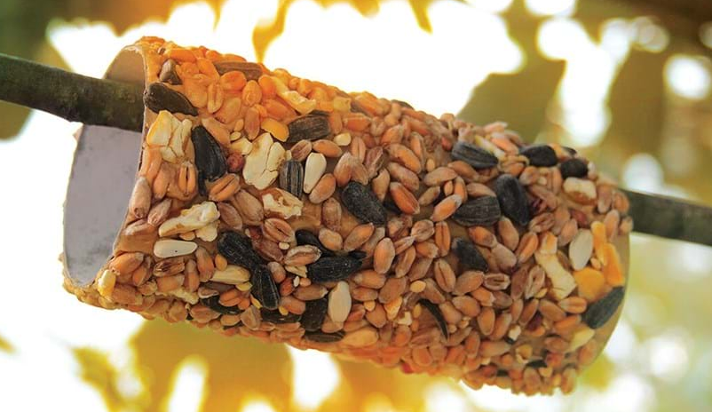
Thursday | Practise your spellings ready for Friday’s test – your challenge is to try and put them into a sentence.  https://www.teachhandwriting.co.uk/continuous-cursive-beginners-choice-3.html practise a letter every day. Don’t forget to practise the capital letter as well. Remember capital letters always go to the top and watch out for those ascending letters (letters that go to the top - t, h, k, l, d, b) and descending letters (letters that go below the line - q, y, p, f, g, j)  SLoR – reading for 10 minutes to your puppy. Create a new character for the story. What would they be called? What would they look like?  English – Think of your favourite dinner. Write a description of it to someone who has never heard of it or tasted it before. Don’t forget to use capital letters, full stops and finger spaces.  Maths – Choose a maths game to play each day. https://www.topmarks.co.uk/Search.aspx?Subject=16&AgeGroup=2  Practise counting forwards and backwards to 20 and then to 100.  Practise writing your numbers to 20. Remember not to write any alien (backwards) numbers!  Adding Numbers - Watch the addition video: https://www.bbc.co.uk/bitesize/topics/zwv39j6/articles/z8hyfrd With your adult choose two numbers to add together e.g. 9 + 7 = or 11 + 6 =. Use counters/raisins/Lego or other objects from round the house to help you.  Try this adding different numbers.  Outdoor learning – Make natural art! Put the pencils and crayons to one side and if possible go outside and look for natural art materials instead. You could collect fallen leaves, petals and sticks and use them to make a picture or sculpture.  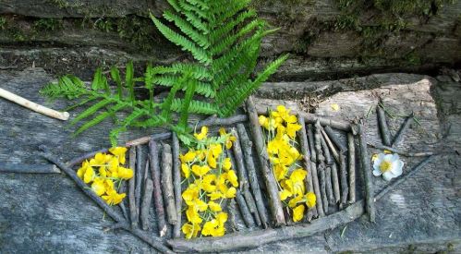
Friday | Follow @PuppyDiariesYr1 on twitter to have your weekly spelling test at 9am or alternatively get your grown-up to test you! If you get 6/6 you are a superstar!  https://www.teachhandwriting.co.uk/continuous-cursive-beginners-choice-3.html practise a letter every day. Don’t forget to practise the capital letter as well. Remember capital letters always go to the top and watch out for those ascending letters (letters that go to the top - t, h, k, l, d, b) and descending letters (letters that go below the line - q, y, p, f, g, j)  SLoR – reading for 10 minutes to your puppy. Create a book review on the book you have read this week. Remember to include the title of the book, what your favourite part was and why and then how many stars you would rate it out of 5. You could even draw a picture of your favourite part.  English – Draw a picture of yourself and write 5 or more sentences that describe you. Remember to add in lots of detail to your picture and try to use adjectives and conjunctions (such as ‘and’) to join your sentences together.  Maths – Choose a maths game to play each day. https://www.topmarks.co.uk/Search.aspx?Subject=16&AgeGroup=2  Practise counting forwards and backwards to 20 and then to 100.  Practise writing your numbers to 20. Remember not to write any alien (backwards) numbers!  Subtraction Numbers - Watch the subtraction video -https://www.bbc.co.uk/bitesize/topics/zwv39j6/articles/z8hyfrd With your adult choose two numbers to subtract from each other e.g. 16 – 7 = or 11- 4 =. Use counters/raisins/Lego or other objects from around the house to help you. Try this with subtracting different numbers.  Art/Topic – Remember our new topic is Unique United Kingdom – research the countries that make up the United Kingdom and look at their flags. Design and create your own flag for your own island.

Learning Activities
Year 1 2019-20

Self-isolation learning Week 4
 | Lessons set | Additional comments
Monday | Weekly spellings to learn for a spelling test on Friday – old, cold, gold, told, every, great  https://www.teachhandwriting.co.uk/continuous-cursive-beginners-choice-3.html practise a letter every day. Don’t forget to practise the capital letter as well. Remember capital letters always go to the top and watch out for those ascending letters (letters that go to the top - t, h, k, l, d, b) and descending letters (letters that go below the line - q, y, p, f, g, j)  SLoR – reading for 10 minutes to your puppy. Play the reading game after reading.  English – This week you will be writing a story about an adventure. First you need to create a main character. Draw a picture of your character and describe them using full sentences. E.g. Lucy has brown curly hair and is a cheeky girl. She’s very brave and likes to go on adventures around the United Kingdom.  Maths – Choose a maths game to play each day. https://www.topmarks.co.uk/Search.aspx?Subject=16&AgeGroup=2  Practise counting forwards and backwards to 20 and then to 100.  Practise writing your numbers to 20. Remember not to write any alien (backwards) numbers!  2D shapes and 3D shapes  How many 2D and 3D shapes can you name? Go round your house/garden and make a list of all the circles, squares, rectangles and triangle shapes you can see. Can you find any other 2D shapes? Then go round looking for 3D shapes (cubes, cuboids, cylinders and spheres). Can you find any others?  Can you group what you have found? Film yourself explaining how you grouped them and why. Use the Vocab mat at the end of this sheet to help you.  Science – We are going to have our own mini science week! Each day you will have a science activity to complete. Let’s start with plants… What flowers can you find in the garden? Draw a picture of them! Can you label them? | Each day complete a home learning task.  Each day complete the Ninja maths sheet – 2 minute time limit. You could watch these videos to help support your child in answering these key instant recall facts –  https://www.youtube.com/watch?v=lD9tjBUiXs0  and https://www.youtube.com/watch?v=iiR8hqJeQsw  Link to a blog on maths games:  https://matr.org/blog/fun-maths-games-activities-for-kids/
Tuesday | Practise your spellings ready for Friday’s test – your challenge is to try and put them into a sentence.  https://www.teachhandwriting.co.uk/continuous-cursive-beginners-choice-3.html practise a letter every day. Don’t forget to practise the capital letter as well. Remember capital letters always go to the top and watch out for those ascending letters (letters that go to the top - t, h, k, l, d, b) and descending letters (letters that go below the line - q, y, p, f, g, j)  SLoR – reading for 10 minutes to your puppy. Play the reading game after reading.  English – Well done for creating your character yesterday. Now we need to send your character on an adventure somewhere in the United Kingdom. Your character can go anywhere you like. Perhaps think of a famous landmark they could visit? Or even send them to somewhere you have visited before. The choice is yours! You need to think of somewhere and then describe the setting using full sentences. E.g. Outside Big Ben there are lots of people rushing around. The city is full of fast cars and big, red buses.  Maths – Choose a maths game to play each day. https://www.topmarks.co.uk/Search.aspx?Subject=16&AgeGroup=2  Practise counting forwards and backwards to 20 and then to 100.  Practise writing your numbers to 20. Remember not to write any alien (backwards) numbers!  2D shapes and 3D shapes  From your list you made yesterday draw the objects that were circles, squares, rectangles and triangle shapes on the poster.  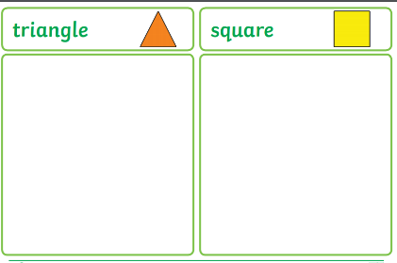  Ask your grown up to cut out some 2D shapes (see separate sheet for some 2d shapes). Can you make different pictures with them? Try drawing out a picture using just 2D shapes.  Science - Go on a bug hunt in your garden! What can you find? Maybe you could make a bug hotel.
Wednesday | Practise your spellings ready for Friday’s test – your challenge is to try and put them into a sentence.  https://www.teachhandwriting.co.uk/continuous-cursive-beginners-choice-3.html practise a letter every day. Don’t forget to practise the capital letter as well. Remember capital letters always go to the top and watch out for those ascending letters (letters that go to the top - t, h, k, l, d, b) and descending letters (letters that go below the line - q, y, p, f, g, j)  SLoR – reading for 10 minutes to your puppy. Play the reading game after reading.  English – You have now created a character and your setting. Well done! Now we need to write the beginning of our adventure story. You could search the internet for some great story starters or even think of your own to wow your teachers! Don’t forget to use capital letters, full stops and finger spaces.  e.g. - One sunny day Lucy woke up and decided it was time for an adventure. She put on her bright red coat and yellow wellington boots and headed off to London, the capital city of England.  Maths – Choose a maths game to play each day. https://www.topmarks.co.uk/Search.aspx?Subject=16&AgeGroup=2  Practise counting forwards and backwards to 20 and then to 100.  Practise writing your numbers to 20. Remember not to write any alien (backwards) numbers!  2D shapes and 3D shapes  Recap on 2d shapes. Can you find their properties? How many sides and corners do they have?  What properties are there of 3d Shapes? How many edges, vertices (points) and faces does each one have?  Complete the 3d shape property grid and stick it in your home learning exercise book.  Science - Find 10 animals and sort them in to the correct groups of mammals, fish, birds, reptiles and amphibians. Choose two of each animal in each group. What do they have in common?
Thursday | Practise your spellings ready for Friday’s test – your challenge is to try and put them into a sentence.  https://www.teachhandwriting.co.uk/continuous-cursive-beginners-choice-3.html practise a letter every day. Don’t forget to practise the capital letter as well. Remember capital letters always go to the top and watch out for those ascending letters (letters that go to the top - t, h, k, l, d, b) and descending letters (letters that go below the line - q, y, p, f, g, j)  SLoR – reading for 10 minutes to your puppy. Play the reading game after reading.  English – Well done for starting your beginning of your story. Now we need to write the middle of our adventure story. What does your character do now? Where do they go? What do they see? Don’t forget to use capital letters, full stops and finger spaces.  e.g. - Once Lucy arrived in London her first stop was to go to Buckingham Palace to see the Queen. The Queen had shiny diamonds in her crown and was playing with her two beautiful corgi’s. Next, Lucy wanted to visit Big Ben, she got on a big, red bus to take her there. Big Ben was as tall as a mountain and Lucy took some pictures to show her mummy and daddy. After that, Lucy went and took an exciting ride on the London Eye. She could see for miles across the beautiful skyline and wondered what it would look like at night.  Maths – Choose a maths game to play each day. https://www.topmarks.co.uk/Search.aspx?Subject=16&AgeGroup=2  Practise counting forwards and backwards to 20 and then to 100.  Practise writing your numbers to 20. Remember not to write any alien (backwards) numbers!  2D shapes and 3D shapes  Using all you have learnt this week about shapes around the house. Create your own 2d and 3d shape game. It could be similar to snakes and ladders, it could be like top trumps. You decide on the game you want to make and play.  Science - Draw around your body and label your body parts. You could use chalk outside if it’s a nice day!  arm/leg/foot/chest/hand/face/stomach/knee/elbow/ankle/wrist/hip/thigh/shoulder.
Friday | Follow @PuppyDiariesYr1 on twitter to have your weekly spelling test at 9am or alternatively get your grown-up to test you! If you get 6/6 you are a superstar!  https://www.teachhandwriting.co.uk/continuous-cursive-beginners-choice-3.html practise a letter every day. Don’t forget to practise the capital letter as well. Remember capital letters always go to the top and watch out for those ascending letters (letters that go to the top - t, h, k, l, d, b) and descending letters (letters that go below the line - q, y, p, f, g, j)  SLoR – reading for 10 minutes to your puppy. Play the reading game after reading.  English – Well done for completing your beginning and middle of your story. Now we need to write the end of our adventure story. What does your character do now? How do they get home? Don’t forget to use capital letters, full stops and finger spaces.  e.g. - Lucy began to feel sad and tired because her legs were aching from all of the walking she had been doing around the capital city of England. She thought to herself that her mummy and daddy must be missing her and she decided it was time to go home. When Lucy arrived home she gave her mummy and daddy a big tight squeeze and showed them all of her pictures from her amazing adventure in London.  Well done on completing your story! You could even record yourself reading your story and post this on twitter for your teachers and friends to see! We look forward to listening to your stories  Maths – Choose a maths game to play each day. https://www.topmarks.co.uk/Search.aspx?Subject=16&AgeGroup=2  Practise counting forwards and backwards to 20 and then to 100.  Practise writing your numbers to 20. Remember not to write any alien (backwards) numbers!  Money  Ask your grown-up for some money (only to borrow!) Can you identify all the coins? Can you make 10p? Can you find a different way to make 10p using different coins? Try this for different amounts of money such 7p, 20p etc.  Science - Make a collage of various materials you find in your garden and around your house. Let’s see how colourful you can make it.

