13/3/2020
LO: To be able to count in multiples of 2s, 5s and 10s.
SC: I can count in 2s, 5s and 10s.
I can find the missing number.

Count up in 2s:
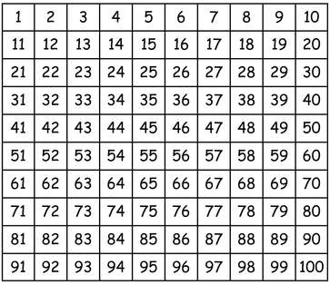

Count up in 5s:

Count up in 10s:

Fill in the missing numbers:


