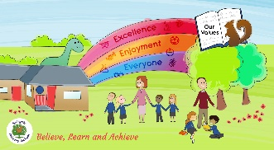
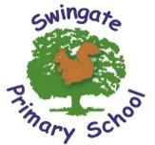

Believe, Learn and Achieve

What to expect in year 6!

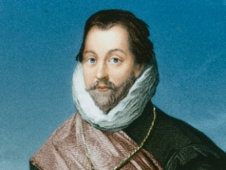
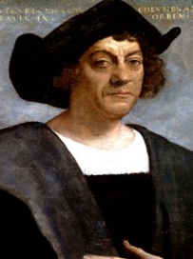
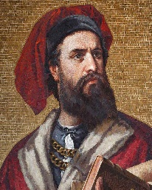
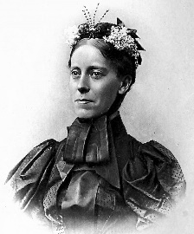

As a school we feel it is important that we share with the expectations of the year 6 curriculum with you. As your child enters their last year of primary school, they need to be well prepared for life in secondary school.

All of the end of year expectation objectives will be worked on throughout the year and will be the focus of direct teaching. Any extra support you can provide in helping your children to achieve these is greatly valued.

If you have any queries or want support in knowing how best to help your child, please talk to us. We have also included some recommended websites below to help with your child’s learning.

Recommended websites:
http://www.swingate.medway.sch.uk/ (curriculum hyperlink then maths option)
http://www.conkermaths.org/cmweb.nsf/pages/kirfs.html
http://www.topmarks.co.uk/maths-games/7-11-years/ordering-and-sequencing-numbers
http://www.transum.org/Tables/Times_Tables.asp
https://readtheory.org/
https://www.topmarks.co.uk/maths-games/hit-the-button
http://www.swingate.medway.sch.uk/page/?title=Maths&pid=96

Mathematics:

- Read, write, order and compare whole numbers to 10,000,000 and decimals to 3 d.p.
- Know all timestable to 12 x 12 and identify common factors, common multiples and prime numbers.
- Round any whole number to a required degree of accuracy.
- Multiple and divide numbers by 10, 100, and 1000
- Use knowledge of order of operations to carry out calculations involving four operations.
- Multiply 4-digit by 2-digit and divide 4-digit by 2-digit
- I can solve a range of multi-step problems including the four operations
- I can solve recognise the relationship between fractions, decimals and percentages
- Add, subtract, multiple and divide fractions with different denominators and mixed numbers, writing the answer in the simplest form.
- Divide proper fractions by whole numbers.
- recognise the relationship between fractions, decimals and percentages
- I can convert between unit of measurements for length, mass volume and time up to 3.dp and solve a range of problems
- I can calculate the area and perimeter of a range of shapes (including triangles and parallelograms and irregular shapes
- I know a range of 2D shapes and can classify them based on their properties
- I can recognise missing angles on a straight line and in a shape.
- I can interpret a range of pie charts and graph
- TT Rockstars – children are expected to practise this at home to improve recall of times table facts

Writing at the expected standard:

Throughout the year children will have the opportunity to repeatedly write for a range of purposes. These are the skills that children will need to be using independently by the end of the year.

- Writes for a range of purposes
- Can describe settings, characters and atmosphere using appropriate vocabulary
- Include dialogue to convey character and advance the action
- Use a range of conjunctions, adverbial phrases, pronouns and synonyms to link sentences and paragraphs.
- Use vocabulary and grammatical structures to reflect writing style (e.g. contracted words in speech, passive voice, modal verbs)
- I can use the correct tense consistently in a piece of writing
- I can use a range of punctuation (full stops, question marks, exclamation marks, commas, inverted commas, semi colons, colons, dashes, and hyphens)
- I can spell most words from the year 5&6 spelling list and use a dictionary to check my spellings
- My handwriting is consistently joined

Reading:

These are some of the key skills that children will be developing over the course of the year. To aid the development of these skills the children will use the following strategies

Use background knowledge to make links with what they are reading.

Ask questions as they read

Recognizing unknown language and using the context to aid meaning.

Key Skills:

Read age-appropriate books with confidence and fluency
- Read aloud with intonation that shows understanding.
- Work out the meaning of words from the context
- Draw inferences such as characters’ feelings, thoughts and motives from their actions and justify these inferences with evidence.
- Predict what might happen from details stated and implied
- Retrieve information from non-fiction and fiction
- Summarise main ideas, identifying key details

Children need to be reading at home every evening as part of their weekly home learning. In May, the SAT reading tests taken require stamina in reading. The test consists of reading three pieces of long text and answering questions in an hour. Therefore children need to be able to read with speed, fluency and understanding.
Below are some examples of questions to ask your child as they are reading.

Give/explain the meaning of words in a context
- Look at the paragraph beginning…Find one word meaning…
- In the sentence/paragraph which word most closely matches the meaning of the word…
- Give the meaning of the word…in this sentence.

Retrieve and record information/identify key details from fiction and non-fiction.
- What did…have to do in order to…?
- Look at the paragraph beginning…give one/two reasons why…
- True or false
- How does the … behave when…?

Make inference from the text…
- Why did … feel …?
- How do you think … felt when (or about) …?
- What do you think…was thinking?
Top 30 reads for year 6 as recommended by children and teachers.

Who Let the Gods Out? by Maz Evans
Beetle Boy by M.G Leonard
Miss Peregrine’s Home for Peculiar Children by Ransom Riggs
Cogheart by Peter Bunzl
Goldfish Boy by Lisa Thompson
The Bubble Boy by Stewart Foster
There May Be a Castle by Piers Torday
Wonder by R J Palacio
Inside Out and Back Again by Thannha Lai
The Secret of Nightingale Wood by Lucy Strange
The Many World of Albie Bright by Christopher Edge
Room 13 by Robert Swindells
Percy Jackson and the Lightning Thief by Rick Riordan
Time Travelling with a Hamster by Ross Welford
Cloud Busting by Malorie Blackman
Phoenix by S F Said
Artemis Fowl by Eoin Colfer
Clockwork by Phillip Pullman
Girl of Ink and Stars by Kiran Millwood-Hargrave
The Nowhere Emporium by Ross Mackenzie
Rooftoppers by Katherine Rundell
George’s Secret Key to the Universe by Lucy and Stephen Hawking
Shadow Forest by Matt Haig
The London Eye Mystery by Siobhan Dowd
How to Train Your Dragon by Cressida Cowell
Pax by Sara Pennypacker
Skulduggery Pleasant by Derek Landy
Strange Star by Emma Carroll
Coraline by Neil Gaiman
A Series of Unfortunate Events by Lemony Snicket

