Maths
By the end of year 2 children should be able to:
-Count in 2, 3, 5, 10s forward and back
-Recognise the value of each digit in a two digit number
-Know number bonds to 20 as well as subtraction facts
-Estimate numbers on a number line
-Order numbers using <> =
-Read and write numbers to 100 in numbers and words.
-Recall addition and subtraction facts to 20 fluently.
-Add and subtract 2 digit numbers and using £, understand that adding can be done in any order but not when subtracting.
-Use the inverse operation to check their answers
-Recall multiplication n division facts for 2, 5 and 10 times table
-Recognise odd and even numbers
-Calculate using + - X and ÷
-Recognise and find fractions 1/3, 1/4, 2/4 and 3/4 of a length, shape, set of objects or quantity and recognise their equivalence.
-Measure length and height, temperature, capacity using appropriate equipment
-Use £ and find different combinations of coins that equal the same amounts of money
-Tell and write the time to five minutes, including quarter past/to the hour and draw the hands on a clock face to show these times.
-know the number of minutes in an hour and the number of hours in a day
-Identify and describe the properties of 2-D and –D shapes –Use the terminology clockwise, anti-clockwise
-Use tables, graphs, pictograms to interpret data.

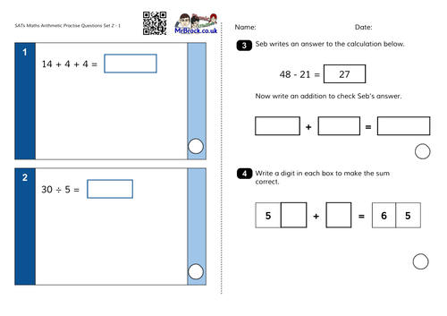
The school website has helpful videos to show how calculations are taught throughout the year. At the moment, children in year 2 are using jottings using tens and ones to add and subtract as previously show in Family Friday sessions. These methods can be seen here:
http://www.swingate.medway.sch.uk/page/?title=Addition&pid=99

We do not show the children the column method for adding or subtracting until later on when their reasoning is much greater.

Here is an example of a SATS maths paper:
Children are encouraged to use working out to complete questions but are unable to be given any support and no apparatus is allowed.

Common exception words:
door floor poor because find kind mind behind climb child children wild most only both old cold gold hold told clothes every everybody hour even any many great break steak pretty beautiful after fast last past father class grass pass plant path bath busy move prove improve sure sugar could should would eye people water who whole again half money parents Mr Mrs Christmas the a do to today of said says are were was is his has I you your they be he me she we ask go so no by my here there where friend love come some one once school put push pull full house our
Books covered over the next year:
Term 1 | The Three Little Pigs
Term 2 | Oliver Twist  Where the Poppies now grow
Term 3 | The Wizard of Oz  Extreme weather  The Fantastic Flying Books of Mr Morris Lessmore
Term 4 | The Great Fire of London  Samuel Pepys diary entries
Term 5 | The Twits  Wombat goes Walkabout  Wombat Stew
Term 6 | Charlie and the Chocolate Factory  The Enormous Crocodile

Reading
All children have the opportunity to change their reading books on a daily basis. Reading logs are looked at every day. By the end of year 2 children should be able to:
-Segment and blend to read words.
-Listen and discuss books and poetry which they can read independently.
-Sequence a story as well retell fairy stories and traditional tales.
-Understand the structure of a non-fiction text and be able to use it to find relevant information.
-Discuss the meaning of words and also say what their favourite word or phrase is.
-Explain what they have read to show that they understand the plot.
-Correct themselves
-Infer what is being said and done
-Ask and answer questions relating to the text they have read.
-Predict the ending of a story.
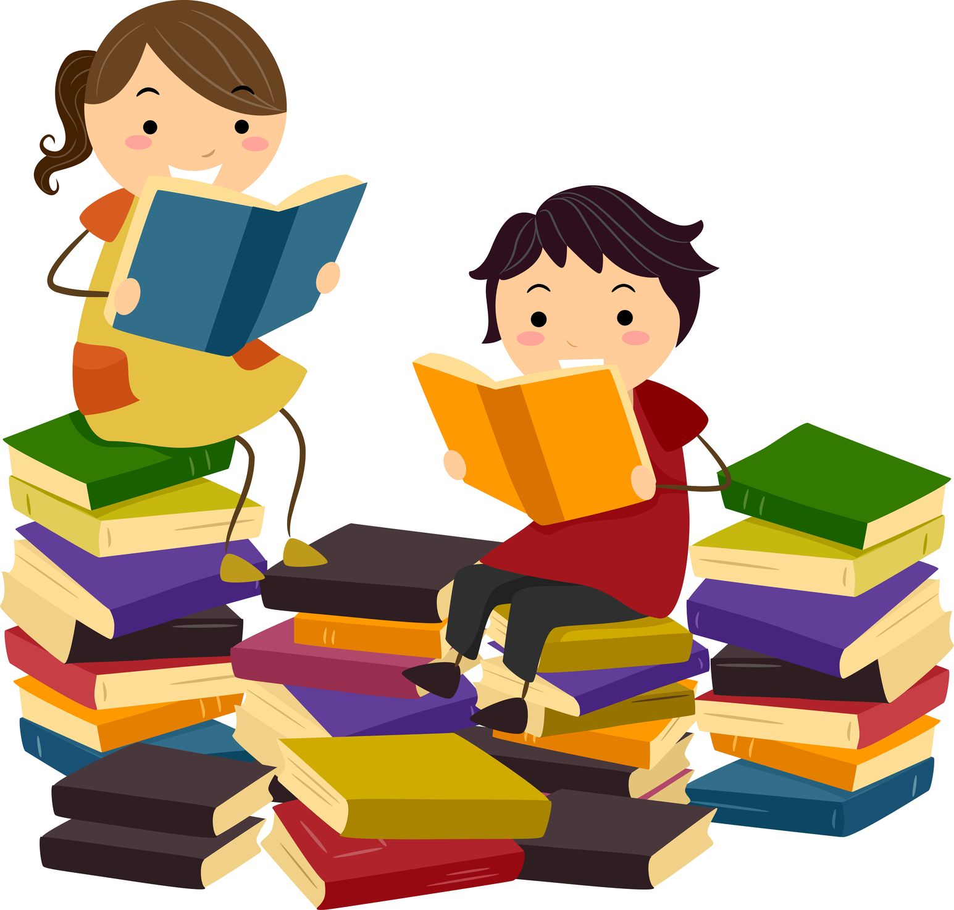
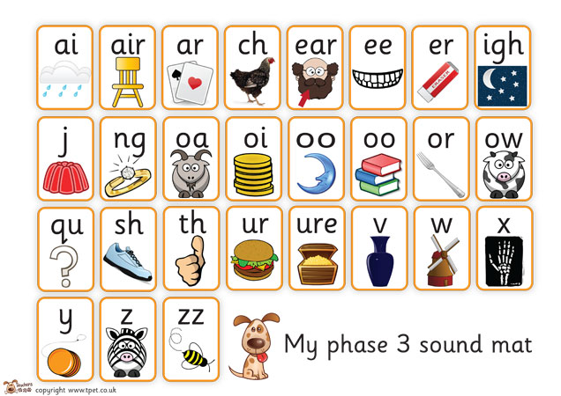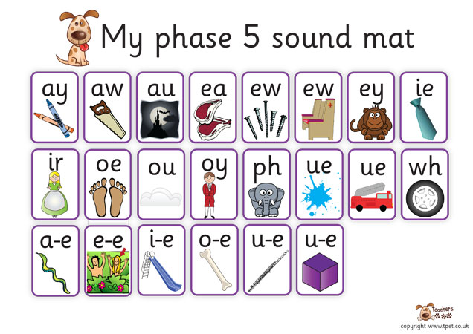
These are the phase 3/5 sound mats that we use in school to support with reading and spelling.
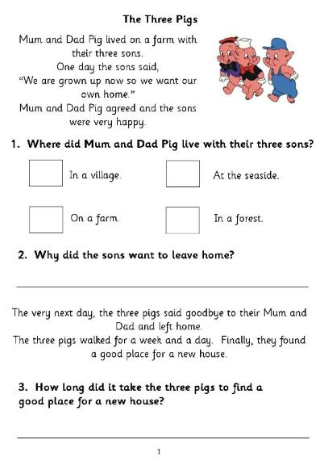
Please continue to support your child at home by reading on a daily basis. Children in year 2 should be able to read 90 words in a minute with understanding. Practising reading fluency and expression are great skills to make your child a ‘better’ reader.
It really does make a difference.

Writing
By the end of year 2 children should be able to:
Word | Use suffixes: ment, ness, ful, less, ly, er, est
Sentence | Subordination (when, if, that, because)  Co-ordination (or, and, but)  Expanded noun phrase  Statements  Exclamations  Questions  commands
Text | Use the present and past tense
Punctuation | Capital letters  Full stops  Commas in a list  Apostrophes to make letters missing  Apostrophes to show possession
Terminology | Noun  Adjectives  Expanded noun  Verb  Suffix  Adverb  Past/present tense  Apostrophe  comma
Spelling | Common exception words (words that do not fit a common spelling pattern)  Spell words with contracted forms
Handwriting | To begin to join letters together using cursive joins  http://www.teachhandwriting.co.uk/

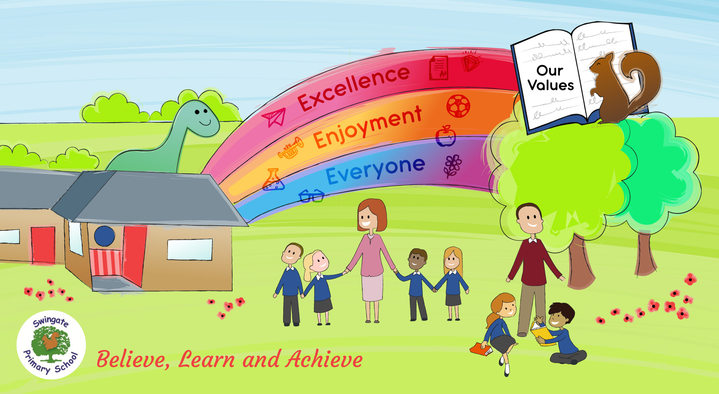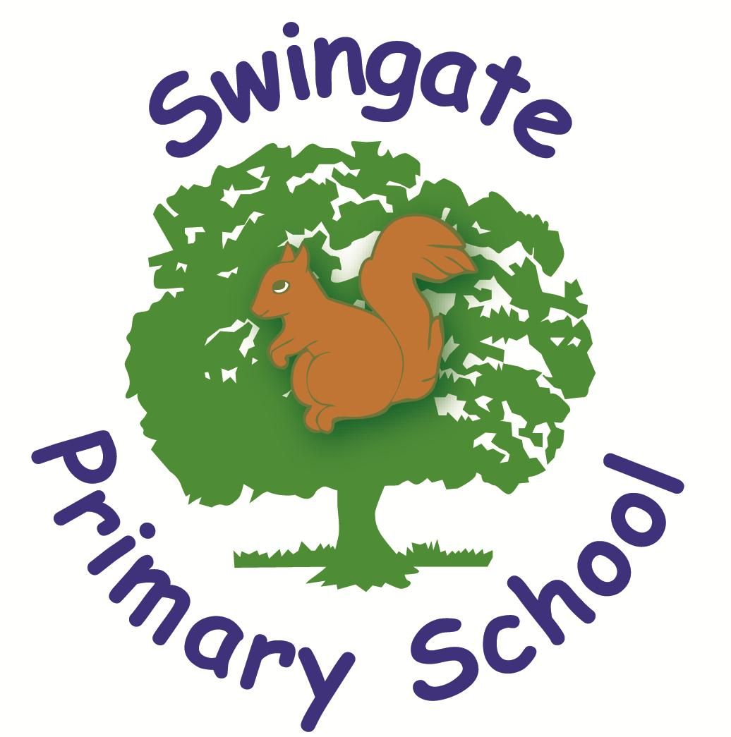

Believe, Learn and Achieve

Welcome to year 2

As many of you will be aware the Key Stage 1 SATS commence in May. To ensure the children are as calm as possible we call these ‘special quizzes’ as the children will complete these in small groups. The information in this booklet is not only to aid the children in these tests but to ensure that they achieve as much as they can whilst they are with us. Please use this booklet as a guide for ‘what’s going on’ in Parrot, Giraffe and Meerkat class.

