
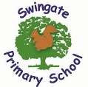
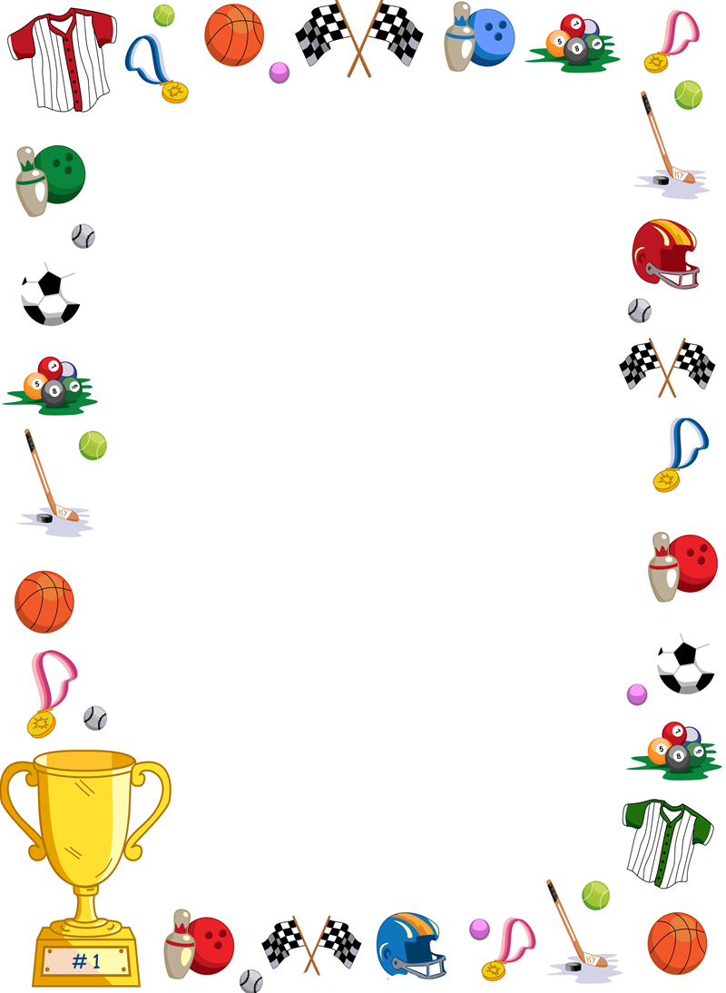
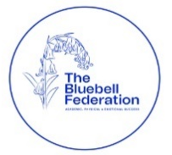

Club news
In term 1 there were a total of 12 clubs (8 sports clubs) run at the school. New clubs in term 2 will include table tennis club and fun sports club.

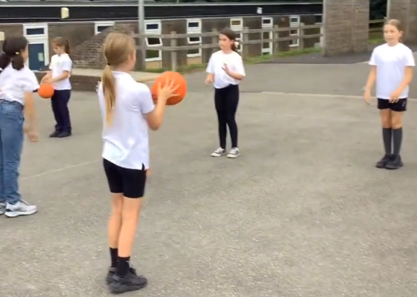
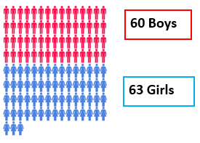

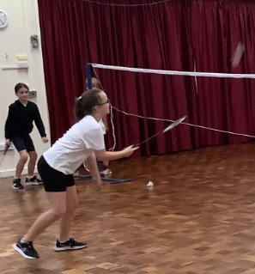
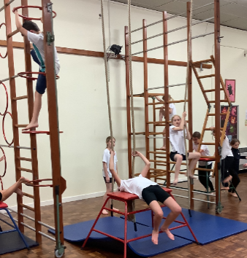
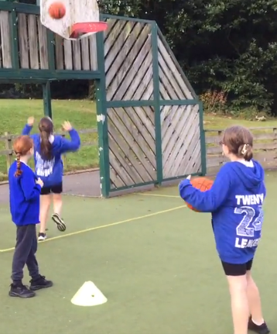
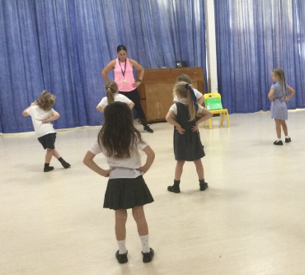
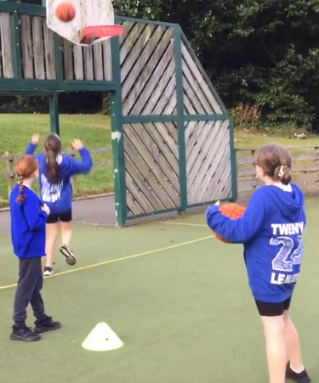
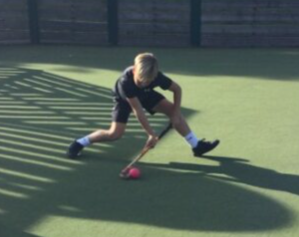
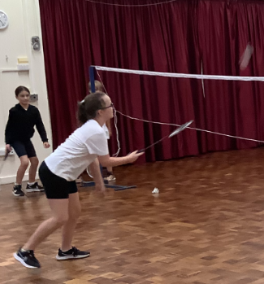

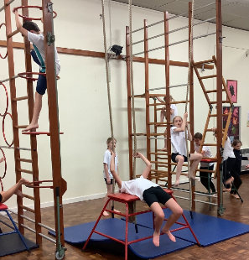
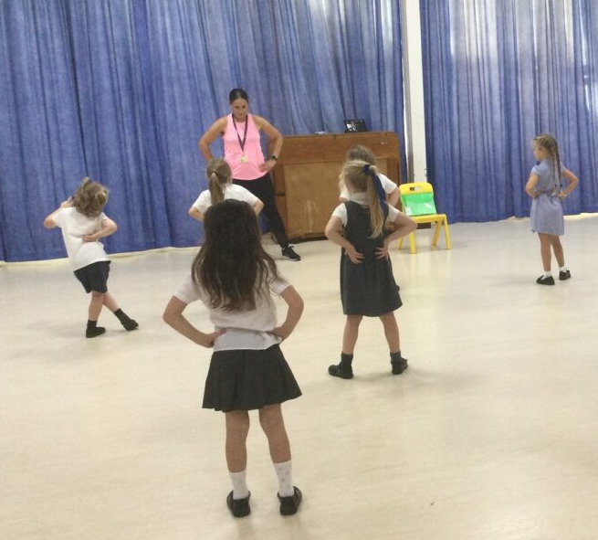

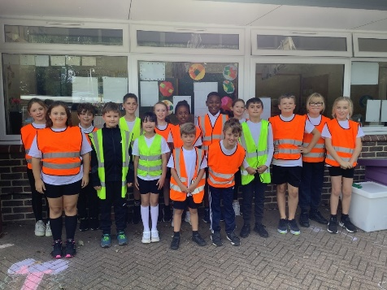
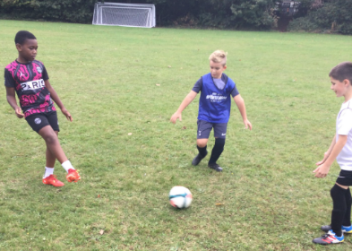

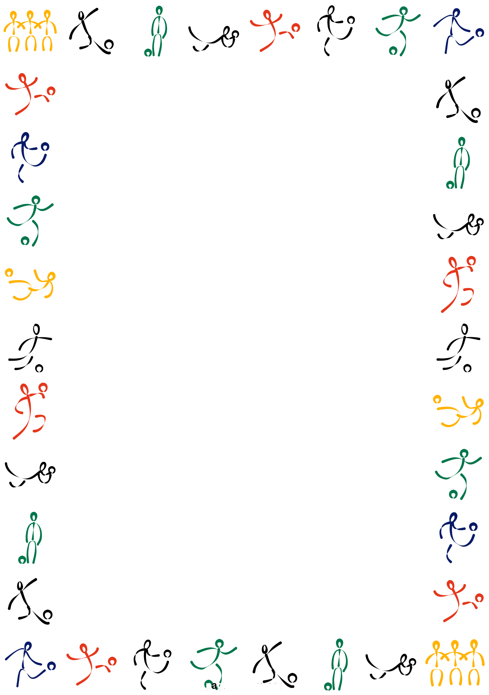
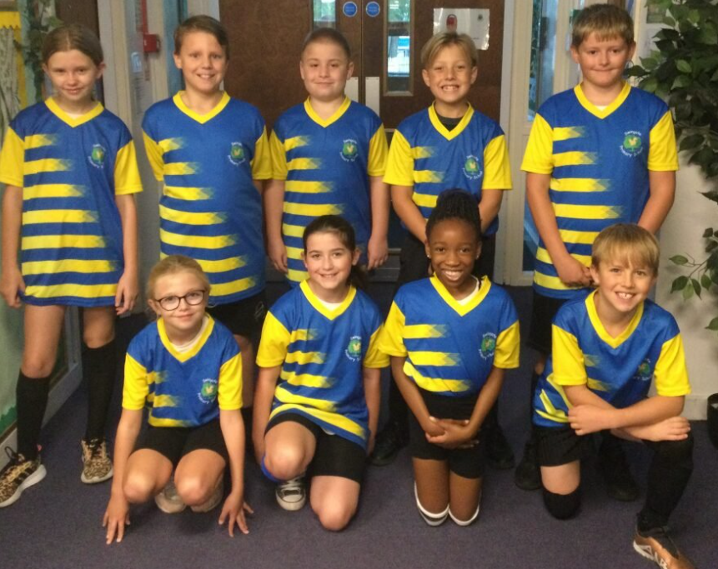
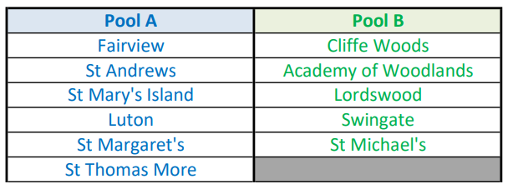
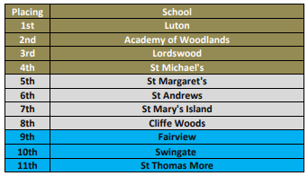
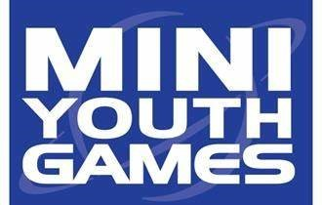
MYG Rugby

The first MYG of the year was hockey and took place at Holcombe Hockey Club on Tuesday 10th October. The children were against some tough opposition and tried their best, showing great sportsmanship and teamwork throughout the day. They eventually finished in 10th position but were awarded the fair play trophy which is voted for by the other school teachers and is awarded to one school that shows amazing fair play e.g. positive attitude, congratulating the opposition, handshakes etc.

In term five we look forward to the netball MYG on the 25th April and cricket MYG on the 23rd May.

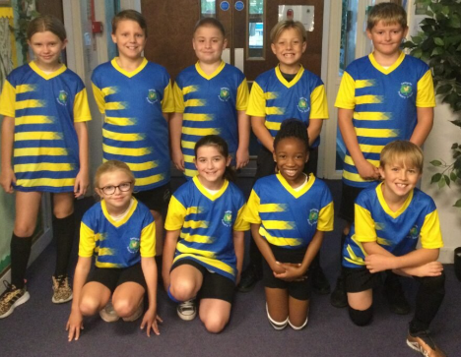
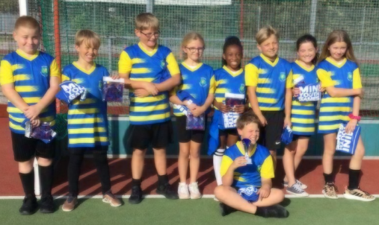

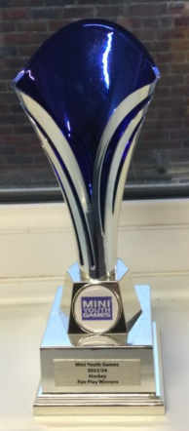
Badminton and Basketball are the next two MYG sports in term 2.

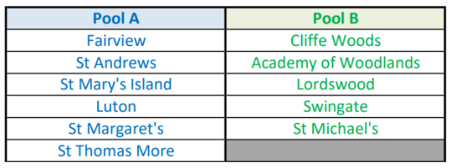

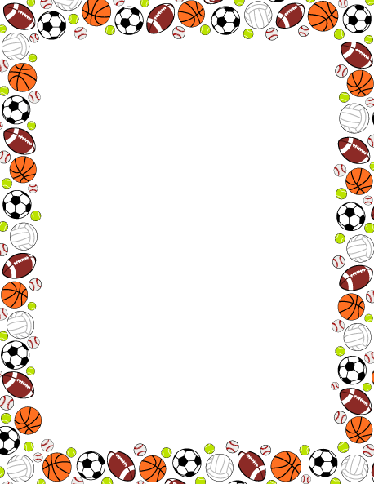

Year 5 playground leaders have been supporting Y3 children at lunchtime by organising and running a variety of different sporting activities including: cup stacking, parachute games, catching and throwing drills, athletic challenges. The training they received from the Howard School Sports Partnership have allowed them to flourish and show off their talents with a focus on:
- Planning and leading activities in the playground to engage all
- Recognising the skills and qualities of a good leader
- Understanding the need to work as a team when completing group activities
- Reflecting on learning through practical application and peer feedback to improve activities e.g. number of children per activity/space and equipment required
- Raising the profile of PE and school sport/sportsmanship in the school



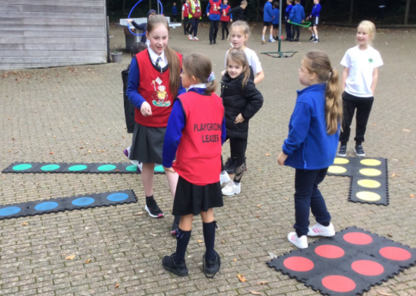
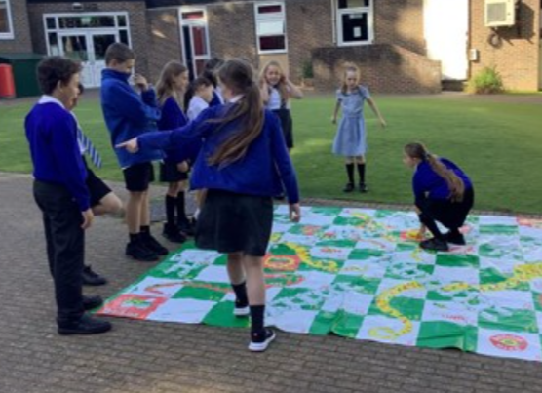

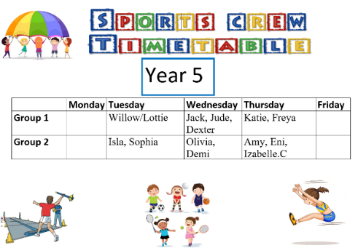
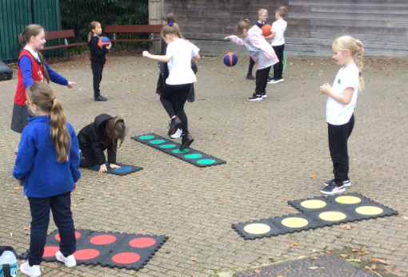

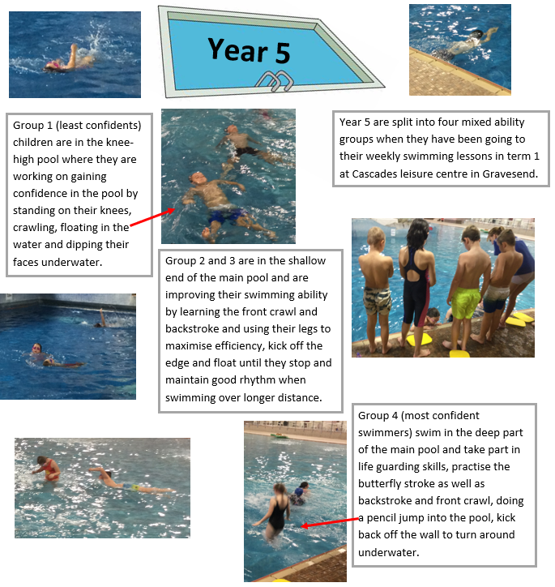


Next term year 4 will be going swimming.

