Maths
- By the end of year 1 children should be able to:
- Count to and across 100, forwards and backwards from any number.
- Read and write numbers to 20 in numerals and words.
- Read and write numbers to 100 in numerals.
- Say 1 more/1 less to 100.
- Count in multiples of 2, 5 and 10.
- Use bonds and subtraction facts to 20.
- Add and subtract 1 digit and 2 digit numbers to 20, including zero.
- Solve one-step multiplication and division using objects, pictorial representation and arrays.
- Recognise half and quarter of object, shape or quantity.
- Sequence events in chronological order.
- Use language of day, week, month and year.
- Tell time to hour and half past.

These are our recommended websites:
http://www.conkermaths.org/cmweb.nsf/pages/kirfs.html
http://resources.woodlands.kent.sch.uk/maths/index.html
http://www.topmarks.co.uk/maths-games/7-11-years/ordering-and-sequencing-numbers
http://www.bbc.co.uk/bitesize/ks1/maths/multiplication/play/
http://www.transum.org/Tables/Times_Tables.asp

Our KIRF’s are: (Key instant recall facts year 1 children should know).

To help develop children’s fluency in mathematics, we ask them to learn Key Instant Recall Facts each half term. We expect children to practise their KIRFs at least 3 times a week, which is done in Start the Day the Maths Way. (We sing songs, play games and learn through being active).

Term 1: Days of the Week and Months of the Year.
Term 2: Number bonds to 6
Term 3: Doubles and halves of numbers to 10.
Term 4: Number bonds to 10.
Term 5: Tell the time to o’clock and half past.
Term 6: Number bonds to 10.
Our Calculation Policy

The school website has helpful videos to show how calculations are taught throughout the year. At the moment, children in year 1 are using jottings using tens and ones to add and subtract as previously show in Family Friday sessions. These methods can be seen here:
http://www.swingate.medway.sch.uk/page/?title=Addition&pid=99



Reading
All children have the opportunity to change their reading books on a daily basis. Reading logs are looked at every day. By the end of year 1 children should be able to:

- Identify which words appear again and again.
- Recognise which words appear again and again.
- Recognise and join in with predictable phrases.
- Recognise common exception words.
- Relate reading to own experiences.
- Re-read if reading does not make sense.
- Re-tell with considerable accuracy.
- Discuss significance of title and events.
- Make predictions on basis of what has been read.
- Make inferences on basis of what is being said and done.
- Read aloud with pace and expression, i.e.
- Recognise: capital letters, full stops, question marks, exclamation marks and ellipsis
- Know why the writer has used the above punctuation in a text.
- Know the difference between fiction and non-fiction texts.

Common exception words:
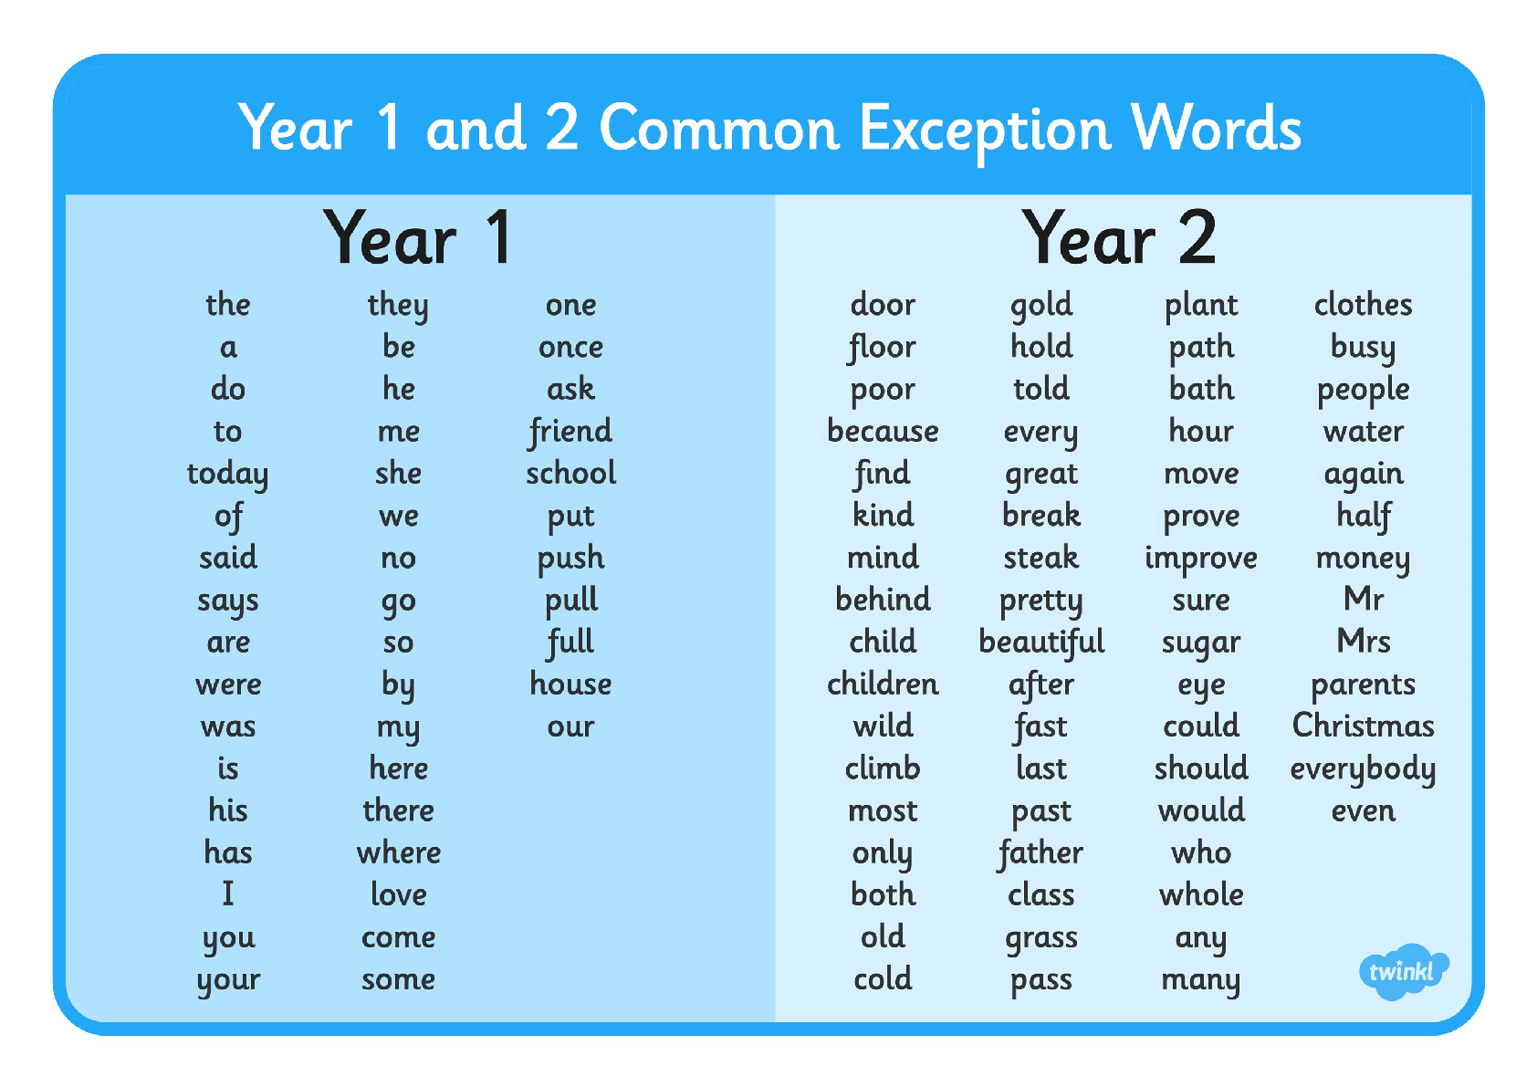
Books used to support your child’s learning this year:
Term 1  (Dockside Discovery) | The Enormous Turnip  Grandads’ Island  The Storm Whale  Pirate folk tales
Term 2  (Ice Ice Baby) | Polar Express (film)  Rainbow Bear  Ice Bear  The Snowman
Term 3  (Time to Play) | Traction Man  Traditional Tales  Toy Story (film)
Term 4  (To infinity and Beyond) | Beegu  Bob the Man on the Moon  Space and planets non-fiction books
Term 5  (Unique United Kingdom) | Handas Surprise  Naughty Bus  London non-fiction books
Term 6  (Cracking Ideas) | On Sudden Hill  Not a box

Writing
By the end of year 1 children should be able to:
- Write clearly demarcated sentences.
- Use ‘and’ to join ideas.
- Use conjunctions to join sentences (e.g. so, but)
- Use standard forms of verbs, e.g. go/went.
- Introduce use of:
    - capital letters
    - full stops
    - question marks
    - exclamation marks
- Use capital letters for names and personal pronoun ‘I’.
- Write a sequence of sentences to form a short narrative (as introduction to paragraphs).
- Use correct formation of lower case – finishing in right place.
- Use correct formation of capital letters.
- Use correct formation of digits.



Phonics
At Swingate Primary School we use synthetic phonics. Children are taught to read letter or groups of letter by saying the sound(s) they represent-
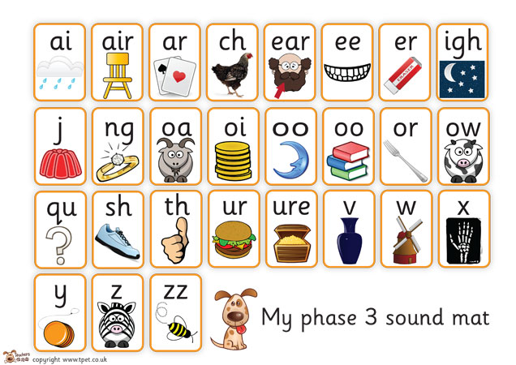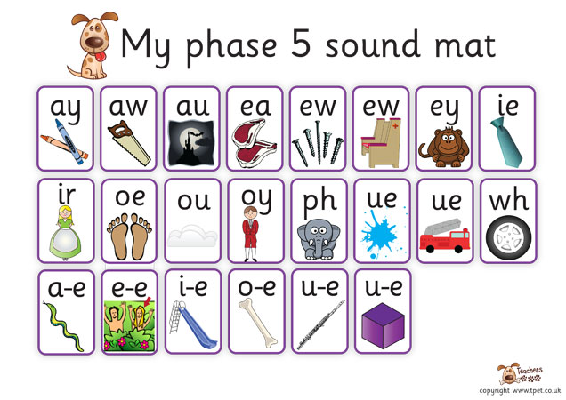
In June 2018 the children will take part in the National Phonics Screening Check. This will test their knowledge of phonics. They will be asked to read 40 real and pseudo (alien words).
Book Bands
Please continue to support your child at home by reading on a daily basis. Children should be reading 5-10 minutes a day. Children should leave Year 1 on Turquoise band or above.
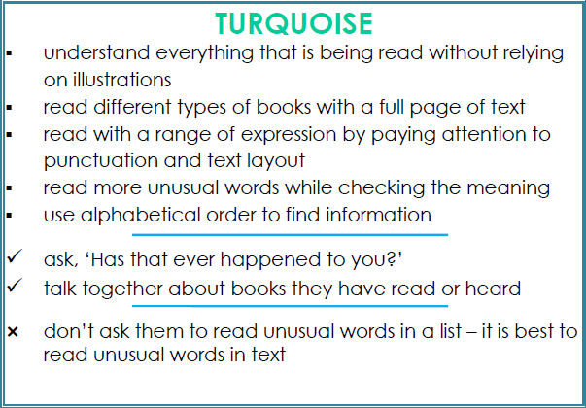
Children who are reading regularly at home and at school practise reading fluency and expression are great skills to make your child a ‘better’ reader. It really does make a difference.

How you can help me at home…

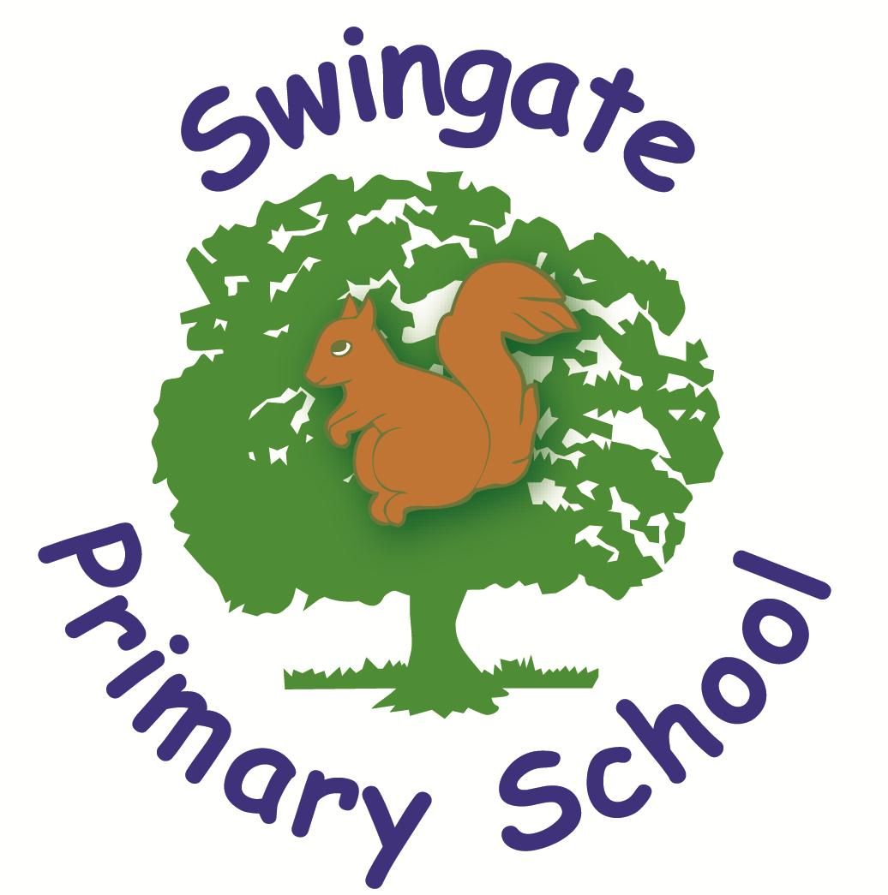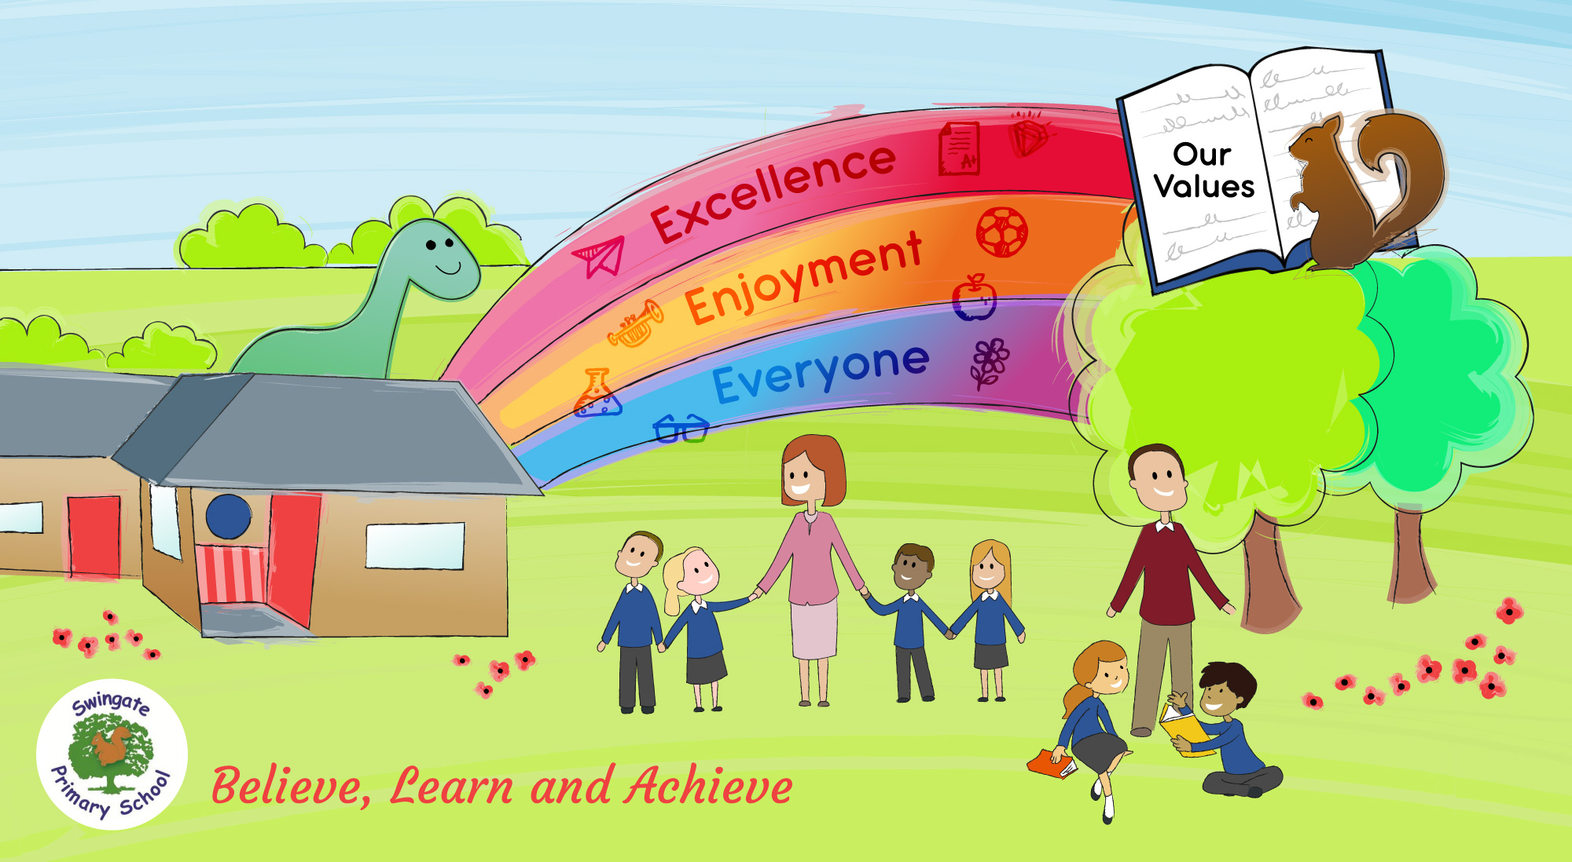

Believe, Learn and Achieve

Welcome to year 1
The information in this booklet is not only to aid the children in their learning but also to support you as their parent with your child’s learning. This is to ensure that they achieve as much as they can whilst they are with us. Please use this booklet as a guide for ‘what’s going on’ in Unicorn, Tiger and Panda class.



