Mathematics
Numbers
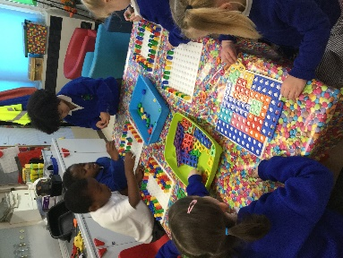
- Children count reliably with numbers from 1 to 20 and place them in order.
- They say which number is one more or one less than a given number.
- They add and subtract two single-digit numbers.
- They solve problems, including doubling, halving and sharing.
Shape, Space and Measures
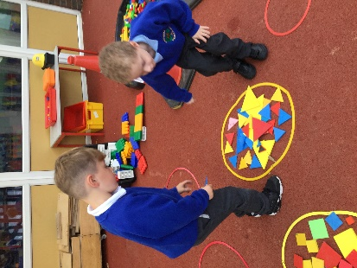
- Children use everyday language to talk about size, weight, capacity, position, distance, time and money to compare quantities and objects to solve problems.
- They recognise, create and describe patterns.
- They explore characteristics of everyday objects and shapes and use mathematical language to describe them.

These are our recommended websites:
http://www.swingate.medway.sch.uk/ (curriculum hyperlink then maths option)
http://www.conkermaths.org/cmweb.nsf/pages/kirfs.html
http://resources.woodlands.kent.sch.uk/maths/index.html
http://www.topmarks.co.uk/maths-games/5-7-years/ordering-and-sequencing-numbers
http://www.bbc.co.uk/bitesize/ks1/maths/multiplication/play/​
http://www.transum.org/Tables/Times_Tables.asp

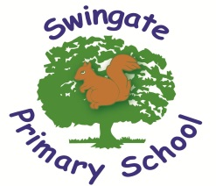
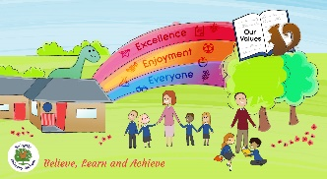

Believe, Learn and Achieve

Helping your child at home.

Now that you child has started full time school, it is important we let you know what we are learning so you can help.
Each term you will be given a letter outlining topics of the term but we want you to know the end of year expectations as the year will certainly fly by.



Personal Social Emotional Development
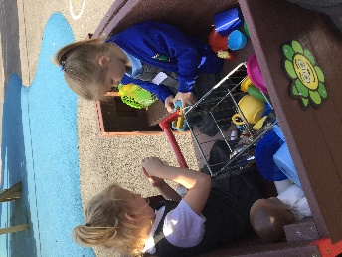
- Children are sensitive to others’ needs and feelings.
- They are confident to speak in a familiar group, will talk about their ideas know that some behaviour is unacceptable.
- They work as part of a group or class, and understand and follow the rules
Communication and Language
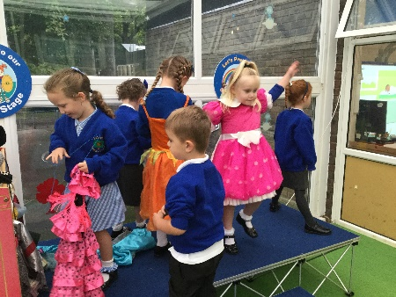
- Children follow instructions involving several ideas or actions
- They give their attention to what others say and respond appropriately, while engaged in another activity.
- They develop their own narratives and explanations by connecting ideas or events.
Physical Development
- Children show good control and co-ordination in large and small movements.
- They move confidently in a range of ways, safely negotiating space.
- They handle equipment and tools effectively, including pencils for writing.
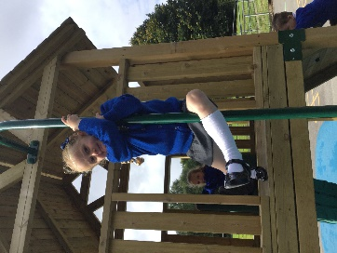
- Children know the importance for good health of physical exercise, and a healthy diet, and talk about ways to keep healthy and safe.
- They manage their own basic hygiene and personal needs successfully, including dressing and going to the toilet independently.

Reading
- Children read and understand simple sentences.
- They use phonic knowledge to decode regular words and read them aloud accurately.
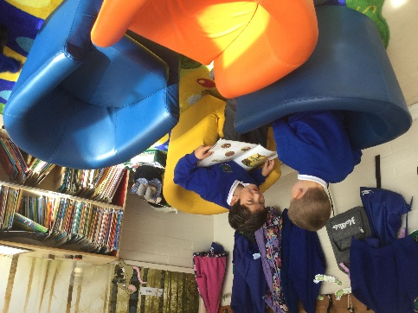
- They also read some common irregular words, e.g. was, said, you, like.
- They demonstrate understanding when talking with others other about what they have read.

Writing
- Children use their phonic knowledge to write words in ways which match their spoken sounds.
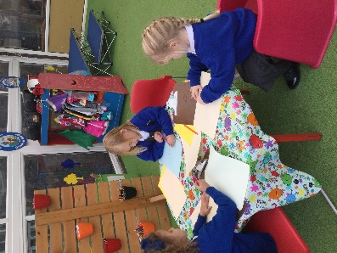
- They also write some irregular common words, e.g. the, my, he, she.
- They write simple sentences which can be ready by themselves and others.
- Some words are spelt correctly and others ae phonetically plausible, e.g. ‘wosht’ instead of ‘washed’ and ‘shi’ instead of ‘shy’.

Remember to use your WOW books to record any learning at home!

