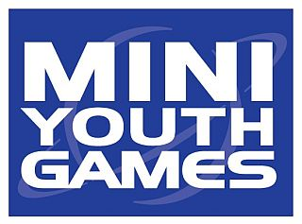

Mini Youth Games

Around 3,700 primary school children take part in the Mini Youth Games series each year.
The Games are open to pupils from every primary school child in Medway and invitational external schools.
Prizes are awarded at each event and points are gained towards the overall MYG title. A fair play trophy is awarded at each event Mini Youth Games brochure cover 2016/17and there is an annual participation prize for the school that selects the largest number of children to take part in MYG events.
Leading schools also qualify for Night of Champions finals as part of the summer Medway Festival of Sport.

Inter and Intra schools games

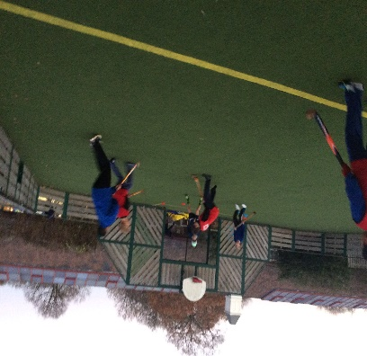
At Swingate we encourage all to take part in sporting activities and provide inter house and inter school competitions.

We regularly host home matches and we look forward to our away matches with our brand new mini bus.

We also arrange daily house fixtures at break time in Football, Basketball and Handball with an overall league position.

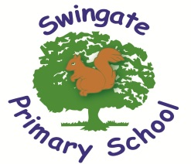

Believe, Learn and Achieve

PE and Sport at Swingate
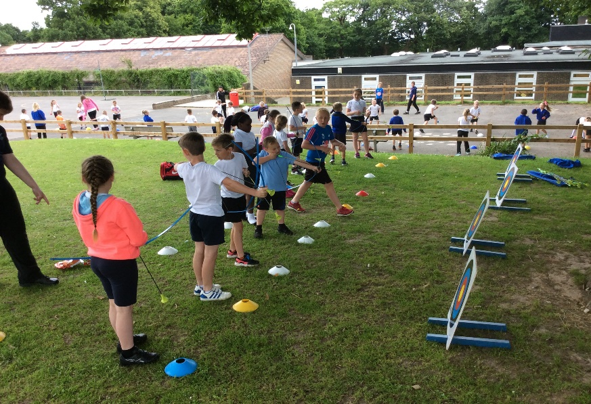
This booklet provides a summary of the different sporting and PE arrangements at Swingate Primary School.

Lunch, Break and After School Clubs
- We always encourage all children to take part in an extra-curricular sports club. Our target is to encourage 80% of our children to participate in a sports club.
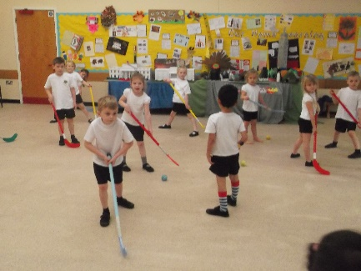
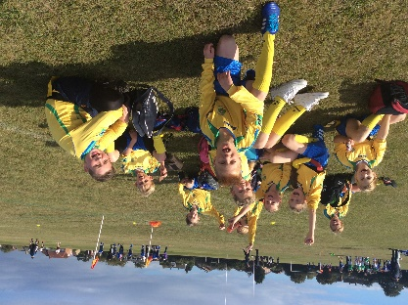
- In terms one and two we ran clubs in Tag Rugby, Hockey, Basketball, Netball, Football and Badminton. These clubs were open to all abilities and other schools were invited to play our school in some of these sports. These clubs were all used to develop a team to attend the Mini Youth Games
- Tournaments. We look forward to our future clubs such as Athletics, Rounders, Cricket and many more!
- As well as these clubs we have nurtured some of our pupils’ leadership skills and created a Sports Crew. This is a group of children that are selected to help children in KS1 during lunchtime by running small sporting activities for them.

BEAM – Balance, Education and Movement
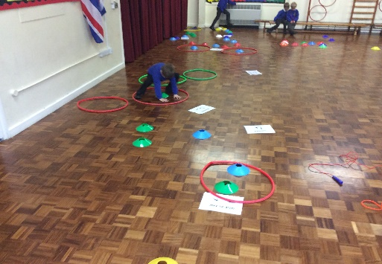
- Beam is a small focus group concentrating on the fundamental skills of physical development. Some of these skills include: Balance, coordination and physical awareness. As well as these skills they can be taught through adapted sports.

Curriculum
- We encourage all pupils to succeed and excel in competitive sport and other physically-demanding activities. We provide opportunities for pupils to become physically confident in a way which supports their health and fitness. Opportunities to compete in sport and other activities build character and help to embed values such as fairness and respect.

Aims
- The national curriculum for physical education aims to ensure that all pupils:
- Develop competence to excel in a broad range of physical activities
- Are physically active for sustained periods of time
- Engage in competitive sports and activities
- Lead healthy, active lives.
- To be able to swim.

Sports Premium Grant
The Government currently give all primary schools a sum of money to spend on developing sport and PE across the school. Take a look on our website to see how we use our funding.

