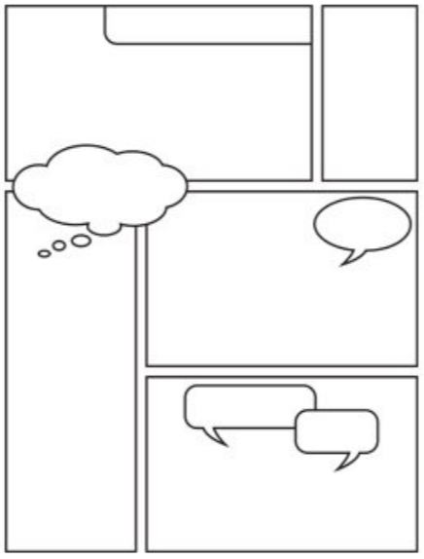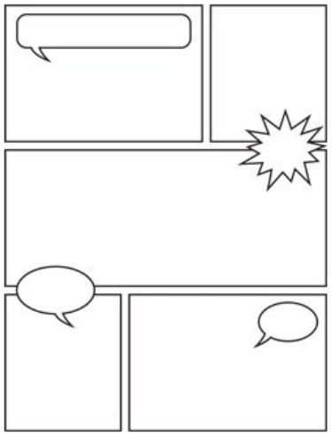

Come up with a catchy title for your comic strip.

Use this sheet to plan out your comic strip – you can sketch out your pictures, write dialogue ideas in the speech bubbles and write some key words and phrases for your sentences.