My memories from Red Panda Class…

This is me!
Words to describe me: _______, ________, ________ and ________.

My teachers
Mrs Bowman:

Mrs Turpie & Mrs Hutchings:

How my teachers have helped me… ____________________________________________________________________________________________________________________________________________________________
My favourites…
Food: ______________________________________________________________________
Animal: ______________________________________________________________________
Colour: ______________________________________________________________________
T.V show: ______________________________________________________________________
Topic I’ve learnt: ______________________________________________________________________
Game: ______________________________________________________________________
My friends…

A great memory I have of my friends…
________________________________________________________________________________________________________________________________________________________________________________________________________________________________________________________________________________________
LOOK at this BOOK!
(All about my favourite book)
Book title: __________________

My favourite part: _________________________________________________________________________________________________________

I like this book because: _______________________________________________________________________________________________________________________________________________________________________________
Our school trip…
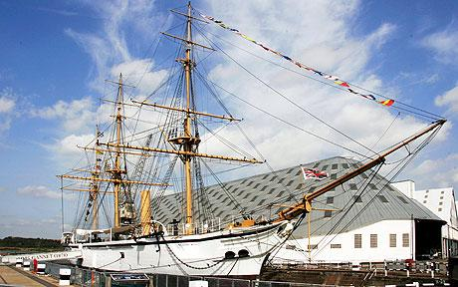
My favourite part of Chatham Dockyard… ______________________________________________________________________________________________________________________________________________________________________________________________________________________________________________________________________________________________________________________________________________________________
What I learnt in year 1…
My favourite topic was ____________ I learnt
______________________________________________________________________
My favourite activity was…
______________________________________________________________________
One thing I learnt was…
______________________________________________________________________
The funniest moment was when…
_________________________________________________________________________________________________________
I’ll never forget…
_________________________________________________________________________________________________________
A look into the future…
How I am feeling
about year 2…

I’m most excited about year 2 because…
_______________________________________________________________________________________________________________________________________________________________________________
In year 2 I hope to…
_______________________________________________________________________________________________________________________________________________________________________________

